AI INFRASTRUCTURE FOR LLMs
GPUs, Interconnects, Clusters, Inference Optimization, Distributed Training, Serving and Observability

A technical reference and interview preparation guide
Prepared for Uzair | September 2026 | v2
Your goal is not just to make a model work. It is to make it fast, scalable, reliable and cost-efficient.

Table of Contents

1. Read This First: Corrections to the Original Notes 4
2. Why AI Infrastructure Is Its Own Discipline 5
3. GPU Concepts Step by Step: Simple First, Then Deep 6
3.1 Step 1: GPU Fundamentals 7
3.2 Step 2: GPU Memory 12
3.3 Step 3: Compute and Numerical Precision 17
3.4 Step 4: GPU Generations 21
3.5 Step 5: LLM Training and Inference 23
3.6 Step 6: From One GPU to Many 26
3.7 Step 7: GPU Interconnects and Communication 29
3.8 Step 8: Scaling LLMs Across GPUs 32
4. GPU and VRAM Fundamentals 37
4.1 What a GPU does for an LLM 37
4.2 The two phases of inference 37
4.3 Where VRAM goes 37
4.4 HBM vs GDDR 38
4.5 How to optimize VRAM for LLMs 38
5. GPU Architectures and Generations 40
5.1 What changed each generation (and why it matters for LLMs) 41
5.2 Choosing a form factor 41
6. Interconnects: PCIe, NVLink and NVSwitch 42
6.1 PCIe (Peripheral Component Interconnect Express) 42
6.2 NVLink and NVSwitch 43
7. How a GPU Cluster Is Built 45
7.1 Hierarchy: GPU -> node -> rack -> pod 45
7.2 Scale-up vs scale-out 45
7.3 The four networks of a GPU cluster 46
7.4 InfiniBand vs RoCE Ethernet 46
7.5 Rack-scale NVLink: GB200 NVL72 46
8. Connecting Two Nodes: Step by Step 48
8.1 Hardware 48
8.2 Software stack 48
8.3 Validate before running real jobs 49
8.4 Run a model across two nodes with vLLM 49
9. Power Consumption and Cooling 50
10. Quantization and Batching 51
10.1 Quantization 51
10.2 Batching 51
11. Inference Engines: vLLM and TensorRT-LLM 53
11.1 vLLM 53
11.2 TensorRT-LLM 54
11.3 Comparison 54
12. KV Caching and Speculative Decoding 55
12.1 KV cache 55
12.2 Speculative decoding 57
13. Token Throughput and Latency Metrics 58
14. Distributed Training: DDP, FSDP and DeepSpeed 59
14.1 DDP (Distributed Data Parallel) 59
14.2 FSDP (Fully Sharded Data Parallel) 59
14.3 DeepSpeed ZeRO 60
14.4 3D / 4D parallelism 61
15. Model Serving, Autoscaling and GPU Scheduling 62
15.1 Serving stack 62
15.2 Autoscaling 62
15.3 GPU scheduling and sharing 62
16. Embeddings, Vector Databases, Retrieval, Reranking and RAG 64
16.1 Pipeline 64
16.2 Components 64
17. Prompt Caching and Cost Optimization 65
17.1 Prompt caching 65
17.2 Cost model 65
17.3 Cost levers (roughly in order of impact) 65
18. Monitoring, Tracing and LLM Observability 66
18.1 Infrastructure metrics (DCGM exporter -> Prometheus -> Grafana) 66
18.2 Serving metrics (vLLM /metrics) 66
18.3 Tracing and LLM observability 66
19. Optimization Playbook 67
20. Interview Questions and Answers 68
20.1 GPU fundamentals and vocabulary 68
20.2 Hardware and interconnects 68
20.3 Inference optimization 69
20.4 Training and distributed systems 71
20.5 Serving, RAG, cost and operations 71
21. References and Image Credits 73

1. Read This First: Corrections to the Original Notes
The source notes this guide expands on contain a few statements that are close but wrong in ways an interviewer will catch. They are corrected here up front so the rest of the document builds on the right mental model.
Original note | What is actually true
"In the same rack, GPUs follow the same architecture and are connected with PCIe; H200 and B200 use NVLink." | This mixes up node and rack. Inside one server (node), the CPU always reaches GPUs over PCIe (except Grace CPUs, which use NVLink-C2C). GPU-to-GPU traffic uses NVLink + NVSwitch on HGX boards (A100, H100, H200, B200) and falls back to PCIe on cards without NVLink (L4, L40S, RTX PRO). Between different nodes in the same rack there is no PCIe at all: nodes talk over a network (InfiniBand or Ethernet). The exception is rack-scale systems like GB200 NVL72, where NVLink spans the whole rack.
"Another node can be linked with Ethernet or NVLink." | Partly. Standard multi-node links are InfiniBand or RoCEv2 Ethernet with one high-speed NIC per GPU. NVLink between separate boxes only exists when NVLink Switch trays are part of the design (NVL72-class racks). You cannot cable two ordinary HGX H200 servers together with NVLink.
"Inferencing link" | There is no dedicated "inference link." What matters is which parallelism crosses which link: tensor parallelism needs NVLink-class bandwidth and should stay inside one NVLink domain; pipeline, data and (with care) expert parallelism can cross the slower node-to-node network.
"Same rack follows same architecture" | Not a rule, but a strong best practice. Mixing GPU generations in one parallel job makes the slowest GPU set the pace and complicates drivers and NCCL. Heterogeneous clusters are fine when each job is pinned to a homogeneous pool.

Key point: Rule of thumb: scale-up = make one NVLink domain bigger (8 GPUs in HGX, 72 in NVL72). Scale-out = add more nodes/racks connected by a network. Your parallelism strategy should mirror this hierarchy.

2. Why AI Infrastructure Is Its Own Discipline
A model running on a laptop answers one person, tolerates multi-second pauses, and costs nothing per token. Serving the same model to thousands of concurrent users turns it into a distributed-systems problem with four competing goals: fast (low latency), scalable (throughput grows with hardware), reliable (no dropped requests when a GPU fails), and cost-efficient (cost per million tokens).
These goals trade off against each other. Bigger batches raise throughput and cut cost but increase per-user latency. Aggressive quantization cuts memory and cost but can degrade quality. More replicas improve reliability but sit idle at night. Nearly every technique in this guide is a way to move along those trade-off curves deliberately rather than by accident.
Layer | What lives here | Main question
Hardware | GPUs, VRAM, CPUs, NVMe | How much memory and bandwidth do I have?
Interconnect | PCIe, NVLink/NVSwitch, InfiniBand/RoCE | How fast can GPUs talk to each other?
Facility | Power, cooling, racks | Can the building actually run this?
Runtime | vLLM, TensorRT-LLM, SGLang, PyTorch, DeepSpeed | How efficiently is each GPU used?
Orchestration | Kubernetes, Slurm, Ray, autoscalers | Where does each workload run, and how many copies?
Application | RAG, embeddings, caching, routing | How many tokens does each request really need?
Observability | Metrics, traces, evals | Is it fast, correct, and within budget right now?

3. GPU Concepts Step by Step: Simple First, Then Deep
This section walks through the core GPU vocabulary in eight steps. Every concept follows the same pattern: a plain-language explanation you could give a non-engineer, a picture, and then the in-depth version an infrastructure interview expects. Later sections (4 onward) go deeper still on the parts that matter most for serving LLMs.
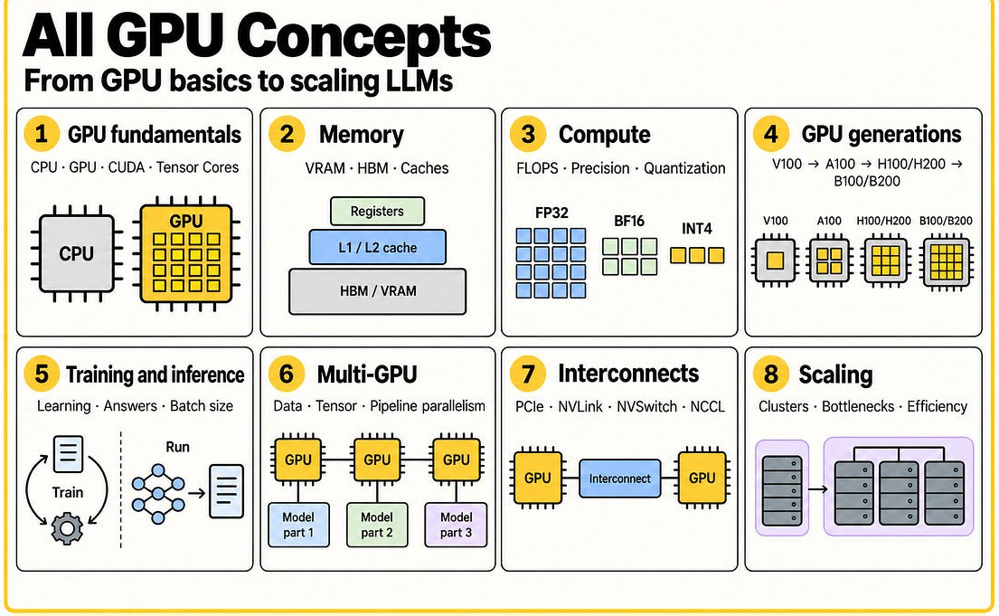
Figure 3.0 - The eight areas covered in this section, from single-GPU fundamentals to cluster scaling.
Source: JAM with AI newsletter, "All GPU related concepts simply explained" (S. Khosravi Jam & S. Ladhwe, 17 Sep 2026)
Step | Area | Question it answers
1 | GPU fundamentals | Why does AI run on GPUs at all?
2 | GPU memory | Will my model fit, and how fast can data reach the cores?
3 | Compute and numerical precision | How many bits per number, and what does that cost in quality?
4 | GPU generations | What changed from V100 to Blackwell, and why do I care?
5 | Training and inference | How do the two workloads stress a GPU differently?
6 | Multiple GPUs | How do we split a model or a batch across GPUs?
7 | Interconnects | How do GPUs talk to each other, and how fast?
8 | Scaling | Why doesn't 8x the GPUs give 8x the speed?

Key point: When a system is slow, first classify the bottleneck: memory (does not fit / waits for data), compute (arithmetic units saturated) or communication (GPUs waiting on each other). Each has different fixes, and buying a faster GPU only fixes one of them.

3.1 Step 1: GPU Fundamentals

CPU
In simple words: A CPU is a small team of expert workers. Each worker is very smart and can handle complicated, step-by-step jobs, but there are only a few of them.
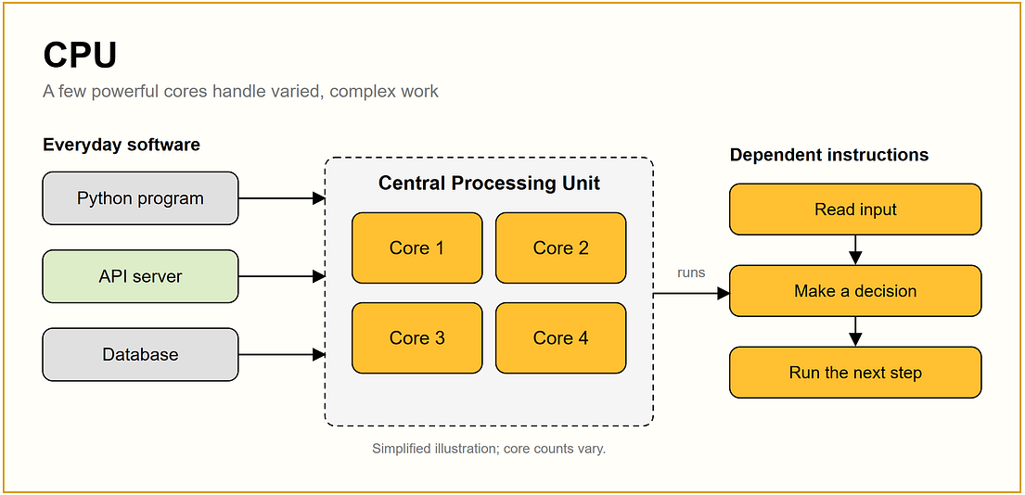
Figure 3.1 - A CPU: a few powerful cores for varied, sequential work.
Source: JAM with AI newsletter, "All GPU related concepts simply explained" (S. Khosravi Jam & S. Ladhwe, 17 Sep 2026)
In depth: Server CPUs have tens to ~200 cores with large per-core caches, branch prediction and out-of-order execution, optimised for low-latency, branch-heavy code. In an LLM server the CPU still matters: it runs the tokenizer, the scheduler, the HTTP server and data loading. A slow or oversubscribed CPU can starve the GPU (visible as low GPU utilization with high CPU load). Pin engine processes to the CPU NUMA node closest to their GPUs.

GPU
In simple words: A GPU is a huge team of simple workers. Each one can only do basic maths, but thousands of them work at the same time, so big repetitive jobs finish fast.
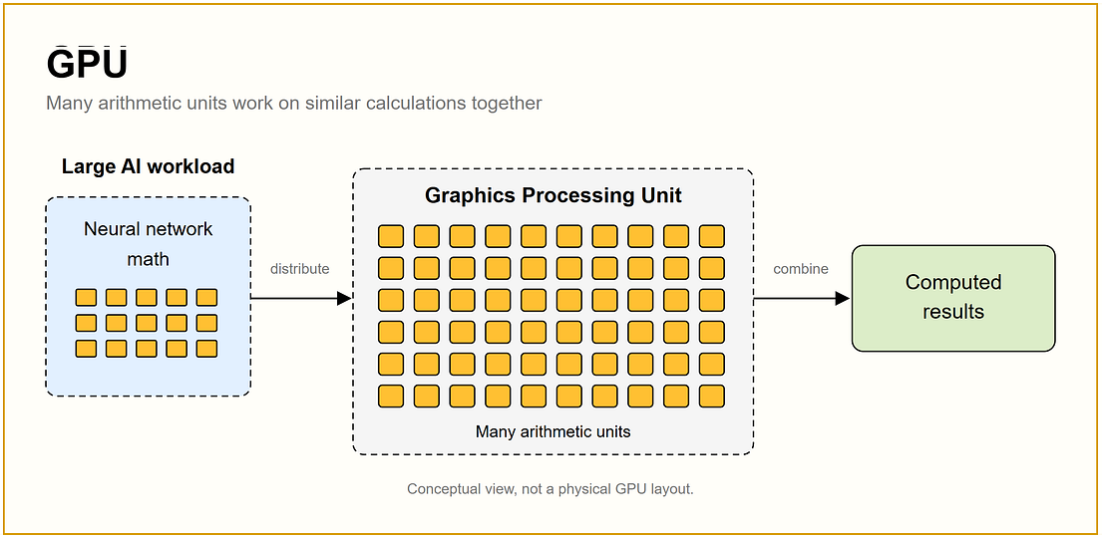
Figure 3.2 - A GPU: many simple arithmetic units working on similar calculations together.
Source: JAM with AI newsletter, "All GPU related concepts simply explained" (S. Khosravi Jam & S. Ladhwe, 17 Sep 2026)
In depth: A data-centre GPU has thousands of cores built for SIMD (single instruction, multiple data) execution and dedicates most of its silicon to arithmetic instead of control logic. Throughput comes from launching the same kernel over millions of tensor elements. GPUs are weak at branchy, sequential logic, which is why the CPU-GPU split in an inference server is deliberate.

Parallel computing
In simple words: If a job can be split into pieces that do not depend on each other, many workers can do those pieces at once instead of one after another.
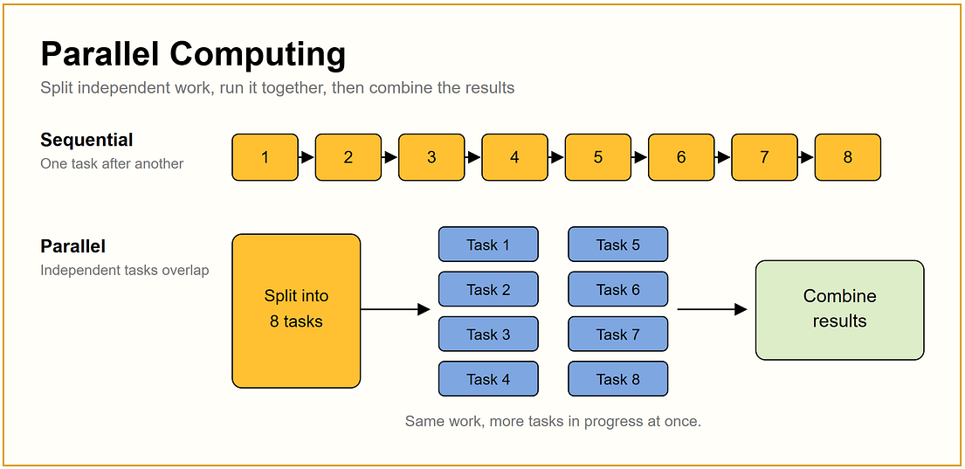
Figure 3.3 - Sequential vs parallel execution of independent tasks.
Source: JAM with AI newsletter, "All GPU related concepts simply explained" (S. Khosravi Jam & S. Ladhwe, 17 Sep 2026)
In depth: Parallelism exists at several levels: inside a kernel (thousands of threads), inside a GPU (many kernels via CUDA streams), and across GPUs (data, tensor, pipeline parallelism). Amdahl's law caps the speed-up: if a fraction s of the work is sequential, the maximum speed-up is 1/s no matter how many workers you add. In LLM decode, the sequential part is the token-by-token loop, which is why batching many users is the main way to use GPU parallelism.

Matrix and tensor operations
In simple words: A matrix is a table of numbers; a tensor is the same idea with more dimensions. Neural networks are mostly giant tables of numbers being multiplied together.
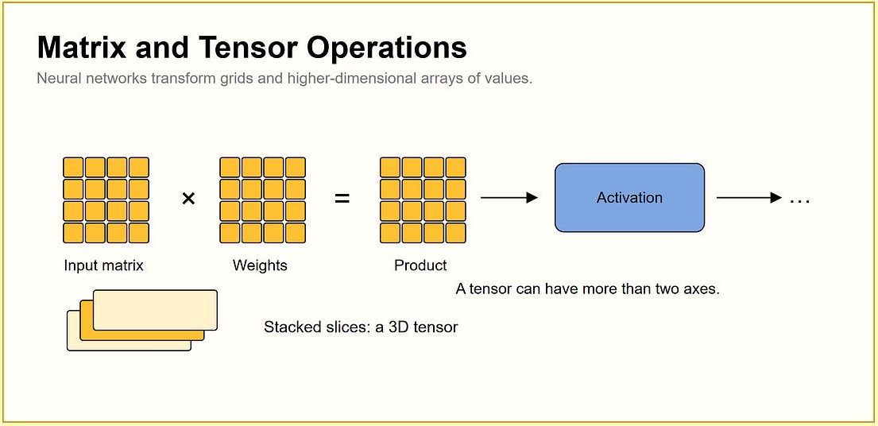
Figure 3.4 - Inputs and weights are multiplied, then passed through an activation. Stacked matrices form a 3D tensor.
Source: JAM with AI newsletter, "All GPU related concepts simply explained" (S. Khosravi Jam & S. Ladhwe, 17 Sep 2026)
In depth: A transformer layer is dominated by general matrix multiplications (GEMM) in attention projections and the MLP, plus attention itself. Tensors carry shapes like [batch, sequence, hidden]. Libraries such as cuBLAS, cuBLASLt and FlashAttention implement these operations with memory-access patterns tuned to the GPU. Understanding shapes is how you estimate memory: every activation tensor is batch x seq x hidden x bytes.

Streaming Multiprocessor (SM)
In simple words: An SM is one of many identical 'departments' inside an NVIDIA GPU. Each department has its own workers and a little fast storage, and many departments run at once.
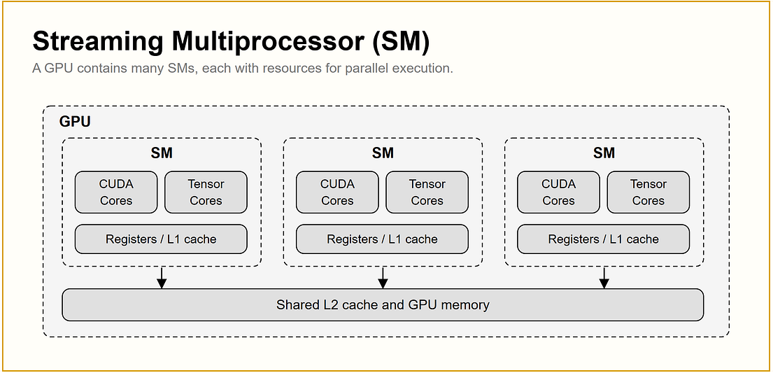
Figure 3.5 - A GPU is made of many Streaming Multiprocessors, each with CUDA/Tensor Cores and local memory.
Source: JAM with AI newsletter, "All GPU related concepts simply explained" (S. Khosravi Jam & S. Ladhwe, 17 Sep 2026)
In depth: SM is NVIDIA's name for the GPU's repeated execution blocks. You rarely manage them directly, but they show up in monitoring: DCGM's DCGM_FI_PROF_SM_ACTIVE reports the fraction of SMs actually doing work, which is a far better saturation signal than nvidia-smi's utilization percentage.

CUDA Cores
In simple words: CUDA Cores are the basic calculators inside an NVIDIA GPU. They add and multiply numbers, and thousands of them do it at the same time.
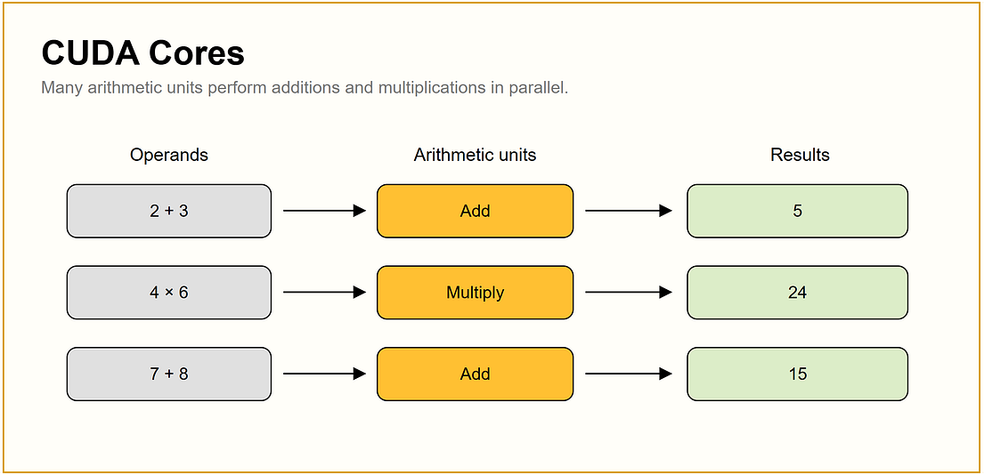
Figure 3.6 - CUDA Cores execute simple arithmetic in parallel.
Source: JAM with AI newsletter, "All GPU related concepts simply explained" (S. Khosravi Jam & S. Ladhwe, 17 Sep 2026)
In depth: 'CUDA core' is NVIDIA's marketing term for its general-purpose arithmetic units; they are not directly comparable to CPU cores (a CUDA core has no independent control flow). Core counts are a poor way to compare GPUs across generations; compare memory, memory bandwidth, supported number formats and interconnect instead.

Tensor Cores
In simple words: Tensor Cores are specialised calculators built for one job AI does constantly: multiplying big tables of numbers and adding the result.
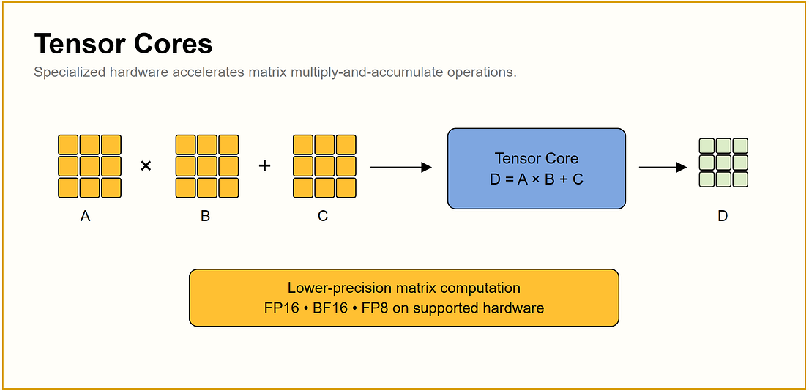
Figure 3.7 - Tensor Cores accelerate the multiply-and-accumulate pattern at lower precision.
Source: JAM with AI newsletter, "All GPU related concepts simply explained" (S. Khosravi Jam & S. Ladhwe, 17 Sep 2026)
In depth: Introduced with Volta, Tensor Cores fuse the D = A x B + C pattern and run it in reduced precision (FP16/BF16, and FP8 from Hopper onward via the Transformer Engine). Frameworks use them automatically when shapes and dtypes qualify; for example, matrix dimensions that are multiples of 8 historically unlocked the fast paths. This is why mixed precision gives several-fold speed-ups, not just memory savings.

Threads
In simple words: A big calculation is chopped into many tiny jobs. Each tiny job is a thread, and the GPU runs huge numbers of them at once.
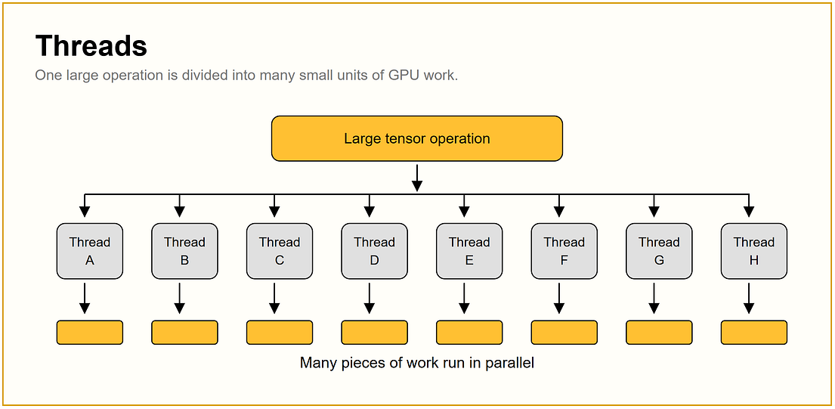
Figure 3.8 - One large tensor operation divided into many threads.
Source: JAM with AI newsletter, "All GPU related concepts simply explained" (S. Khosravi Jam & S. Ladhwe, 17 Sep 2026)
In depth: In CUDA's programming model, a kernel launch creates many threads, organised into blocks, organised into a grid. Each thread uses its thread and block index to decide which tensor element it processes. When writing custom kernels (CUDA C++, Triton), choosing block sizes and avoiding memory contention between threads is a key performance knob.

Warps
In simple words: The GPU does not manage each tiny job alone; it runs them in fixed-size groups that all follow the same instruction together, like a squad marching in step.
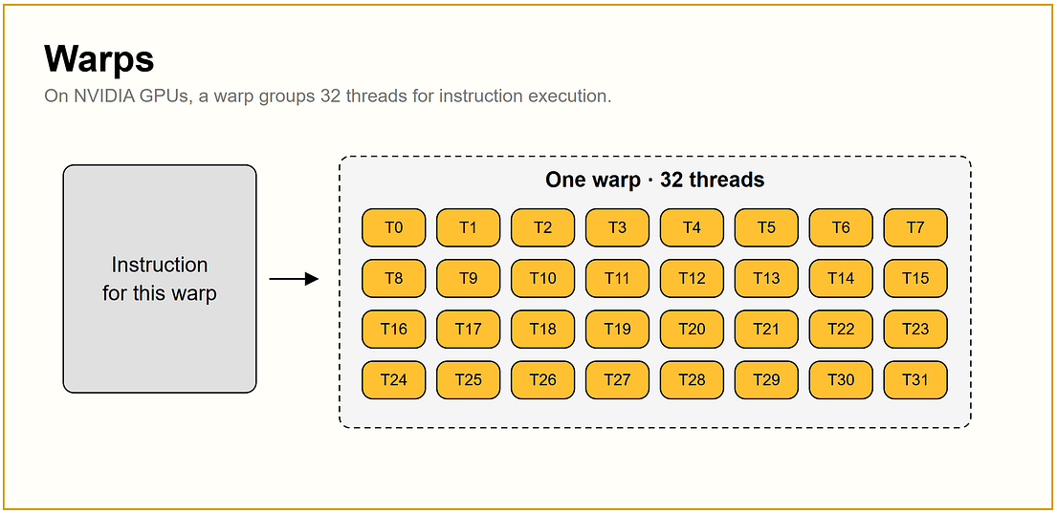
Figure 3.9 - Threads grouped and executed together as a unit.
Source: JAM with AI newsletter, "All GPU related concepts simply explained" (S. Khosravi Jam & S. Ladhwe, 17 Sep 2026)
In depth: This grouping is a hardware scheduling detail of NVIDIA GPUs and is not something CUDA exposes to you: application code only sees threads, blocks and grids. The practical lesson is that GPUs are fastest when every thread in a group executes the same instructions; heavy branching inside a kernel makes threads diverge and wastes the group's parallelism. Treat the exact group size quoted in popular explainers as background, not as something you tune.

CUDA kernels
In simple words: A kernel is a small program the GPU runs across all its threads. When PyTorch multiplies two tensors, it launches a kernel that does the work in parallel.
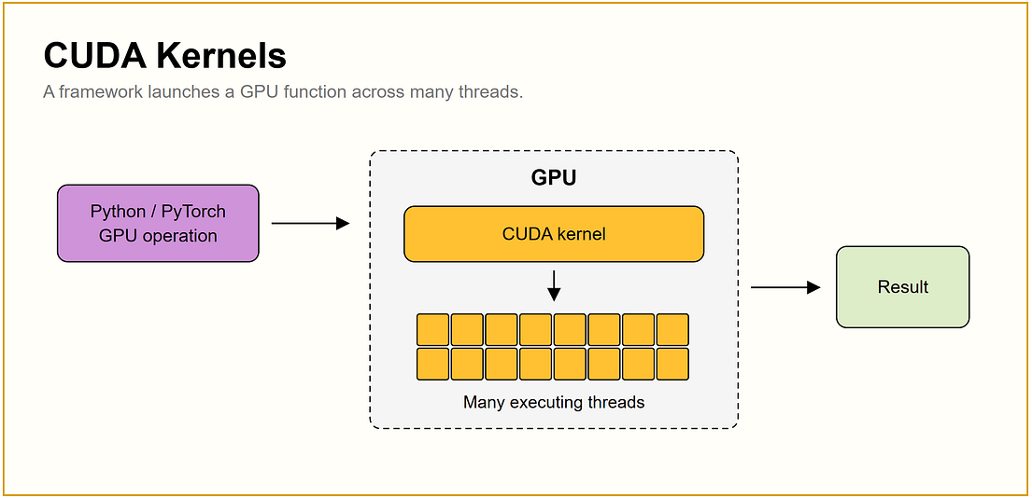
Figure 3.10 - From a PyTorch call to a CUDA kernel executing across many threads.
Source: JAM with AI newsletter, "All GPU related concepts simply explained" (S. Khosravi Jam & S. Ladhwe, 17 Sep 2026)
In depth: Every PyTorch op dispatches to one or more kernels. Kernel launches have CPU overhead, so frameworks reduce their number with kernel fusion (torch.compile, TensorRT), CUDA graphs (record a fixed sequence of kernels once and replay it, used by vLLM for decode), and custom fused kernels (FlashAttention, fused MoE, PagedAttention). In profiles (PyTorch profiler, Nsight Systems), many tiny kernels with gaps between them usually means CPU overhead is the bottleneck.

3.2 Step 2: GPU Memory

VRAM
In simple words: VRAM is the GPU's own workspace. The model and everything it is working on must fit on this desk; if it does not fit, you get an 'out of memory' error.
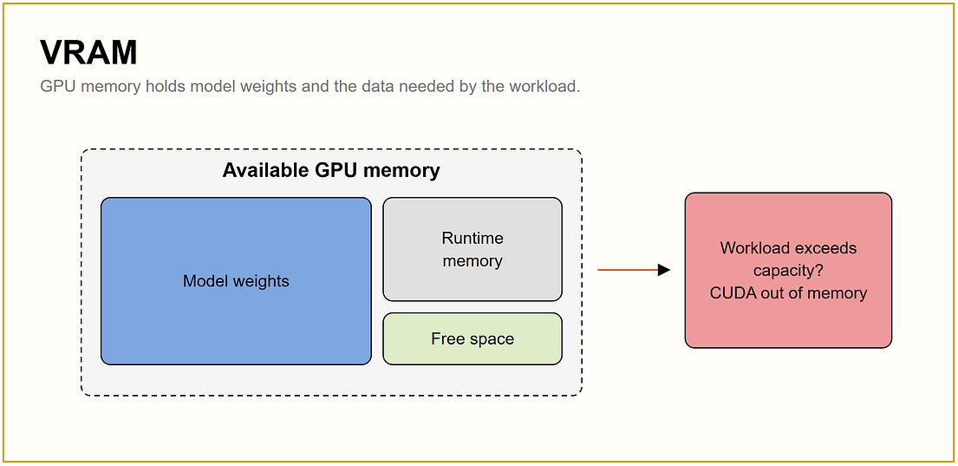
Figure 3.11 - VRAM holds model weights plus runtime memory; exceeding capacity causes CUDA OOM.
Source: JAM with AI newsletter, "All GPU related concepts simply explained" (S. Khosravi Jam & S. Ladhwe, 17 Sep 2026)
In depth: VRAM usage = weights + KV cache + activations + framework overhead (+ gradients and optimizer states in training). Engines like vLLM pre-allocate a fixed fraction (--gpu-memory-utilization) at start-up, so nvidia-smi showing 90% used is normal. Common OOM fixes: lower max context length, lower max concurrent sequences, quantize weights or KV cache, add tensor parallelism, or enable activation checkpointing in training. See Section 4.3 for the formulas.

HBM
In simple words: HBM is very fast memory stacked right next to the GPU chip, so data has only a short trip to the calculators.
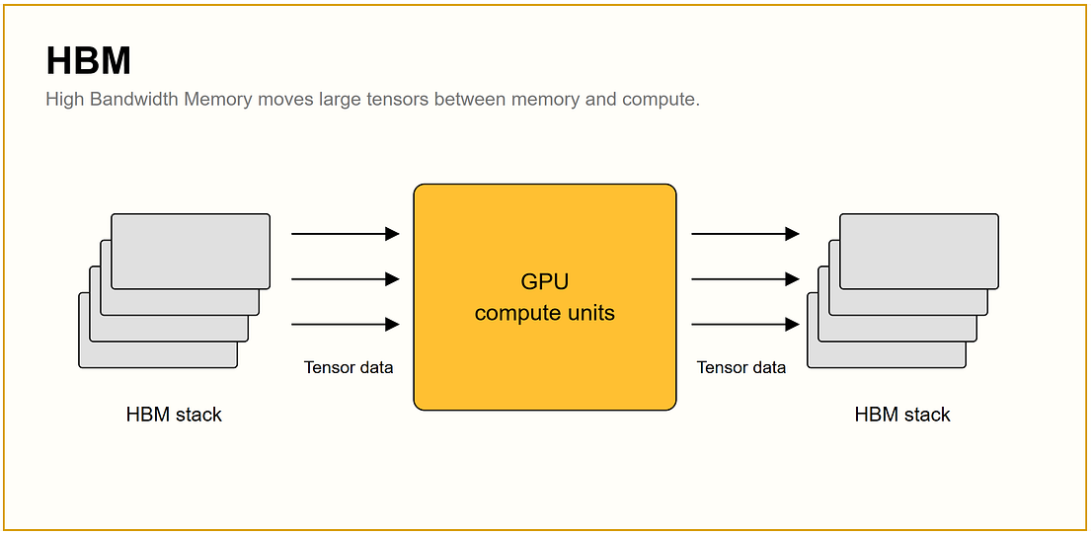
Figure 3.12 - High Bandwidth Memory stacks move large tensors to and from the compute units.
Source: JAM with AI newsletter, "All GPU related concepts simply explained" (S. Khosravi Jam & S. Ladhwe, 17 Sep 2026)
In depth: HBM stacks DRAM dies vertically with through-silicon vias and connects them to the GPU on a silicon interposer (CoWoS packaging). Generations: HBM2 (V100), HBM2e (A100), HBM3 (H100), HBM3e (H200), HBM3/HBM3e (Blackwell), HBM4 (Rubin). HBM is expensive and supply-constrained, which is a major reason high-end GPUs are expensive and hard to obtain.

Memory bandwidth
In simple words: Capacity is how many boxes fit in the warehouse. Bandwidth is how fast the boxes can be moved in and out. A big warehouse with a slow door is still slow.
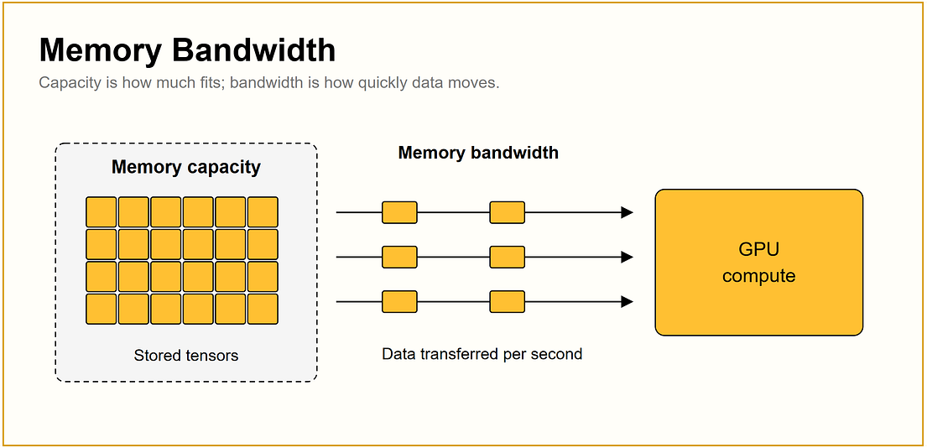
Figure 3.13 - Memory capacity vs memory bandwidth.
Source: JAM with AI newsletter, "All GPU related concepts simply explained" (S. Khosravi Jam & S. Ladhwe, 17 Sep 2026)
In depth: For batch-1 decode, a rough upper bound is tokens/s ~ memory bandwidth / bytes read per token (roughly the model's weight size). That is why an H200 decodes faster than an H100 despite identical compute, and why quantization speeds up decode: fewer bytes per token to move. As batch size grows, the same weight read serves more sequences, so throughput grows until compute becomes the limit.

GPU memory hierarchy
In simple words: Memory close to the calculators is tiny but instant; memory further away is huge but slower. Good software keeps the most-used data closest.
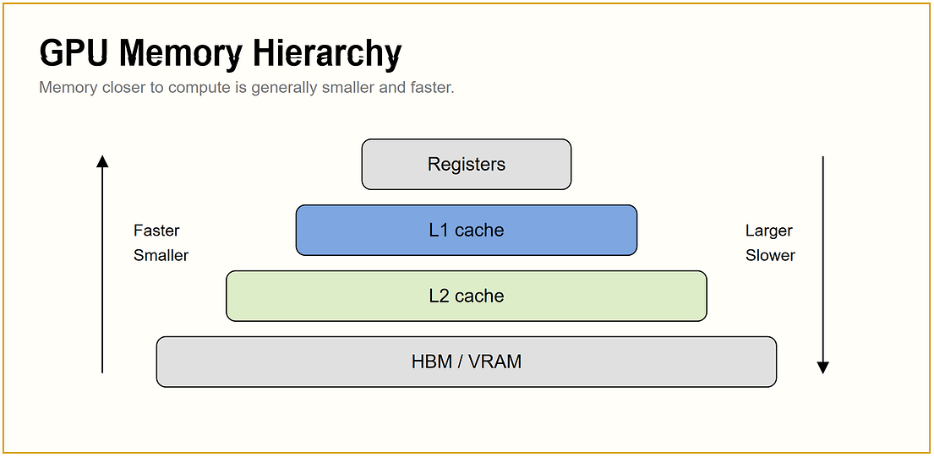
Figure 3.14 - Registers and caches are small and fast; HBM/VRAM is large and slower.
Source: JAM with AI newsletter, "All GPU related concepts simply explained" (S. Khosravi Jam & S. Ladhwe, 17 Sep 2026)
In depth: For LLM infrastructure, the useful hierarchy is: on-chip SRAM (tiny, fastest) -> HBM/VRAM (tens to hundreds of GB) -> CPU DRAM (over PCIe or NVLink-C2C) -> local NVMe -> network storage. FlashAttention wins by keeping attention computation in fast on-chip memory and avoiding round-trips to HBM. KV-cache offloading (Section 12) uses the lower tiers to store reusable prefixes. Note that labelling GPU on-chip memory as 'L1/L2 cache' is an analogy borrowed from CPUs; GPU vendors do not document it that way, so do not rely on those names in an interview.

Registers
In simple words: Registers are the calculator's own tiny notepad: they hold the numbers being worked on right now.
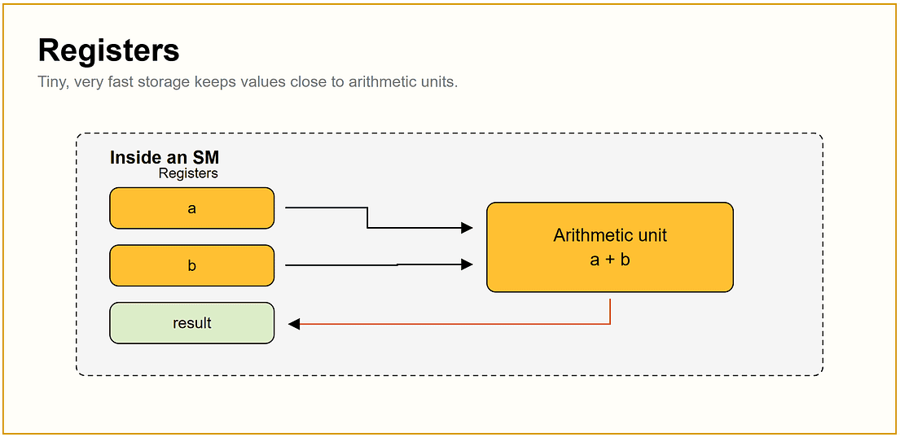
Figure 3.15 - Registers hold operands right next to the arithmetic unit.
Source: JAM with AI newsletter, "All GPU related concepts simply explained" (S. Khosravi Jam & S. Ladhwe, 17 Sep 2026)
In depth: Registers are the fastest storage in any processor but hold only a handful of values. You never manage them in Python; they matter only as the top of the hierarchy that explains why moving data is often slower than computing on it.

L1 cache
In simple words: A small, fast shelf next to each department that holds what was just used, so it does not have to be fetched from far away again.
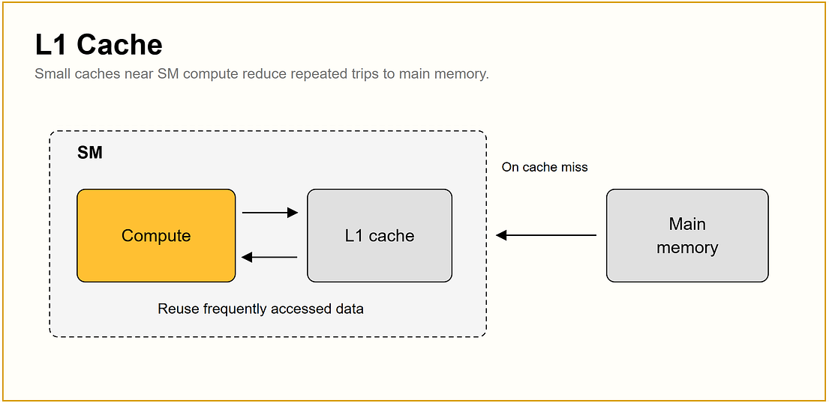
Figure 3.16 - A small fast cache avoids repeated trips to main memory.
Source: JAM with AI newsletter, "All GPU related concepts simply explained" (S. Khosravi Jam & S. Ladhwe, 17 Sep 2026)
In depth: The general principle, locality, is what matters: kernels that touch data in predictable, contiguous patterns run faster. Tiling and fusion techniques (FlashAttention's block-wise attention, fused kernels) are about exploiting fast local memory.

L2 cache
In simple words: A bigger shared shelf between the small local shelves and the main warehouse.
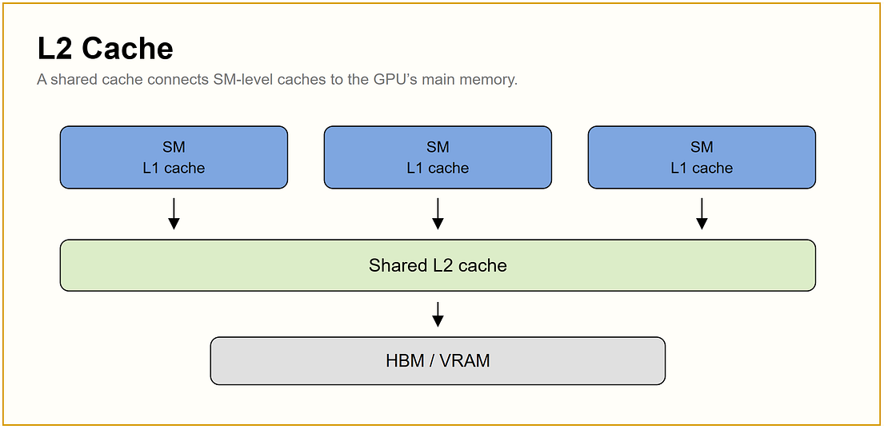
Figure 3.17 - A shared cache sits between local caches and HBM/VRAM.
Source: JAM with AI newsletter, "All GPU related concepts simply explained" (S. Khosravi Jam & S. Ladhwe, 17 Sep 2026)
In depth: Again, treat this as a conceptual layer. For practical capacity planning, focus on VRAM size, memory bandwidth, and the host-memory link (PCIe Gen5 ~64 GB/s per direction vs NVLink-C2C 900 GB/s), because those determine whether offloading is viable.

HBM / VRAM
In simple words: The main warehouse: it holds almost everything the GPU needs, but it is further away than the small shelves.
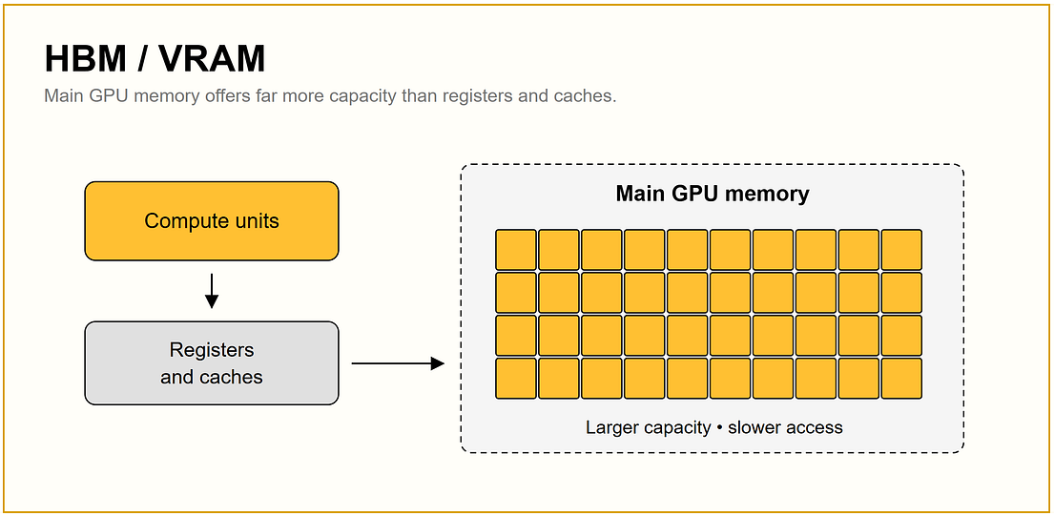
Figure 3.18 - Main GPU memory offers large capacity at slower access than registers and caches.
Source: JAM with AI newsletter, "All GPU related concepts simply explained" (S. Khosravi Jam & S. Ladhwe, 17 Sep 2026)
In depth: This is the number on the datasheet (80 GB, 141 GB, ~180 GB) and the one that decides which models fit. Usable capacity is a few GB lower after the CUDA context and library workspaces.

Model weights
In simple words: Weights are what the model learned. A '7B' model has 7 billion of these numbers, and each one takes up space.
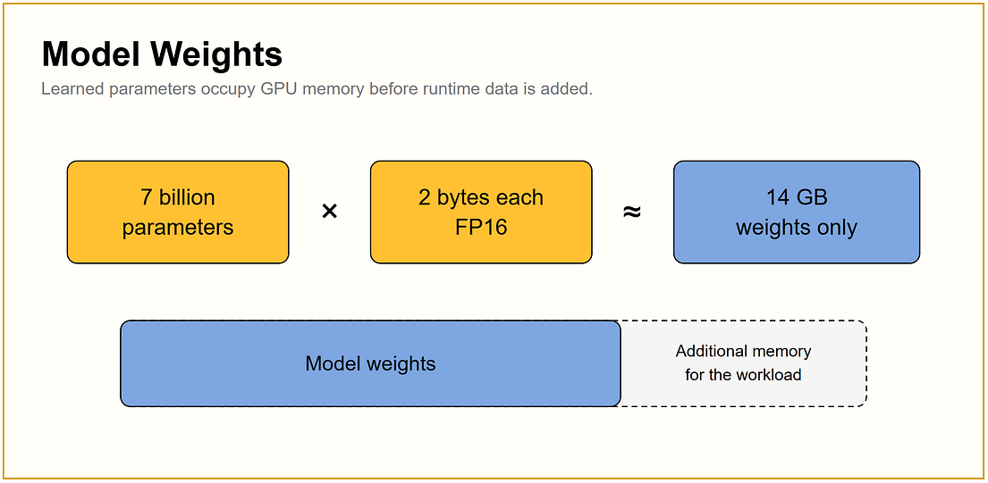
Figure 3.19 - 7 billion parameters x 2 bytes (FP16) = about 14 GB for weights alone.
Source: JAM with AI newsletter, "All GPU related concepts simply explained" (S. Khosravi Jam & S. Ladhwe, 17 Sep 2026)
In depth: Weights (GB) = parameters x bytes per parameter / 1e9: 7B at BF16 = 14 GB, at FP8 = 7 GB, at INT4 = ~3.5-4 GB (quantization scales add a little). Mixture-of-experts models must store all experts even though only a few run per token, so a MoE model's memory is set by total parameters while its compute per token is set by active parameters.

Activations
In simple words: Activations are the intermediate results as data passes through each layer. In training, many are kept so the model can learn from its mistakes.
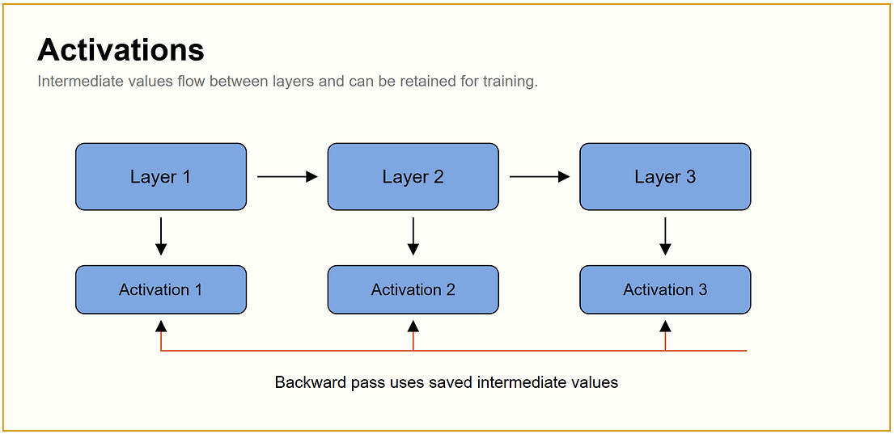
Figure 3.20 - Activations flow between layers and are retained for the backward pass in training.
Source: JAM with AI newsletter, "All GPU related concepts simply explained" (S. Khosravi Jam & S. Ladhwe, 17 Sep 2026)
In depth: Training memory for activations scales with batch x sequence length x hidden size x layers. Activation (gradient) checkpointing stores only some activations and recomputes the rest during backward, trading about 20-30% extra compute for a large memory saving. In inference, activations are temporary and small compared with the KV cache.

KV cache
In simple words: When writing a long answer, the model keeps notes about every earlier word so it does not re-read everything each time. Those notes are the KV cache, and they grow with every word and every user.
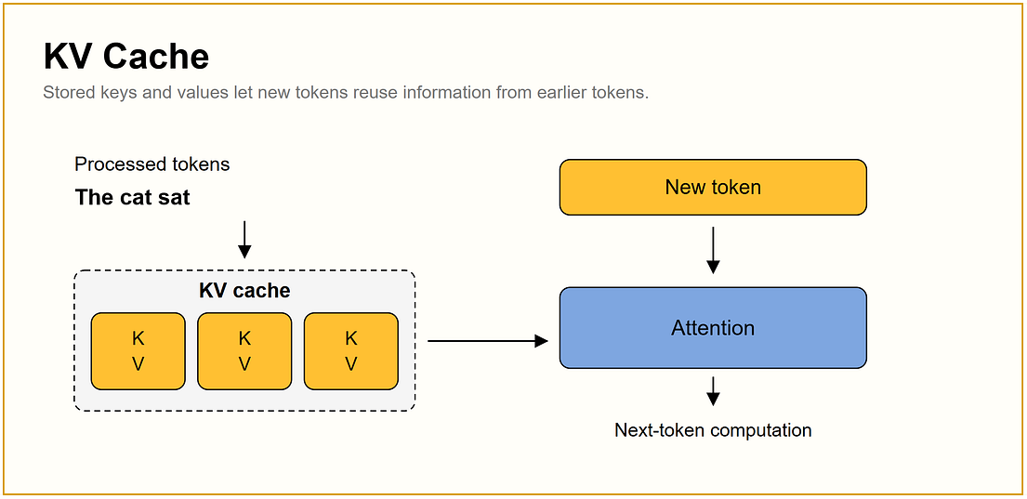
Figure 3.21 - Stored keys and values let each new token reuse earlier computation.
Source: JAM with AI newsletter, "All GPU related concepts simply explained" (S. Khosravi Jam & S. Ladhwe, 17 Sep 2026)
In depth: KV bytes per token = 2 x layers x KV heads x head dim x bytes per element (about 0.33 MB per token for Llama-3-70B in BF16). KV cache is usually the binding constraint for concurrency and context length. Key techniques are paged allocation, prefix caching, FP8 KV quantization, GQA/MLA architectures, and offloading; all are covered in Section 12.

3.3 Step 3: Compute and Numerical Precision

FP32
In simple words: FP32 stores each number with 32 bits (4 bytes): very precise, but it takes the most space.
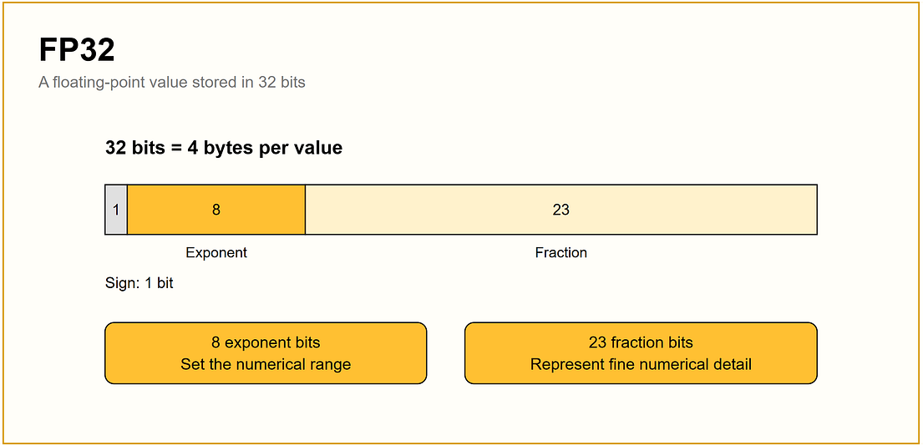
Figure 3.22 - FP32: 1 sign bit, 8 exponent bits, 23 fraction bits.
Source: JAM with AI newsletter, "All GPU related concepts simply explained" (S. Khosravi Jam & S. Ladhwe, 17 Sep 2026)
In depth: FP32 is IEEE 754 single precision. The 8 exponent bits give a range of about +/-3.4e38; the 23 fraction bits give about 7 decimal digits of precision. In modern mixed-precision training it survives mainly as the master copy of weights and optimizer states.

TF32
In simple words: TF32 is a speed trick: the numbers are still stored in 32 bits, but some matrix maths is done with fewer precise digits so Tensor Cores can run faster.
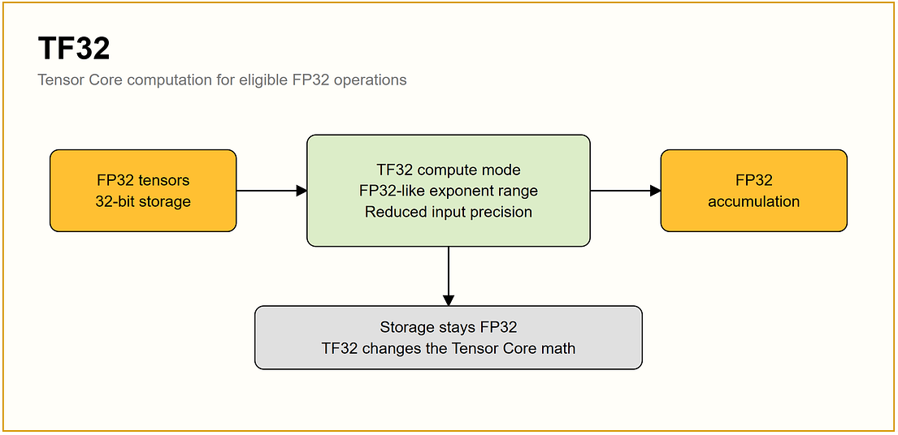
Figure 3.23 - TF32 uses FP32's exponent range with reduced precision inside supported math.
Source: JAM with AI newsletter, "All GPU related concepts simply explained" (S. Khosravi Jam & S. Ladhwe, 17 Sep 2026)
In depth: TensorFloat-32 (Ampere and newer) uses FP32's 8-bit exponent with FP16's 10-bit mantissa inside supported matrix multiplies and convolutions. Storage stays FP32, so it does not save memory. In PyTorch it is controlled by torch.backends.cuda.matmul.allow_tf32 (or torch.set_float32_matmul_precision('high')).

FP16 and BF16
In simple words: Both use 16 bits, half the space of FP32. FP16 keeps more detail but a smaller range; BF16 keeps a bigger range but less detail.
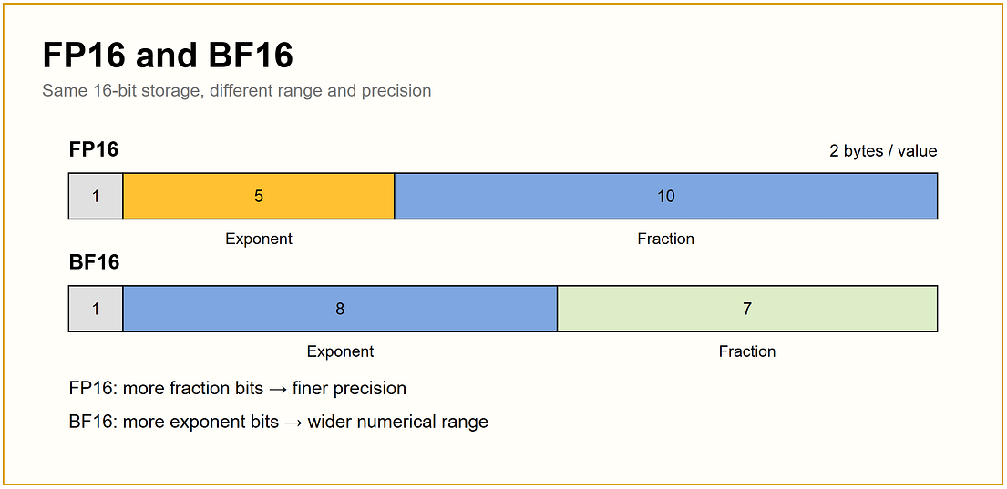
Figure 3.24 - FP16 (1/5/10 bits) vs BF16 (1/8/7 bits).
Source: JAM with AI newsletter, "All GPU related concepts simply explained" (S. Khosravi Jam & S. Ladhwe, 17 Sep 2026)
In depth: FP16's 5-bit exponent overflows around 65,504, so FP16 training needs loss scaling to avoid gradient underflow/overflow. BF16 keeps FP32's 8-bit exponent (same range), which makes training stable without loss scaling; that is why BF16 is the default for LLM training on Ampere and newer. Most open LLM checkpoints are published in BF16.

FP8
In simple words: FP8 uses just 1 byte per number, half of FP16. Newer GPUs can compute directly in this format, so models get smaller and faster.
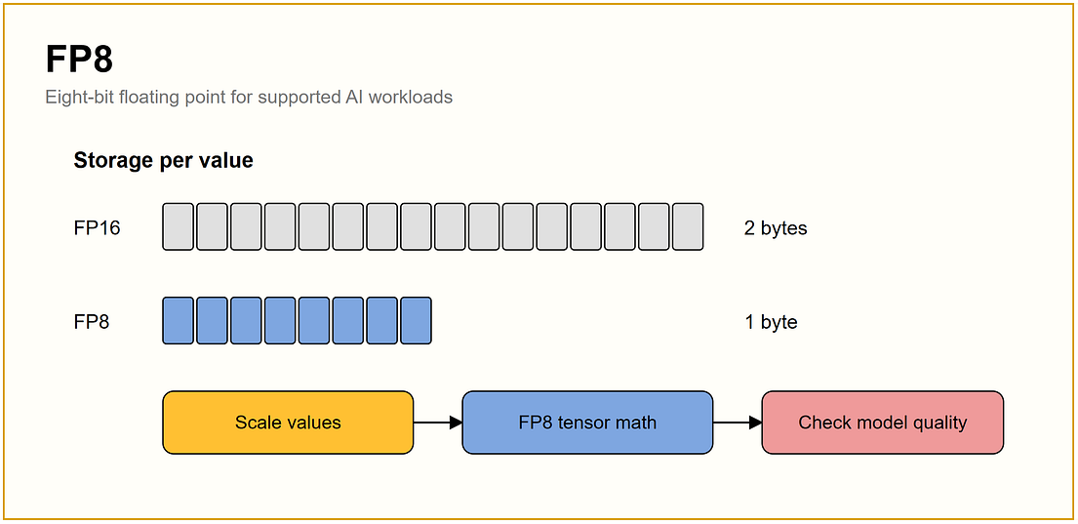
Figure 3.25 - FP8 halves storage vs FP16; values are scaled before FP8 math and quality should be checked.
Source: JAM with AI newsletter, "All GPU related concepts simply explained" (S. Khosravi Jam & S. Ladhwe, 17 Sep 2026)
In depth: Two formats exist: E4M3 (more precision, used for weights and activations) and E5M2 (more range, sometimes used for gradients). Because 8 bits cover a narrow range, tensors are multiplied by scaling factors (per-tensor, per-channel, or per-block). Hopper's Transformer Engine automates this. FP8 inference is near-lossless for most LLMs and is usually the first optimization to try on H100/H200/B200.

FP4, INT8 and INT4
In simple words: These squeeze each number into 8 or even 4 bits. Models become much smaller, but squeezing too hard can make answers worse.
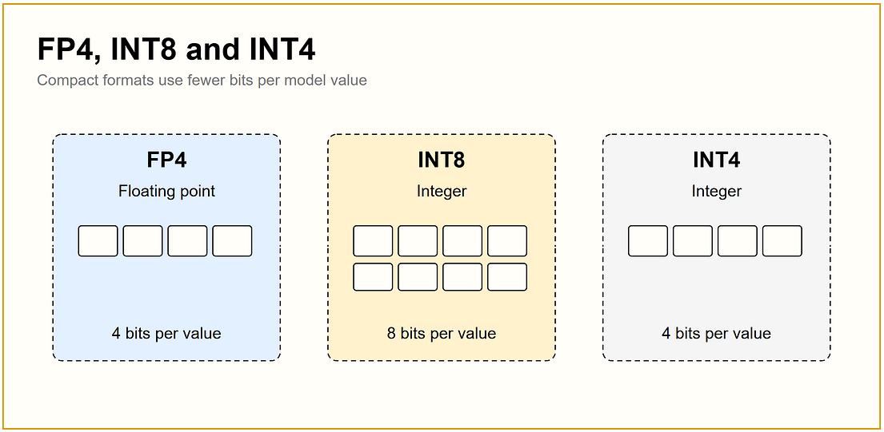
Figure 3.26 - FP4 and INT4 use 4 bits per value; INT8 uses 8 bits.
Source: JAM with AI newsletter, "All GPU related concepts simply explained" (S. Khosravi Jam & S. Ladhwe, 17 Sep 2026)
In depth: INT formats use evenly spaced levels plus a scale (and sometimes a zero point); FP4 formats (NVFP4, MXFP4) use a tiny floating-point grid plus fine-grained block scales, which handles outliers better. INT4 is usually weight-only (AWQ, GPTQ), so compute still runs in 16-bit; NVFP4 on Blackwell can run the math itself in 4 bits. Always validate with task-specific evals, since damage often appears in reasoning, code and long-context tasks before it shows up in perplexity.

Mixed precision
In simple words: Use cheap, small numbers where it is safe and precise numbers only where they are needed.
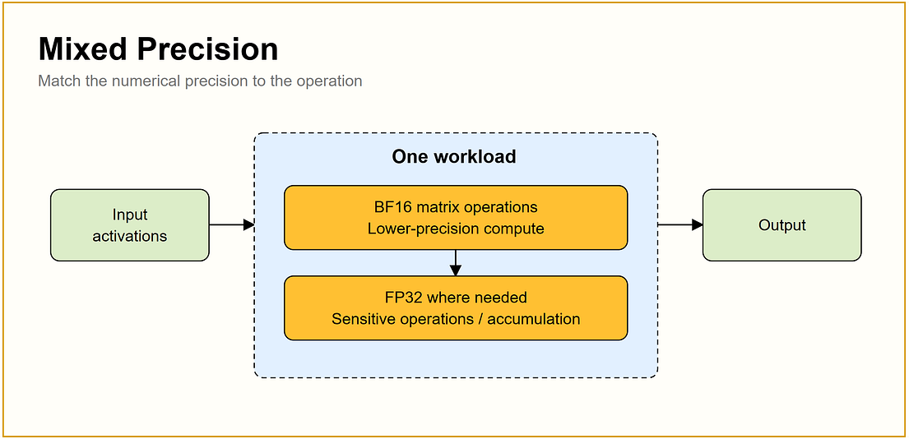
Figure 3.27 - One workload mixing BF16 compute with FP32 where precision matters.
Source: JAM with AI newsletter, "All GPU related concepts simply explained" (S. Khosravi Jam & S. Ladhwe, 17 Sep 2026)
In depth: Classic automatic mixed precision (torch.autocast) runs matmuls in BF16/FP16 while keeping sensitive ops (softmax, norms, loss) and the optimizer's master weights in FP32. FP8 training extends this with per-tensor scaling. In inference, 'mixed precision' often means FP8 weights and activations with BF16 attention or selected layers (first/last layers, lm_head) left unquantized.

Quantization
In simple words: Quantization rounds numbers to fewer possible values so each one needs fewer bits, like measuring in whole centimetres instead of millimetres.
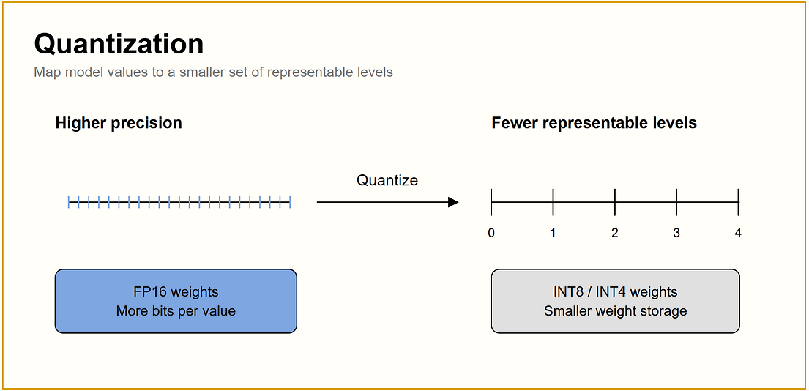
Figure 3.28 - High-precision values mapped to a smaller set of levels.
Source: JAM with AI newsletter, "All GPU related concepts simply explained" (S. Khosravi Jam & S. Ladhwe, 17 Sep 2026)
In depth: Post-training quantization (PTQ) calibrates scales on a small dataset; quantization-aware training (QAT) simulates quantization during training to recover accuracy. Granularity (per-tensor, per-channel, per-group of e.g. 128 weights) trades accuracy for overhead. The payoff is fitting a model on fewer GPUs and larger batches; see Section 10 for formats, tools and trade-offs.

FLOPS
In simple words: FLOPS measures how many calculations a GPU can do per second. It is the engine's horsepower, but horsepower alone does not tell you how fast the car goes.
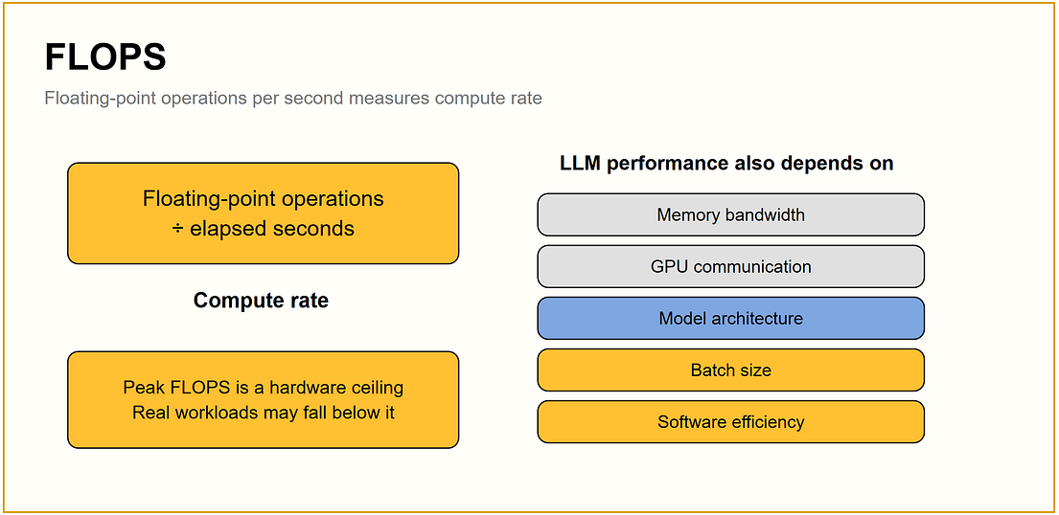
Figure 3.29 - Peak FLOPS is a hardware ceiling; real LLM speed also depends on bandwidth, communication, architecture, batch size and software.
Source: JAM with AI newsletter, "All GPU related concepts simply explained" (S. Khosravi Jam & S. Ladhwe, 17 Sep 2026)
In depth: Distinguish FLOPs (a count of operations: a transformer needs roughly 6 x parameters x tokens FLOPs to train and about 2 x parameters per token to run inference) from FLOPS (operations per second). Model FLOPs Utilization (MFU) = achieved FLOPS / theoretical peak FLOPS; well-tuned large training runs often land around 35-50%. Low MFU points to memory, communication or data-loading bottlenecks, not to a need for more GPUs.

3.4 Step 4: GPU Generations

Volta: V100
In simple words: The V100 was the first NVIDIA data-centre GPU with dedicated AI calculators (Tensor Cores).
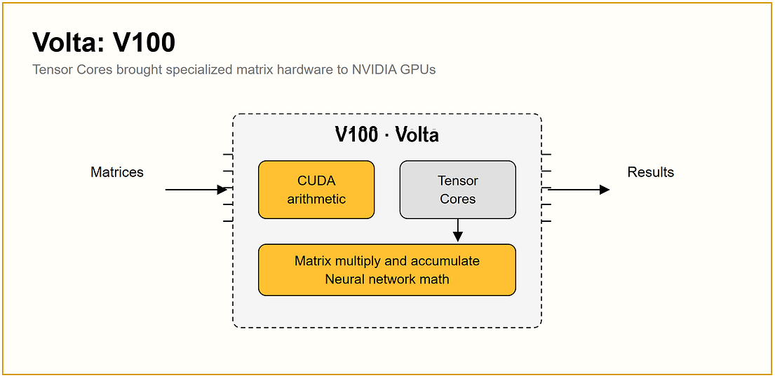
Figure 3.30 - Volta V100: CUDA arithmetic plus the first Tensor Cores.
Source: JAM with AI newsletter, "All GPU related concepts simply explained" (S. Khosravi Jam & S. Ladhwe, 17 Sep 2026)
In depth: V100 (2017) brought Tensor Cores, FP16 mixed precision and NVLink 2 (300 GB/s) in DGX-1/DGX-2 systems. It has no BF16 or FP8 support and is now mostly retired from LLM work.

Ampere: A100
In simple words: The A100 became the standard AI GPU for years: faster Tensor Cores, more memory, and good for both training and serving.
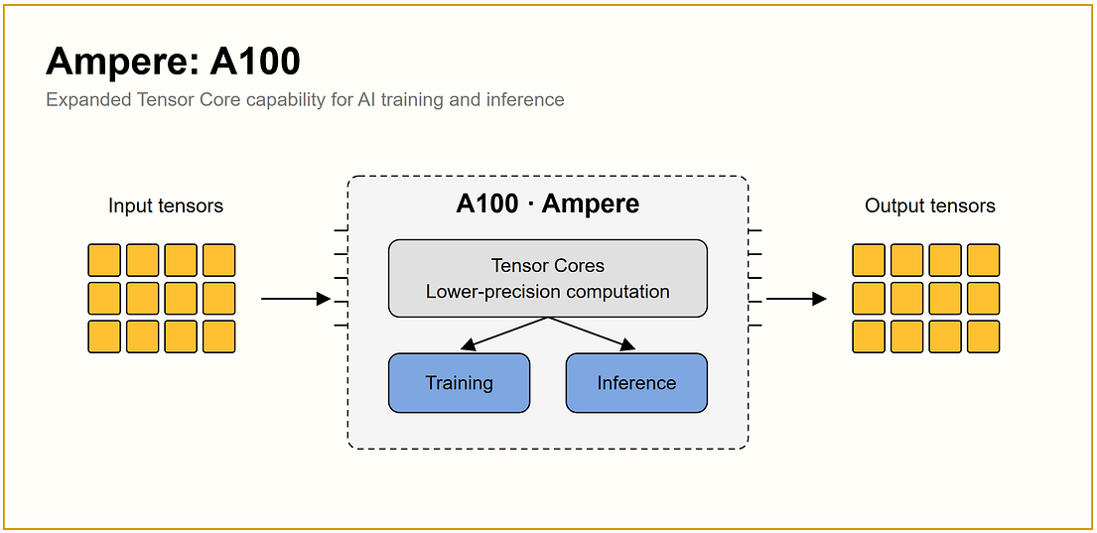
Figure 3.31 - Ampere A100: improved Tensor Cores for training and inference.
Source: JAM with AI newsletter, "All GPU related concepts simply explained" (S. Khosravi Jam & S. Ladhwe, 17 Sep 2026)
In depth: A100 (2020): 40/80 GB HBM2e, NVLink 3 (600 GB/s), BF16 and TF32 support, and MIG for splitting one GPU into up to seven isolated instances. Still widely used for fine-tuning and serving mid-size models; lacks native FP8 compute.

Hopper: H100 and H200
In simple words: The H100 was built with transformers in mind and can compute in FP8. The H200 is the same chip with much more and faster memory.
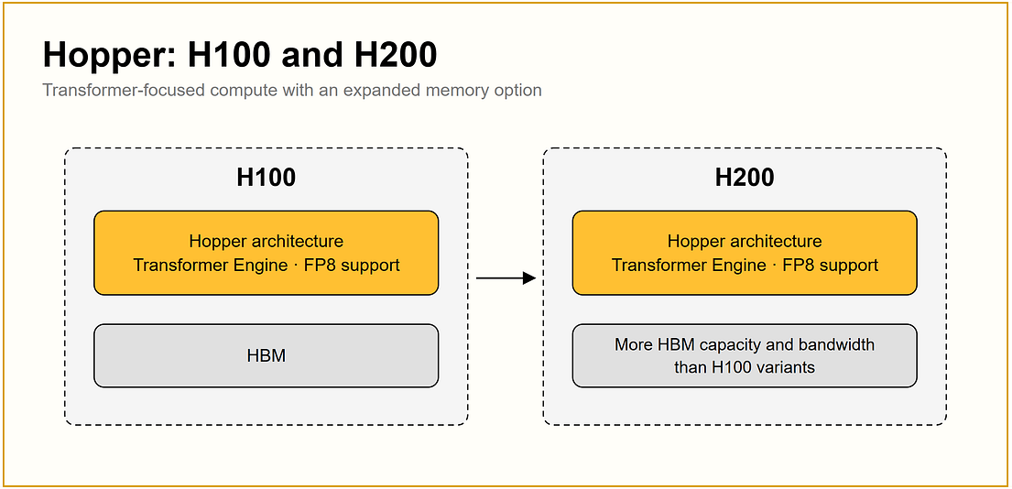
Figure 3.32 - H100 and H200 share the Hopper architecture; H200 adds HBM capacity and bandwidth.
Source: JAM with AI newsletter, "All GPU related concepts simply explained" (S. Khosravi Jam & S. Ladhwe, 17 Sep 2026)
In depth: H100: 80 GB HBM3, NVLink 4 (900 GB/s), Transformer Engine with FP8. H200: 141 GB HBM3e with higher bandwidth, same compute and NVLink. For inference, H200 typically fits larger models per GPU and delivers higher decode throughput and longer contexts; for compute-bound training steps the gain is smaller. See Section 5 for a full comparison table.

Blackwell: B100 and B200
In simple words: Blackwell is the next big step: more compute, more memory, faster links, and 4-bit number support.
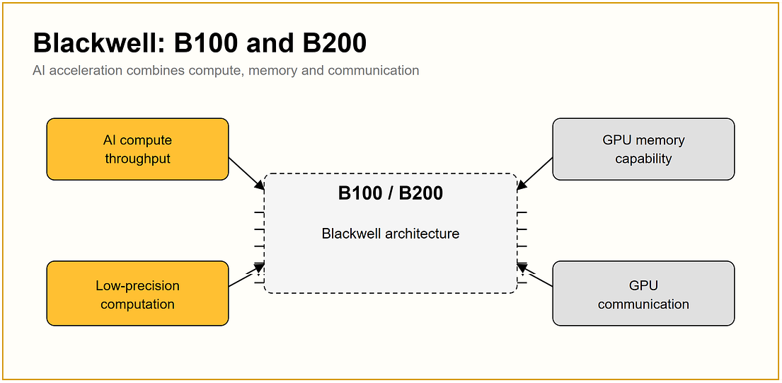
Figure 3.33 - Blackwell raises compute, memory, low-precision support and communication.
Source: JAM with AI newsletter, "All GPU related concepts simply explained" (S. Khosravi Jam & S. Ladhwe, 17 Sep 2026)
In depth: B200: roughly 180-192 GB HBM3, NVLink 5 (1.8 TB/s), second-generation Transformer Engine with FP4 (NVFP4), about 1 kW per GPU. Most large deployments use HGX B200 servers or GB200 NVL72 racks, where 72 GPUs share one NVLink domain. The successor, Vera Rubin, adds HBM4 and NVLink 6 (Section 5).

3.5 Step 5: LLM Training and Inference

LLM training
In simple words: Training is the model's school: it guesses, checks how wrong it was, and adjusts its numbers, billions of times.
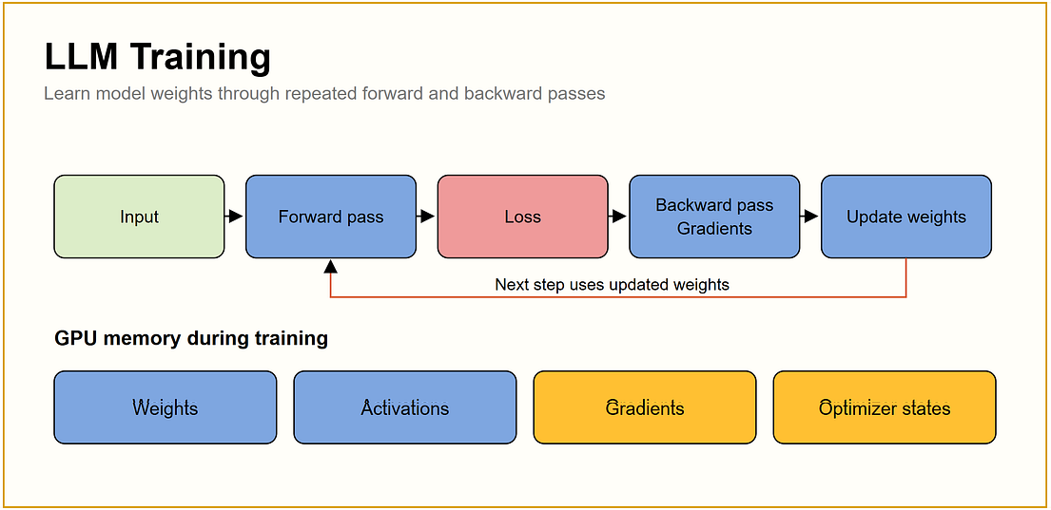
Figure 3.34 - A training step (forward, loss, backward, update) and what it keeps in GPU memory.
Source: JAM with AI newsletter, "All GPU related concepts simply explained" (S. Khosravi Jam & S. Ladhwe, 17 Sep 2026)
In depth: Each step stores weights, activations, gradients and optimizer states; for mixed-precision Adam this is about 16 bytes per parameter before activations. That is why a 7B full fine-tune needs well over 100 GB and uses sharding (FSDP/ZeRO), offloading or LoRA. Training is usually throughput-oriented (tokens per second per GPU, MFU) and runs for days, so checkpointing and failure recovery matter as much as speed.

LLM inference
In simple words: Inference is the model at work: it reads your prompt and writes an answer one token at a time, reusing its notes (KV cache) as it goes.
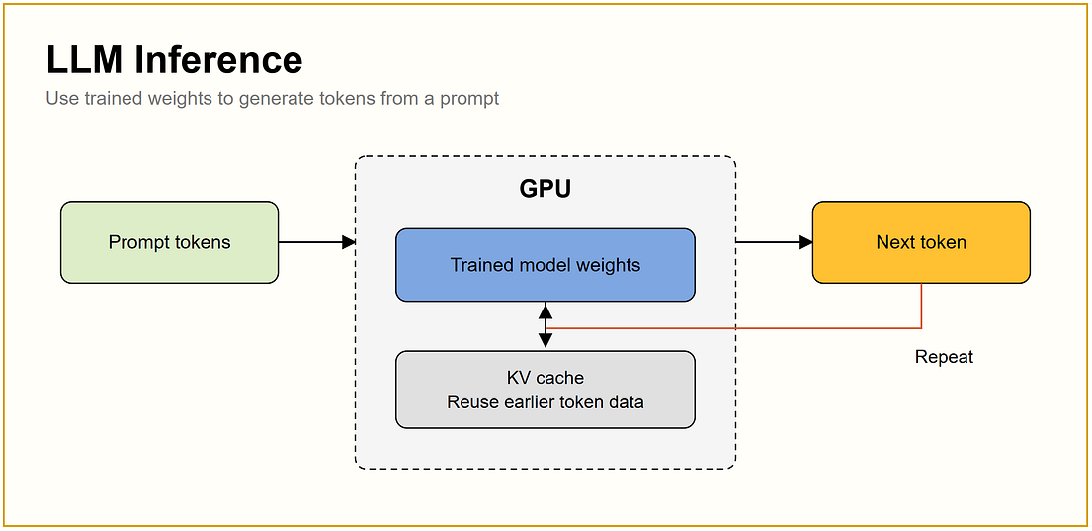
Figure 3.35 - Inference: prompt tokens pass through trained weights; the KV cache is reused for each new token.
Source: JAM with AI newsletter, "All GPU related concepts simply explained" (S. Khosravi Jam & S. Ladhwe, 17 Sep 2026)
In depth: Inference needs no gradients or optimizer states, but has two phases with different bottlenecks (compute-bound prefill, memory-bound decode) and is judged on latency percentiles (TTFT, TPOT) under many concurrent users. Sections 10-13 cover batching, engines, KV caching and metrics.

Batch size
In simple words: Batch size is how many requests or examples the GPU handles in one go. Bigger batches keep the GPU busy but need more memory.
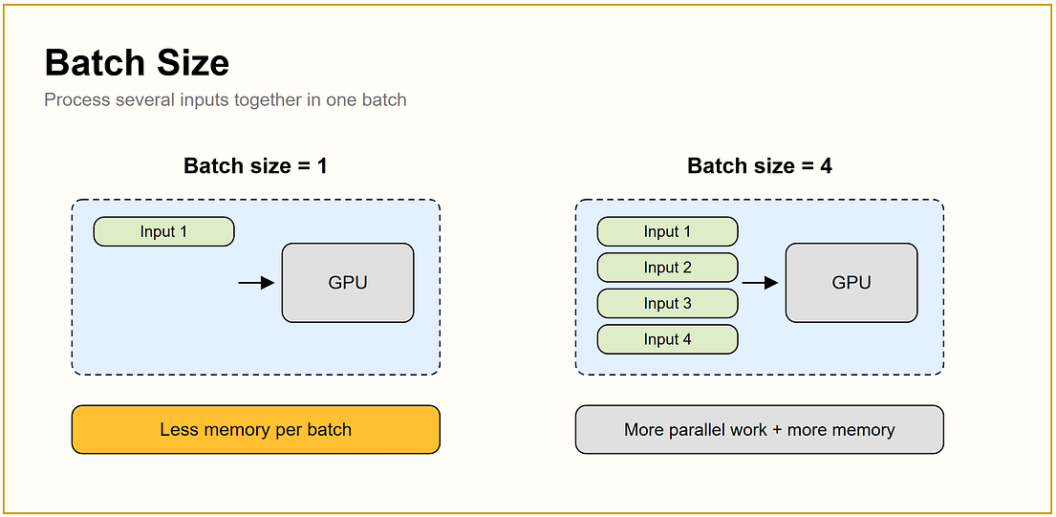
Figure 3.36 - Batch size 1 vs 4: more parallel work, more memory.
Source: JAM with AI newsletter, "All GPU related concepts simply explained" (S. Khosravi Jam & S. Ladhwe, 17 Sep 2026)
In depth: In training, the global batch = micro-batch x gradient-accumulation steps x data-parallel ranks; it affects convergence, not just speed. In serving, the effective batch changes every step with continuous batching, bounded by max-num-seqs and the per-step token budget. Larger batches raise throughput but also per-token latency; the right size is the largest one that still meets your latency SLO.

GPU utilization
In simple words: GPU utilization tells you how often the GPU was doing something, not how hard it was working. A GPU can show 100% while doing very little.
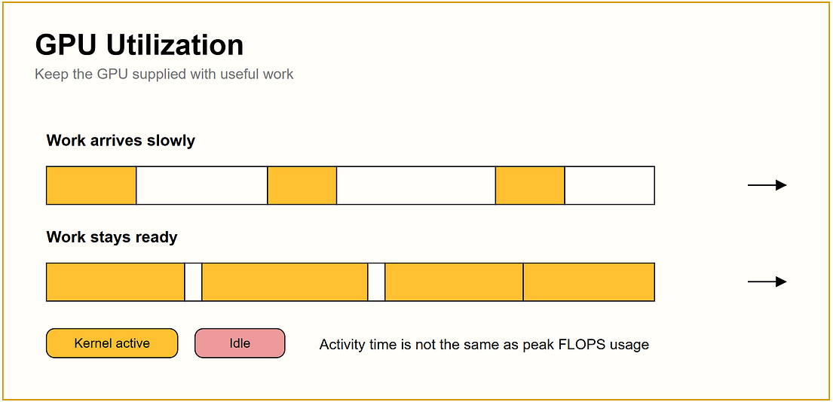
Figure 3.37 - Work arriving slowly leaves idle gaps; keeping work ready keeps the GPU busy.
Source: JAM with AI newsletter, "All GPU related concepts simply explained" (S. Khosravi Jam & S. Ladhwe, 17 Sep 2026)
In depth: nvidia-smi's 'GPU-Util' is the fraction of sampling time at least one kernel ran. Better signals: DCGM SM-active/engine-active metrics, MFU in training, and tokens/s versus a benchmarked maximum in serving. Common causes of idle gaps: slow data loading, CPU-bound tokenization or scheduling, Python overhead between kernels, small batches, and waiting on communication.

Compute-bound workloads
In simple words: The data is ready and waiting, but the calculators cannot go any faster. More compute helps here.
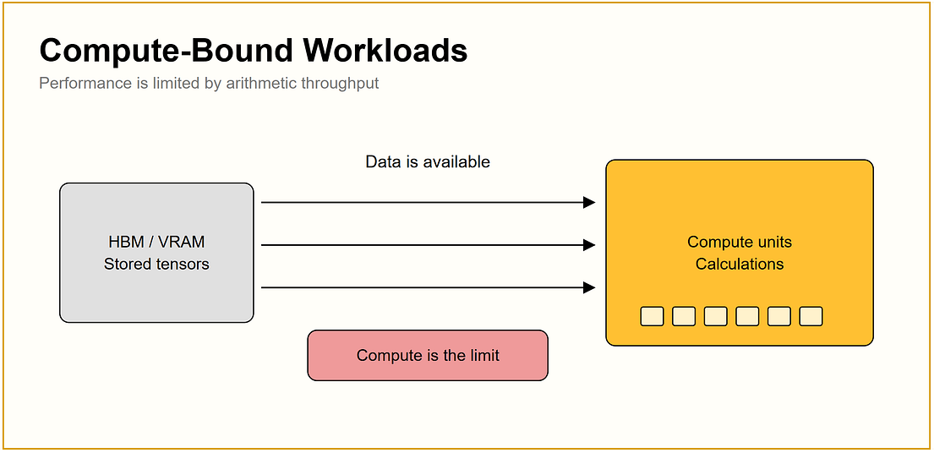
Figure 3.38 - Compute-bound: data is available, compute is the limit.
Source: JAM with AI newsletter, "All GPU related concepts simply explained" (S. Khosravi Jam & S. Ladhwe, 17 Sep 2026)
In depth: Examples: prefill of long prompts, training steps with large batches, large-batch decode, embedding generation. Fixes: faster GPUs, FP8/FP4 compute, kernel fusion, FlashAttention, tensor parallelism, or more replicas.

Memory-bound workloads
In simple words: The calculators are fast but sit waiting because data cannot reach them quickly enough. More compute will not help much.
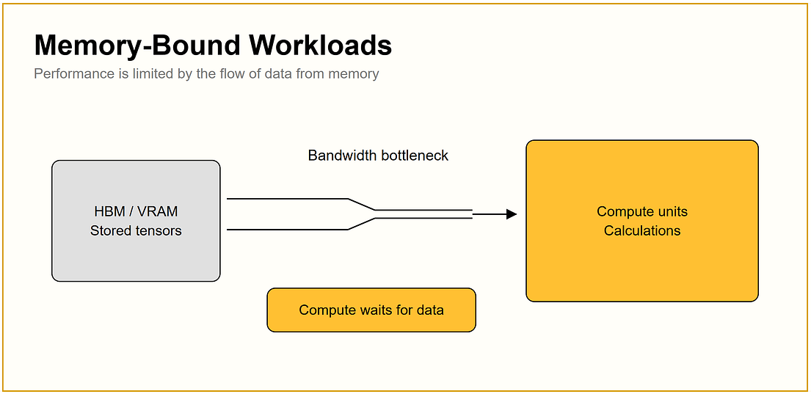
Figure 3.39 - Memory-bound: compute waits for data across a bandwidth bottleneck.
Source: JAM with AI newsletter, "All GPU related concepts simply explained" (S. Khosravi Jam & S. Ladhwe, 17 Sep 2026)
In depth: Example: small-batch decode, where every token needs a full read of the weights. Fixes: higher-bandwidth GPUs (H200 over H100), quantization (fewer bytes to move), batching (share each weight read across many sequences), and speculative decoding (verify several tokens per weight read).

3.6 Step 6: From One GPU to Many

Model sharding
In simple words: If a model is too big for one GPU, cut it into pieces and give each GPU one piece.
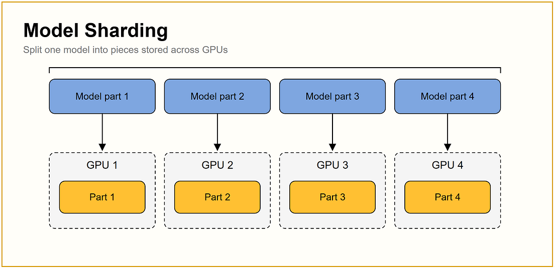
Figure 3.40 - One model split into parts stored on different GPUs.
Source: JAM with AI newsletter, "All GPU related concepts simply explained" (S. Khosravi Jam & S. Ladhwe, 17 Sep 2026)
In depth: Sharding can split parameters by layer (pipeline parallelism), within layers (tensor parallelism), by expert (expert parallelism), or shard parameters, gradients and optimizer states across data-parallel ranks (FSDP/ZeRO-3). The choice depends on the interconnect between the GPUs holding the shards.

Data parallelism
In simple words: Every GPU gets a full copy of the model and a different slice of data. They then agree on one shared update.
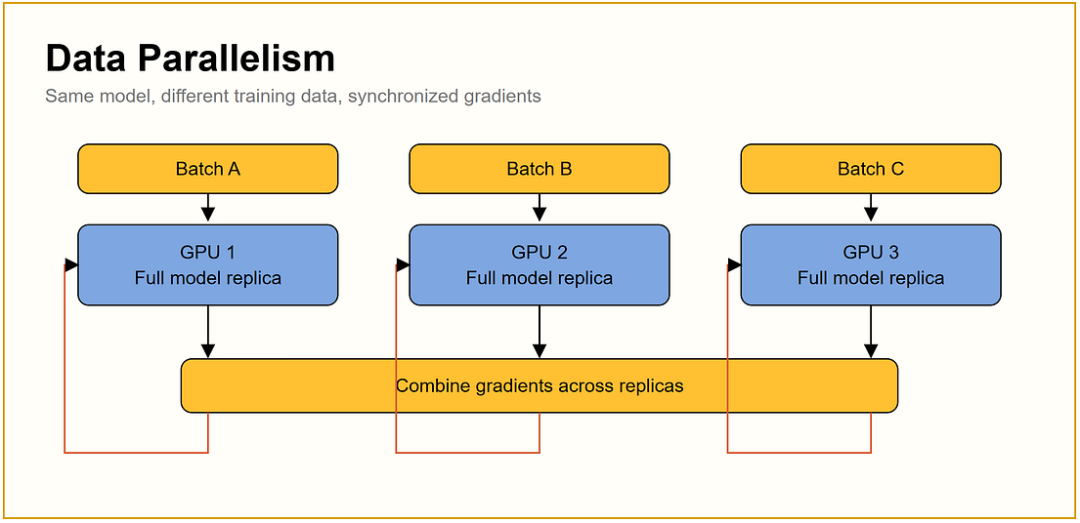
Figure 3.41 - Full replicas process different batches and combine their gradients.
Source: JAM with AI newsletter, "All GPU related concepts simply explained" (S. Khosravi Jam & S. Ladhwe, 17 Sep 2026)
In depth: In training, gradients are averaged with all-reduce after each backward pass (DDP buckets gradients and overlaps communication with backward). In serving, data parallelism simply means independent replicas behind a load balancer, which scales throughput almost linearly and improves fault tolerance. Details in Section 14.

Tensor parallelism
In simple words: One big maths operation is split so several GPUs each do part of it at the same time, then combine their answers.
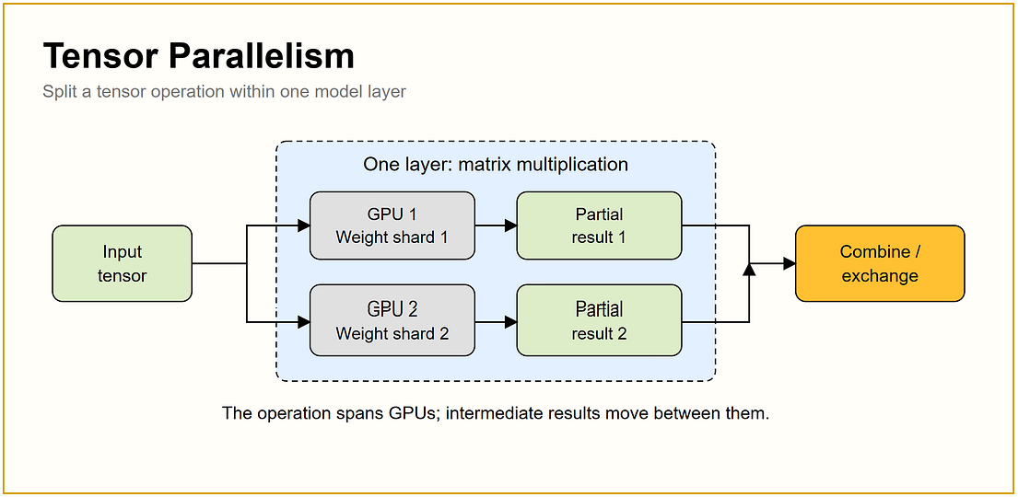
Figure 3.42 - One layer's matrix multiplication split across GPUs, with results exchanged.
Source: JAM with AI newsletter, "All GPU related concepts simply explained" (S. Khosravi Jam & S. Ladhwe, 17 Sep 2026)
In depth: Megatron-style TP splits attention and MLP weight matrices column- and row-wise, requiring an all-reduce in every layer, twice per layer in forward alone. That communication volume needs NVLink-class bandwidth, so TP is normally kept within one node or NVLink domain (TP=2, 4 or 8). It reduces per-GPU memory and per-token latency but gives diminishing throughput returns.

Pipeline parallelism
In simple words: Like an assembly line: the first GPU does the early layers, passes its work to the next GPU, and so on.
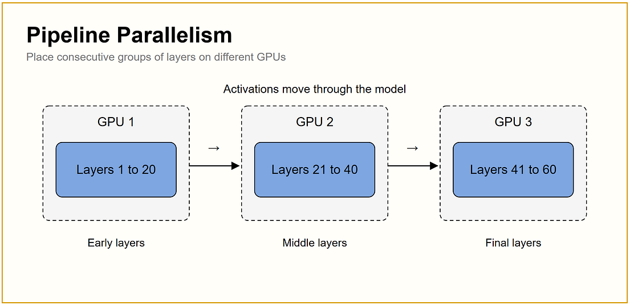
Figure 3.43 - Consecutive groups of layers on different GPUs; activations move between stages.
Source: JAM with AI newsletter, "All GPU related concepts simply explained" (S. Khosravi Jam & S. Ladhwe, 17 Sep 2026)
In depth: Only activations cross stage boundaries (point-to-point sends), so PP tolerates slower links and works across nodes. The cost is 'pipeline bubbles' (idle stages), reduced with micro-batching schedules such as 1F1B. In inference, PP adds some latency but lets models span nodes; vLLM supports it with --pipeline-parallel-size.

Model parallelism
In simple words: The umbrella term for any way of spreading one model across several GPUs.
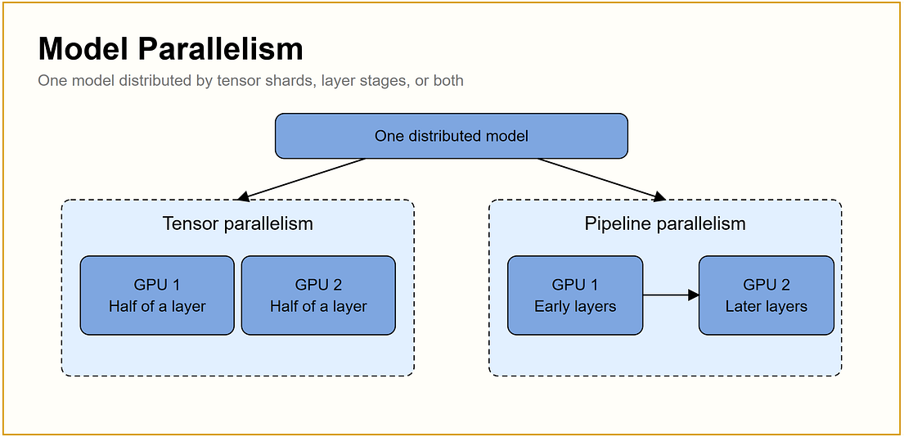
Figure 3.44 - Tensor and pipeline parallelism as two forms of model parallelism.
Source: JAM with AI newsletter, "All GPU related concepts simply explained" (S. Khosravi Jam & S. Ladhwe, 17 Sep 2026)
In depth: Large systems compose parallelisms: TP inside the node, PP across nodes, DP/FSDP across everything, plus expert parallelism (EP) for mixture-of-experts and context/sequence parallelism for very long inputs. The layout should mirror the network hierarchy, with the most communication-heavy parallelism on the fastest links.

Communication overhead
In simple words: Whenever GPUs have to send results to each other, time is spent moving data instead of computing.
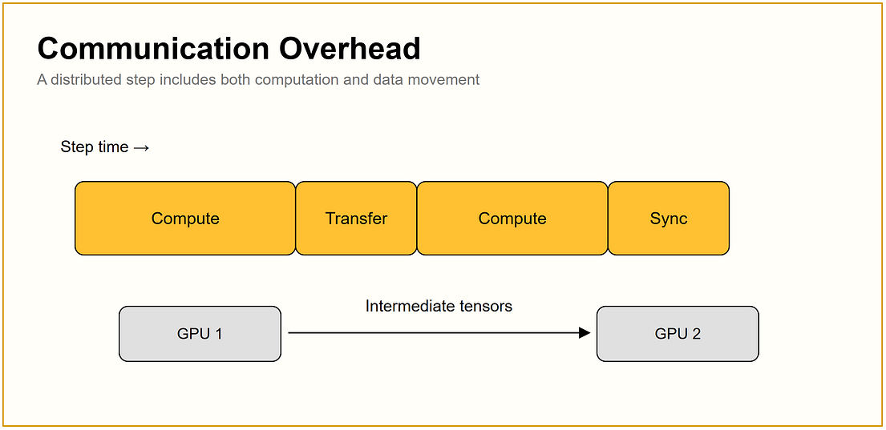
Figure 3.45 - A step includes both compute and transfer/synchronisation time.
Source: JAM with AI newsletter, "All GPU related concepts simply explained" (S. Khosravi Jam & S. Ladhwe, 17 Sep 2026)
In depth: Overhead depends on message size, frequency, link bandwidth, latency and collective algorithm. Mitigations: overlap communication with computation, bucket small messages, use the right parallelism for the link, compress or reduce precision of communication, and use topology-aware placement. Profiling tools (Nsight Systems, PyTorch profiler) show NCCL kernels explicitly, so you can measure the share of step time spent communicating.

3.7 Step 7: GPU Interconnects and Communication

PCIe
In simple words: PCIe is the standard road inside every server connecting the CPU, GPUs, network cards and drives. It works everywhere, but it is not the fastest road.
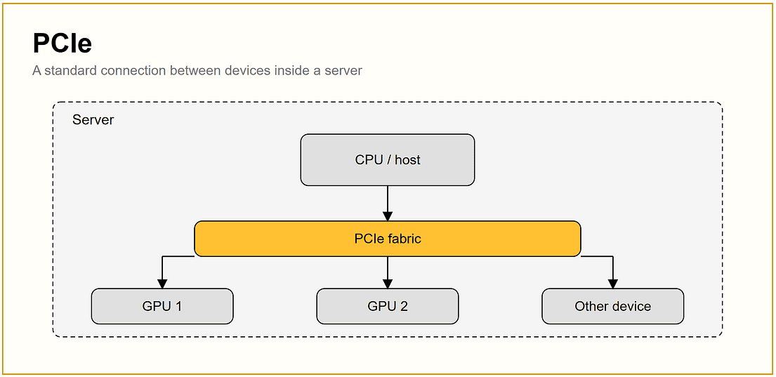
Figure 3.46 - PCIe connects the CPU/host to GPUs and other devices through a PCIe fabric.
Source: JAM with AI newsletter, "All GPU related concepts simply explained" (S. Khosravi Jam & S. Ladhwe, 17 Sep 2026)
In depth: PCIe Gen5 x16 gives about 64 GB/s per direction and is shared through PCIe switches. It is fine for data-parallel replicas and small TP groups, but GPU-to-GPU traffic across CPU sockets is slow. Section 6.1 covers generations, P2P, GPUDirect and nvidia-smi topology labels.

NVLink
In simple words: NVLink is NVIDIA's private express highway between GPUs, many times wider than the PCIe road.
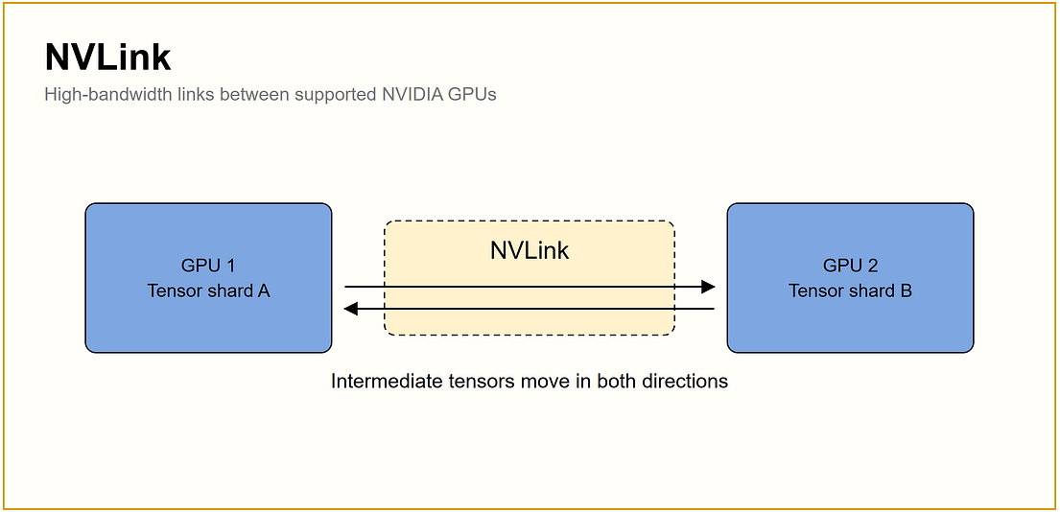
Figure 3.47 - NVLink carries intermediate tensors in both directions between GPUs.
Source: JAM with AI newsletter, "All GPU related concepts simply explained" (S. Khosravi Jam & S. Ladhwe, 17 Sep 2026)
In depth: NVLink 4 (H100/H200) provides 900 GB/s per GPU across 18 links; NVLink 5 (B200) provides 1.8 TB/s; NVLink 6 (Rubin) is announced at 3.6 TB/s. This makes tensor and expert parallelism practical. NVLink-C2C connects Grace/Vera CPUs to GPUs at 900 GB/s (Section 6.2).

NVSwitch
In simple words: NVSwitch is a central interchange so every GPU can reach every other GPU on the express highway directly.
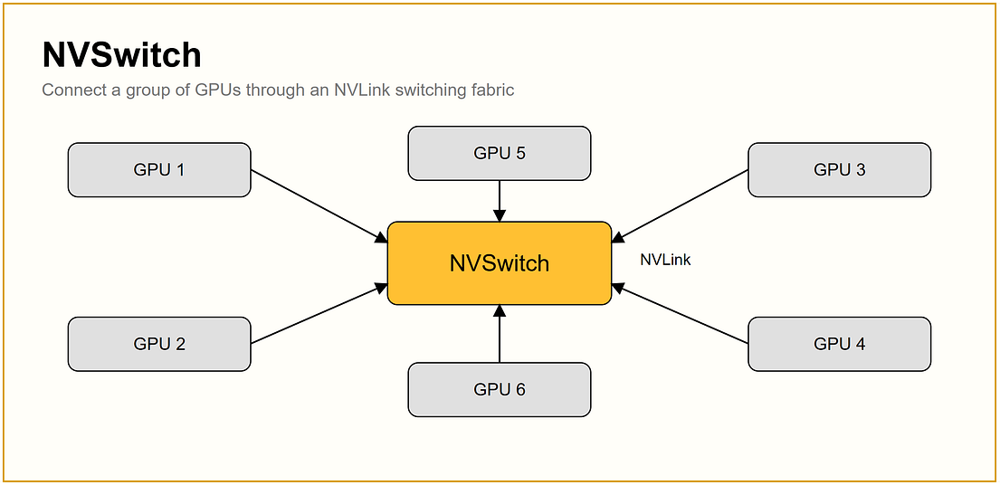
Figure 3.48 - NVSwitch connects a group of GPUs through an NVLink switching fabric.
Source: JAM with AI newsletter, "All GPU related concepts simply explained" (S. Khosravi Jam & S. Ladhwe, 17 Sep 2026)
In depth: On HGX boards, every GPU connects to every NVSwitch chip, giving uniform all-to-all bandwidth among 8 GPUs. NVLink Switch trays extend this to 72 GPUs in GB200 NVL72 racks. Without NVSwitch, NVLink topologies are partial meshes where some GPU pairs are faster than others.

Inter-GPU bandwidth
In simple words: Bandwidth is how wide the road between GPUs is. A narrow road forces data to queue even if the GPUs are fast.
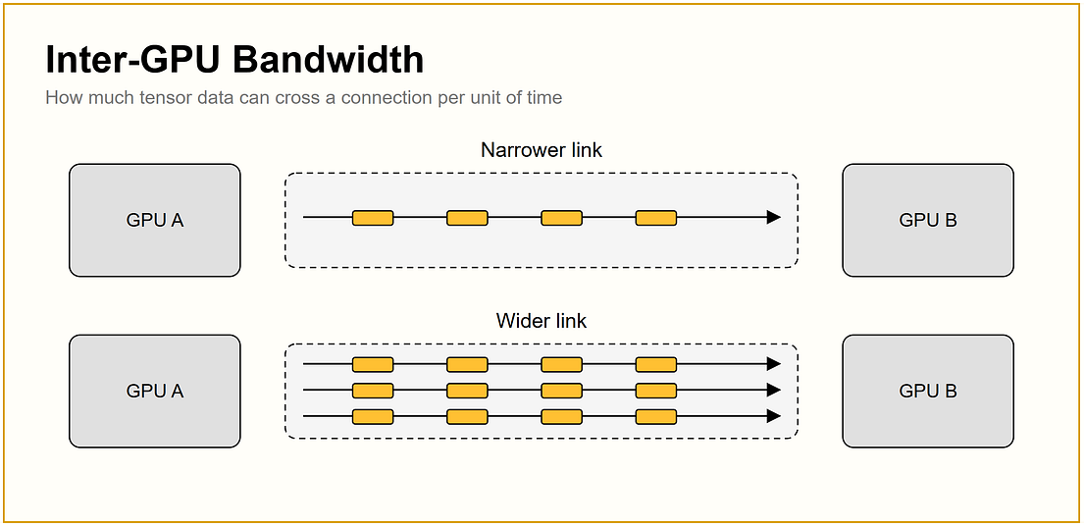
Figure 3.49 - A narrower link moves less data per unit of time than a wider link.
Source: JAM with AI newsletter, "All GPU related concepts simply explained" (S. Khosravi Jam & S. Ladhwe, 17 Sep 2026)
In depth: Bus bandwidth, as reported by nccl-tests, is the standard way to measure it. Rough per-GPU figures: PCIe Gen5 ~128 GB/s bidirectional, InfiniBand NDR ~100 GB/s (400 Gb/s), NVLink 4 900 GB/s, NVLink 5 1.8 TB/s. Latency also matters, especially for the small messages common in inference.

NCCL
In simple words: NCCL is NVIDIA's library that handles GPU-to-GPU communication for you, so frameworks like PyTorch do not have to reinvent it.
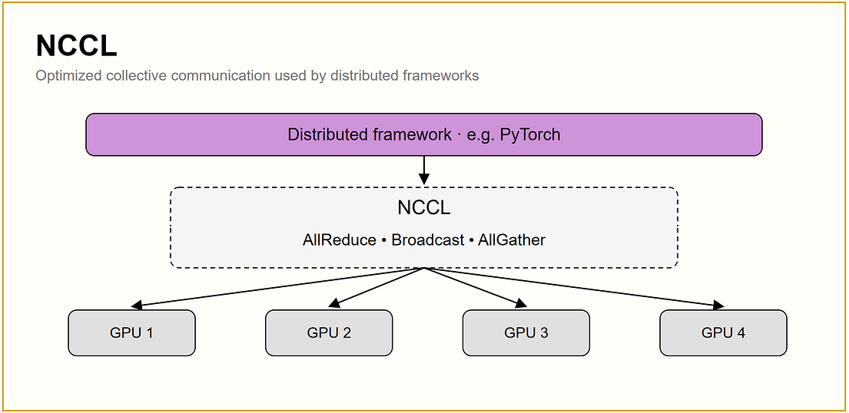
Figure 3.50 - Frameworks call NCCL, which runs collectives such as AllReduce, Broadcast and AllGather.
Source: JAM with AI newsletter, "All GPU related concepts simply explained" (S. Khosravi Jam & S. Ladhwe, 17 Sep 2026)
In depth: NCCL discovers the topology (NVLink, PCIe, InfiniBand/RoCE) and picks ring or tree algorithms and transports automatically. Useful environment variables: NCCL_DEBUG=INFO (verify transport), NCCL_IB_HCA (select NICs), NCCL_SOCKET_IFNAME (bootstrap interface). AMD's equivalent is RCCL. Validate clusters with nccl-tests before running real jobs (Section 8.3).

AllReduce
In simple words: Every GPU computes its own result; AllReduce adds them all up and gives every GPU the same combined answer.
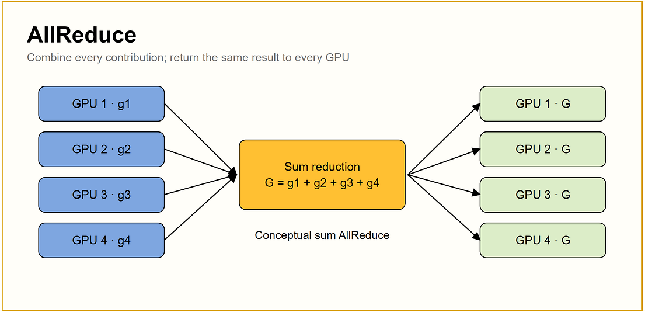
Figure 3.51 - AllReduce sums values from all GPUs and returns the same result to each.
Source: JAM with AI newsletter, "All GPU related concepts simply explained" (S. Khosravi Jam & S. Ladhwe, 17 Sep 2026)
In depth: Ring all-reduce performs a reduce-scatter followed by an all-gather; each GPU sends about 2 x (N-1)/N times the data size, which is bandwidth-optimal and nearly independent of GPU count, but latency grows with N. Tree algorithms reduce latency at scale, and in-network reduction (InfiniBand SHARP) offloads work to switches. In LLMs, all-reduce synchronises gradients (DP) and combines tensor-parallel shards (TP).

3.8 Step 8: Scaling LLMs Across GPUs

Single GPU
In simple words: If the model fits on one GPU and it is fast enough, stop there. It is the simplest and most reliable setup.
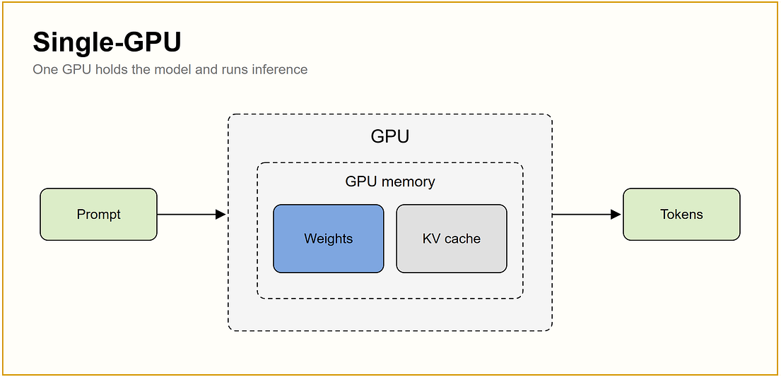
Figure 3.52 - One GPU holds the weights and KV cache and serves the prompt.
Source: JAM with AI newsletter, "All GPU related concepts simply explained" (S. Khosravi Jam & S. Ladhwe, 17 Sep 2026)
In depth: With FP8 or INT4 quantization, models up to roughly 30B (and 70B at 4-bit with modest context) fit on one 80 GB GPU. Scaling out single-GPU replicas with data parallelism is often more cost-efficient than tensor parallelism, because there is no inter-GPU communication.

Multi-GPU
In simple words: When one GPU is not enough, several GPUs in one server share the model and the work, and talk to each other constantly.
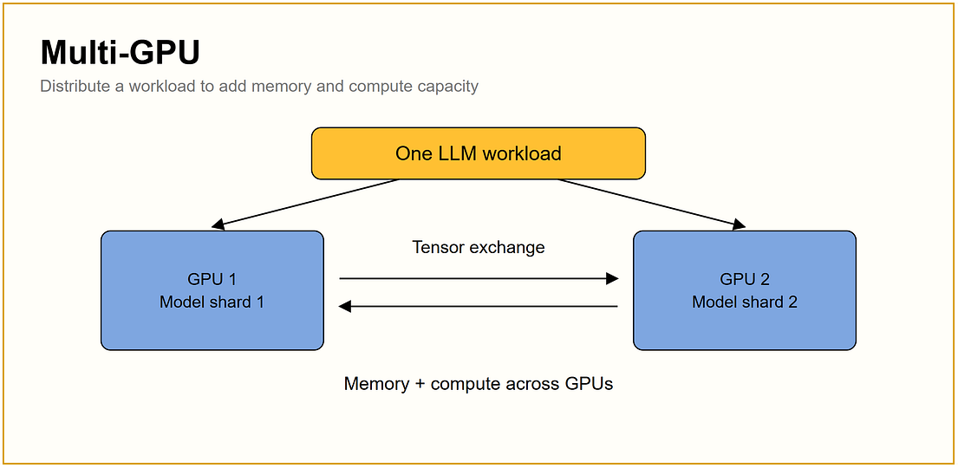
Figure 3.53 - Two GPUs each hold part of the model and exchange tensors.
Source: JAM with AI newsletter, "All GPU related concepts simply explained" (S. Khosravi Jam & S. Ladhwe, 17 Sep 2026)
In depth: Within one server, use tensor parallelism across NVLink-connected GPUs. Benchmark TP=2 vs TP=4 vs two separate TP=2 replicas: the best choice depends on whether you need lower latency (more TP) or more throughput (more replicas).

Distributed training
In simple words: Many GPUs across several machines train one model together, constantly syncing what they have learned.
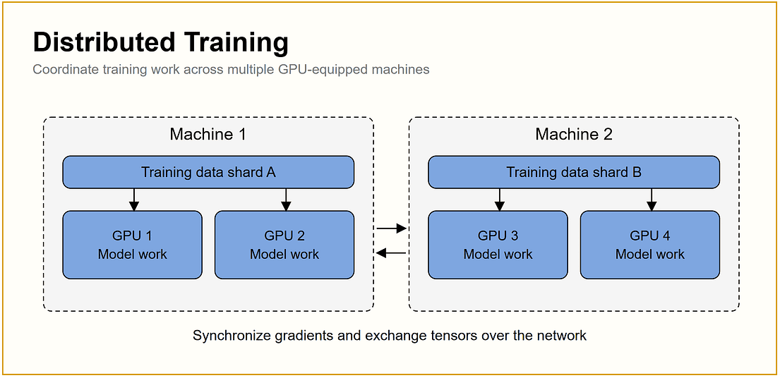
Figure 3.54 - Two machines train on different data shards and synchronise gradients over the network.
Source: JAM with AI newsletter, "All GPU related concepts simply explained" (S. Khosravi Jam & S. Ladhwe, 17 Sep 2026)
In depth: Distributed training combines DP/FSDP, TP and PP, launched with torchrun, Slurm or Kubernetes operators. Beyond throughput, the hard parts are reliability (checkpointing, restarting after GPU failures), stragglers (one slow GPU slows everyone), and network tuning (Section 14).

GPU cluster
In simple words: A GPU cluster is many GPU servers wired together with a fast network so they can act like one big computer.
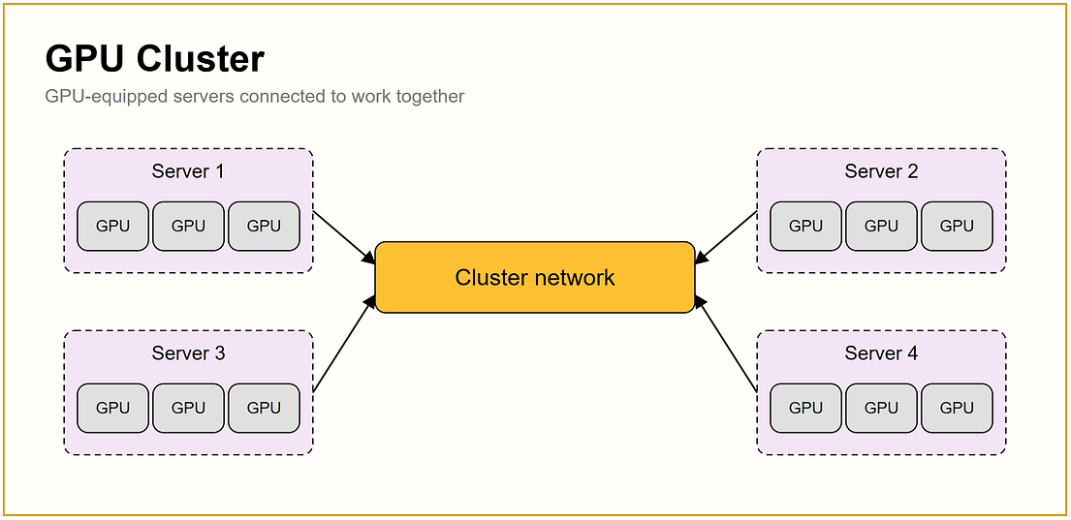
Figure 3.55 - GPU servers connected through a cluster network.
Source: JAM with AI newsletter, "All GPU related concepts simply explained" (S. Khosravi Jam & S. Ladhwe, 17 Sep 2026)
In depth: Real clusters have separate compute, storage, front-end and management networks, rail-optimised leaf-spine fabrics, a scheduler (Slurm, Kubernetes), shared storage and monitoring. Sections 7 and 8 show how nodes and racks are built and connected.

Memory bottleneck
In simple words: The job is stuck because memory is too small or too slow: the model does not fit, the KV cache is full, or data arrives too slowly.
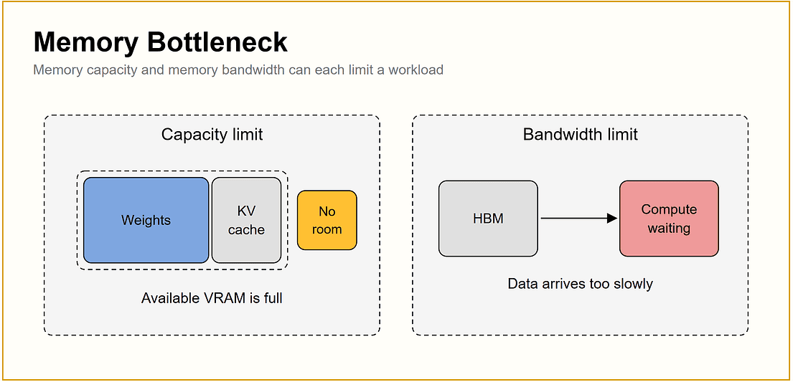
Figure 3.56 - Capacity limits (VRAM full) and bandwidth limits (data arrives too slowly).
Source: JAM with AI newsletter, "All GPU related concepts simply explained" (S. Khosravi Jam & S. Ladhwe, 17 Sep 2026)
In depth: Symptoms: OOM errors, requests preempted or queued while GPUs look idle, KV-cache usage near 100%, decode throughput flat as compute rises. Fixes: quantize weights/KV, reduce context or concurrency, add TP, use GPUs with more/faster memory, enable prefix caching and offloading.

Compute bottleneck
In simple words: The calculators are fully busy and work is queuing up. Here, more or faster compute really helps.
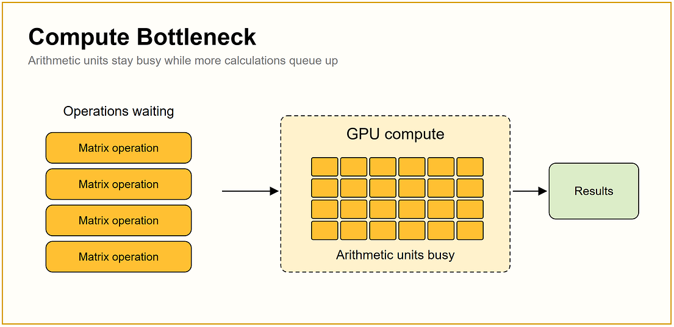
Figure 3.57 - Operations wait because arithmetic units are busy.
Source: JAM with AI newsletter, "All GPU related concepts simply explained" (S. Khosravi Jam & S. Ladhwe, 17 Sep 2026)
In depth: Symptoms: high SM-active, TTFT rising with prompt length, throughput flat as batch grows. Fixes: FP8/FP4 compute, better kernels, chunked prefill tuning, disaggregated prefill, more replicas or faster GPUs.

Communication bottleneck
In simple words: GPUs finish their work and then sit waiting for data from other GPUs. Adding more GPUs can make this worse.
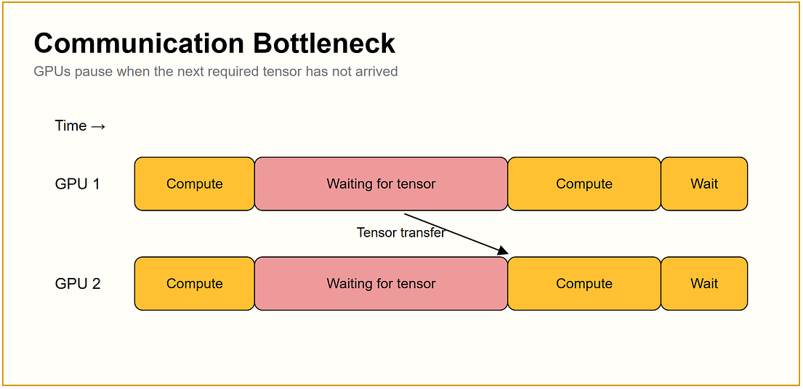
Figure 3.58 - GPUs pause while waiting for tensors from each other.
Source: JAM with AI newsletter, "All GPU related concepts simply explained" (S. Khosravi Jam & S. Ladhwe, 17 Sep 2026)
In depth: Symptoms: large NCCL time share in profiles, poor scaling from 1 to N nodes, low bus bandwidth in nccl-tests, NCCL falling back to sockets. Fixes: move TP inside the NVLink domain, enable GPUDirect RDMA, use rail-optimised topology, tune RoCE, change parallelism layout, overlap communication with compute.

Scaling efficiency
In simple words: Ideally, twice the GPUs finishes the job in half the time. In practice, communication and waiting eat into the gain.
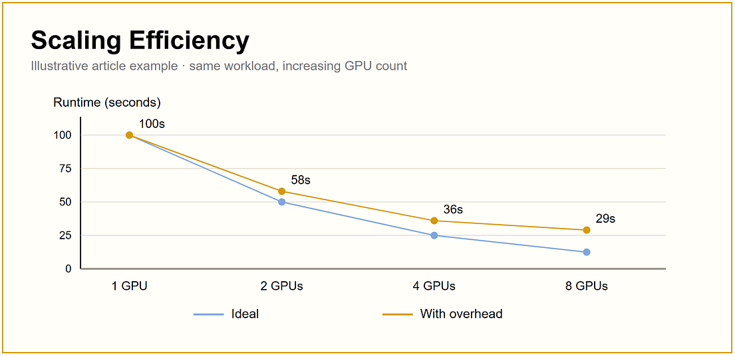
Figure 3.59 - Ideal vs real runtime as GPUs are added (illustrative).
Source: JAM with AI newsletter, "All GPU related concepts simply explained" (S. Khosravi Jam & S. Ladhwe, 17 Sep 2026)
In depth: Scaling efficiency = T1 / (N x TN). With the illustrative numbers (100 s on 1 GPU, 29 s on 8 GPUs) efficiency is 100 / (8 x 29) = 43%, meaning more than half of the extra GPU time is lost to overhead. Distinguish strong scaling (same job, more GPUs, shorter time) from weak scaling (bigger job with more GPUs, same time per GPU); large training runs mostly rely on weak scaling via larger global batches.
Scaling efficiency E(N) = T(1) / (N x T(N))
Speed-up S(N) = T(1) / T(N)
Amdahl's law S(N) <= 1 / (s + (1 - s) / N), s = sequential fraction

Example: T(1)=100 s, T(8)=29 s -> S = 3.45x, E = 43%
Key point: The whole section in one line: GPU speed is the product of compute, memory, precision, parallelism layout and communication. Diagnose which one is limiting before spending money on more GPUs.

4. GPU and VRAM Fundamentals
In simple words: A GPU has two things that matter most: how fast it calculates and how much it can hold in its memory. Writing an answer is limited mostly by memory speed; reading your prompt is limited mostly by calculation speed.

4.1 What a GPU does for an LLM
A GPU contains thousands of small cores optimized for the same operation on many numbers at once, which is exactly what transformer matrix multiplications need. Each NVIDIA GPU has CUDA cores for general parallel math, tensor-optimized paths (Transformer Engine) for FP8/FP4 math, and high-bandwidth memory (HBM) stacked on the same package so the cores are not starved for data.

4.2 The two phases of inference
- Prefill: the whole prompt is processed in one parallel forward pass. This is compute-bound: more FLOPs = faster. It determines time-to-first-token.
- Decode: one new token per forward pass per sequence. Each step must read all model weights plus the growing KV cache from memory, so decode is memory-bandwidth-bound at small batch sizes. Batching many users into one step is how you use the idle compute.
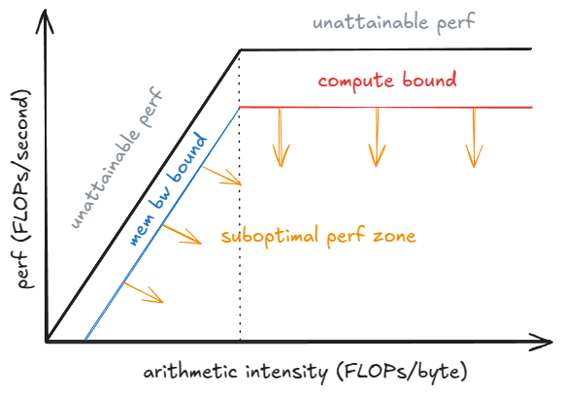
Figure 4.1 - Roofline model: at low arithmetic intensity (decode) performance is capped by memory bandwidth; at high intensity (prefill) it is capped by compute.
Source: vLLM Blog, "Inside vLLM: Anatomy of a High-Throughput LLM Inference System" (A. Gordić), vLLM Blog (github.com/vllm-project/vllm-project.github.io)

4.3 Where VRAM goes
Consumer | Inference | Training
Model weights | params x bytes per param (2 for BF16, 1 for FP8, ~0.5 for INT4) | Same, plus an FP32 master copy in mixed precision
KV cache | Grows with batch x context length; often larger than the weights | Not used the same way
Activations | Small, temporary | Large; scales with batch x seq len x layers (use checkpointing)
Gradients | - | Same size as weights
Optimizer state | - | Adam: 2 extra FP32 tensors per param
Overhead | CUDA context, cuBLAS workspaces, CUDA graphs (~1-4 GB) | Same plus communication buffers

Formulas worth memorising:
Weights (GB) = params x bytes_per_param / 1e9
KV cache per token = 2 x n_layers x n_kv_heads x head_dim x bytes_per_elem
Training (Adam, AMP) ~ 16 bytes x params (+ activations)

Llama-3-70B, BF16: 2 x 80 x 8 x 128 x 2 = 327,680 bytes ~ 0.33 MB per token
8 users x 32k tokens x 0.33 MB ~ 84 GB of KV cache
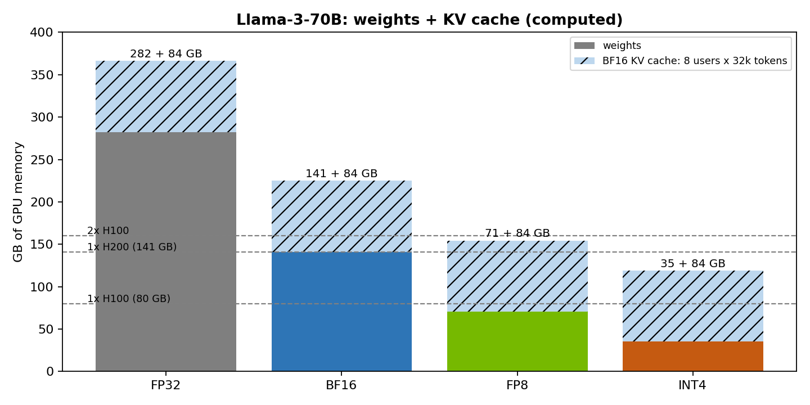
Figure 4.2 - Llama-3-70B memory by precision. Even at INT4 weights, a busy KV cache needs more than one 80 GB GPU. Usable VRAM is a few GB lower than the label.
Chart computed for this guide

4.4 HBM vs GDDR
 | HBM (H100, H200, B200, MI300X) | GDDR6/7 (L4, L40S, RTX PRO)
Placement | Stacked next to the GPU die on an interposer | Separate chips on the PCB
Bandwidth | Very high (best for decode) | Lower
Capacity | 80-288 GB per GPU | 24-96 GB per GPU
Cost | High | Much lower
Best for | Large models, long contexts, training | Small/medium models, embeddings, vision, cost-sensitive inference

4.5 How to optimize VRAM for LLMs
- Pick the smallest precision that passes your quality evals (FP8 is usually near-lossless on H100 and newer).
- Quantize the KV cache (FP8) to roughly double concurrent context.
- Prefer models with GQA/MQA/MLA attention: fewer KV heads means a smaller cache per token.
- Cap max-model-len to what users really need; a 128k limit reserves memory you rarely use.
- Use paged KV cache (vLLM, TensorRT-LLM) to avoid fragmentation, and prefix caching to share memory across requests.
- Offload cold KV blocks to CPU RAM or NVMe when context is long but reuse is likely.
- In training: activation checkpointing, FSDP/ZeRO sharding, and FlashAttention.

5. GPU Architectures and Generations
In simple words: Each GPU generation adds more memory, faster links and support for smaller number formats. Pick the GPU by what your models need (memory and links), not by the newest name.
Figures below are vendor-published headline numbers. Check the current datasheet before quoting a purchase decision, especially for the newest products, whose specifications change between announcement and shipping.
Architecture (year) | GPU | Memory | GPU-GPU link | Host link | Max power | Typical role
Volta (2017) | V100 | 16/32 GB HBM2 | NVLink 2 (300 GB/s) | PCIe 3 | 300 W | Legacy training
Ampere (2020) | A100 | 40/80 GB HBM2e | NVLink 3 (600 GB/s) | PCIe 4 | 400 W | Training and inference; MIG
Ampere (2021) | A10 | 24 GB GDDR6 | None (PCIe) | PCIe 4 | 150 W | Small-model inference
Ada Lovelace (2023) | L4 | 24 GB GDDR6 | None (PCIe) | PCIe 4 | 72 W | Efficient inference, video, embeddings
Ada Lovelace (2023) | L40S | 48 GB GDDR6 | None (PCIe) | PCIe 4 | 350 W | Mid-size inference, graphics
Hopper (2022) | H100 | 80 GB HBM3 | NVLink 4 (900 GB/s) | PCIe 5 | 700 W | Training and FP8 inference
Hopper (2024) | H200 | 141 GB HBM3e | NVLink 4 (900 GB/s) | PCIe 5 | 700 W | Same compute as H100, much more memory
Grace Hopper (2023) | GH200 | 96/144 GB HBM + 480 GB LPDDR5X | NVLink 4 | NVLink-C2C 900 GB/s to Grace | Up to ~1 kW module | Memory-hungry inference
Blackwell (2024) | B200 | ~180-192 GB HBM3 | NVLink 5 (1.8 TB/s) | PCIe 5 | ~1,000 W | Frontier training, FP4 inference
Grace Blackwell (2024) | GB200 NVL72 | 72 x B200 + 36 Grace | NVLink 5 across whole rack | NVLink-C2C | ~120 kW per rack | Rack-scale training/inference
Vera Rubin (H2 2026) | Rubin / VR NVL72 | 288 GB HBM4 | NVLink 6 (3.6 TB/s) | NVLink-C2C to Vera CPU | Rack ~190 kW+ | Next-generation rack-scale
AMD (2023-24) | MI300X / MI325X | 192 / 256 GB HBM3 | Direct GPU mesh on UBB | PCIe 5 | ~750-1,000 W | Memory-heavy inference (ROCm)
Intel (2024) | Gaudi 3 | 128 GB HBM2e | 24 x 200 GbE RoCE on-chip | PCIe 5 | ~900 W | Ethernet-native training/inference

Rubin details come from NVIDIA's platform announcement, which lists NVLink 6 at 3.6 TB/s per GPU and HBM4 memory; volume shipments were targeted for the second half of 2026, so treat these as the newest and least-settled numbers in the table.

5.1 What changed each generation (and why it matters for LLMs)
- Ampere: introduced MIG (split one GPU into up to 7 isolated instances) and BF16/TF32 training at scale.
- Ada: FP8 support in a cheap PCIe card, but no NVLink, so multi-GPU tensor parallelism is slow.
- Hopper: Transformer Engine with FP8, NVLink 4, and the H200's larger memory, which mostly helps decode throughput and long contexts.
- Grace Hopper / Grace Blackwell: CPU and GPU share a 900 GB/s NVLink-C2C link, making CPU memory a practical extension of GPU memory (KV offload, large embeddings).
- Blackwell: native FP4 (NVFP4), NVLink 5 at double the bandwidth, and rack-scale NVLink domains (NVL72) that make 72 GPUs behave like one big accelerator for tensor/expert parallelism.
- Rubin: HBM4, NVLink 6, and a specialised prefill accelerator (Rubin CPX), reflecting the industry move to disaggregated prefill/decode.

5.2 Choosing a form factor
Option | Pros | Cons | Good for
PCIe cards (L4, L40S, RTX PRO) | Cheap, air-cooled, fits standard servers, easy to buy | No NVLink; TP beyond 2 GPUs is slow; less memory | Models up to ~30B (or 70B quantized), embeddings, vision
HGX 8-GPU (H100/H200/B200) | Full NVLink all-to-all; standard for training; strong resale market | Expensive; 10-15 kW per node; lead times | 70B-400B serving, fine-tuning, most training
Rack-scale (GB200/GB300 NVL72) | 72 GPUs in one NVLink domain; best for huge MoE models | ~120 kW+ per rack, liquid cooling mandatory, facility redesign | Frontier training, very large MoE inference
Cloud GPUs | No capex, elastic, fast to start | Highest long-run cost; data residency constraints; quota limits | Experiments, bursty demand

6. Interconnects: PCIe, NVLink and NVSwitch
In simple words: Inside a server, parts talk over PCIe, the universal road. NVIDIA GPUs also get NVLink, a private highway many times wider, and NVSwitch, a junction that connects every GPU to every other.

6.1 PCIe (Peripheral Component Interconnect Express)
PCIe is the general-purpose point-to-point bus that connects everything inside a server to the CPU. A link is made of lanes (x1, x4, x8, x16); GPUs use x16. The CPU contains the root complex; PCIe switches fan one upstream x16 link out to several devices, which is how an 8-GPU server attaches GPUs, NICs and NVMe drives.
Generation | Per-lane rate | x16, one direction (approx.) | Typical platform
PCIe 3.0 | 8 GT/s | ~16 GB/s | V100-era servers
PCIe 4.0 | 16 GT/s | ~32 GB/s | A100, L4, L40S
PCIe 5.0 | 32 GT/s | ~64 GB/s | H100, H200, B200 hosts
PCIe 6.0 | 64 GT/s (PAM4) | ~121 GB/s | Next-generation hosts and NICs

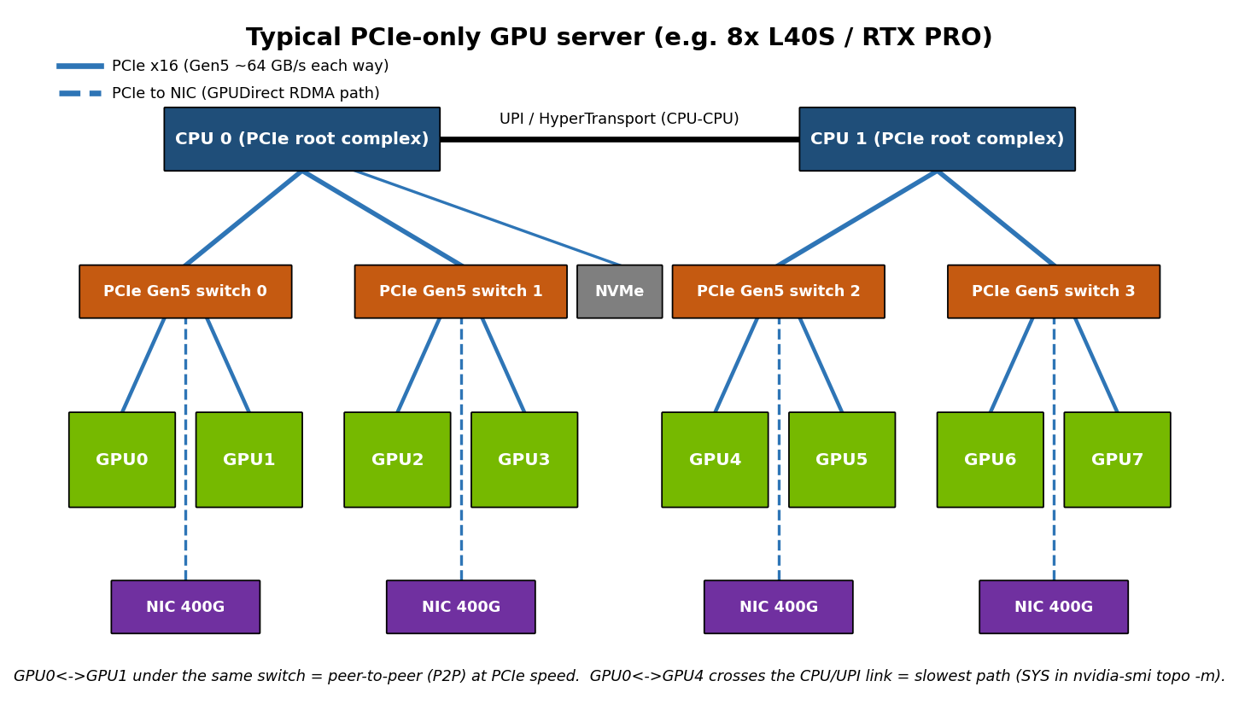
Figure 6.1 - PCIe tree inside a GPU server: CPUs are root complexes; PCIe switches connect GPUs, NICs and NVMe.
Diagram created for this guide from NVIDIA published specifications
Peer-to-peer (P2P): two GPUs under the same PCIe switch can copy memory directly without touching CPU RAM. GPUDirect RDMA lets the NIC read/write GPU memory directly, and GPUDirect Storage does the same for NVMe. All three work best when the devices share a PCIe switch, which is why server designers pair each GPU with a NIC under the same switch.
Check the real topology with nvidia-smi topo -m:
Label | Meaning | Speed
NV# | Connected by a bonded set of # NVLinks | Fastest
PIX | At most one PCIe bridge between them | Good
PXB | Multiple PCIe bridges, no host bridge | Good
PHB | Path crosses a PCIe host bridge (the CPU) | Slower
NODE | Crosses host bridges within one NUMA node | Slower
SYS | Crosses the CPU-to-CPU (SMP) link between NUMA nodes | Slowest

Pros and cons
Pros | Cons
+ Universal, cheap, standardised | - Roughly 7-14x less bandwidth than NVLink for GPU-GPU
+ Connects NICs and storage as well as GPUs | - Shared with other devices behind the same switch
+ Works across vendors | - Cross-socket paths (SYS) are slow and add latency

6.2 NVLink and NVSwitch
NVLink is NVIDIA's dedicated high-speed GPU-to-GPU link. Each GPU has many NVLink ports (18 on H100/H200/B200). NVSwitch is a switch chip that every GPU connects to, so any GPU can reach any other in one hop at full speed. On an HGX board, 8 GPUs connect to 4 NVSwitch chips (Hopper) or 2 (Blackwell).
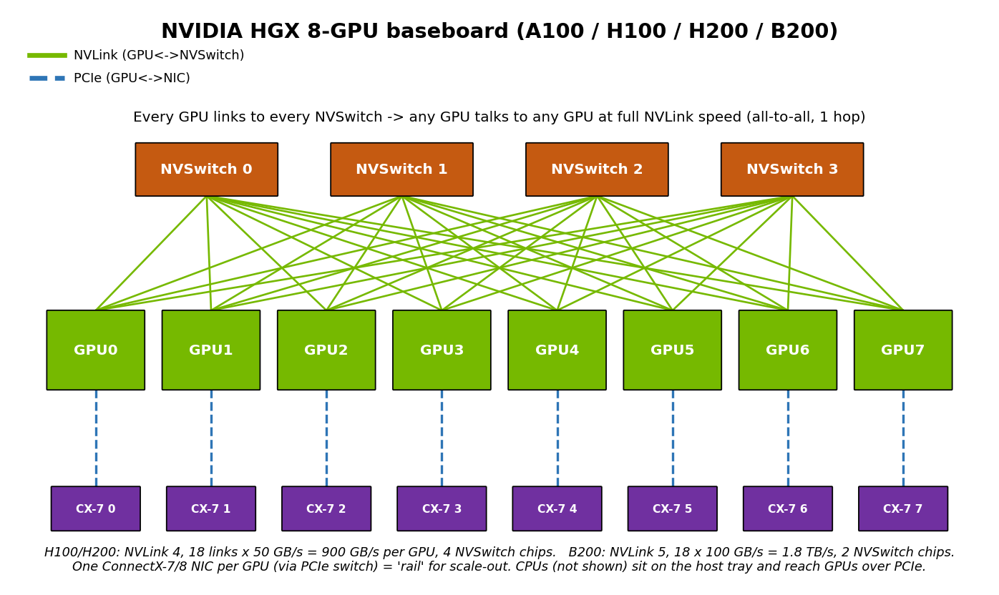
Figure 6.2 - HGX 8-GPU board: every GPU connects to every NVSwitch, and each GPU is paired with its own network card.
Diagram created for this guide from NVIDIA published specifications
NVLink version | GPUs | Per-GPU bandwidth (bidirectional) | Links x speed
NVLink 2 | V100 | 300 GB/s | 6 x 50 GB/s
NVLink 3 | A100 | 600 GB/s | 12 x 50 GB/s
NVLink 4 | H100, H200, GH200 | 900 GB/s | 18 x 50 GB/s
NVLink 5 | B200, GB200 | 1.8 TB/s | 18 x 100 GB/s
NVLink 6 | Rubin | 3.6 TB/s | Announced

NVLink-C2C is the chip-to-chip variant that links Grace or Vera CPUs to GPUs at 900 GB/s, replacing PCIe for CPU-GPU traffic. NVLink Switch trays take NVSwitch out of the server and into the rack, which is how NVL72 builds a 72-GPU NVLink domain.
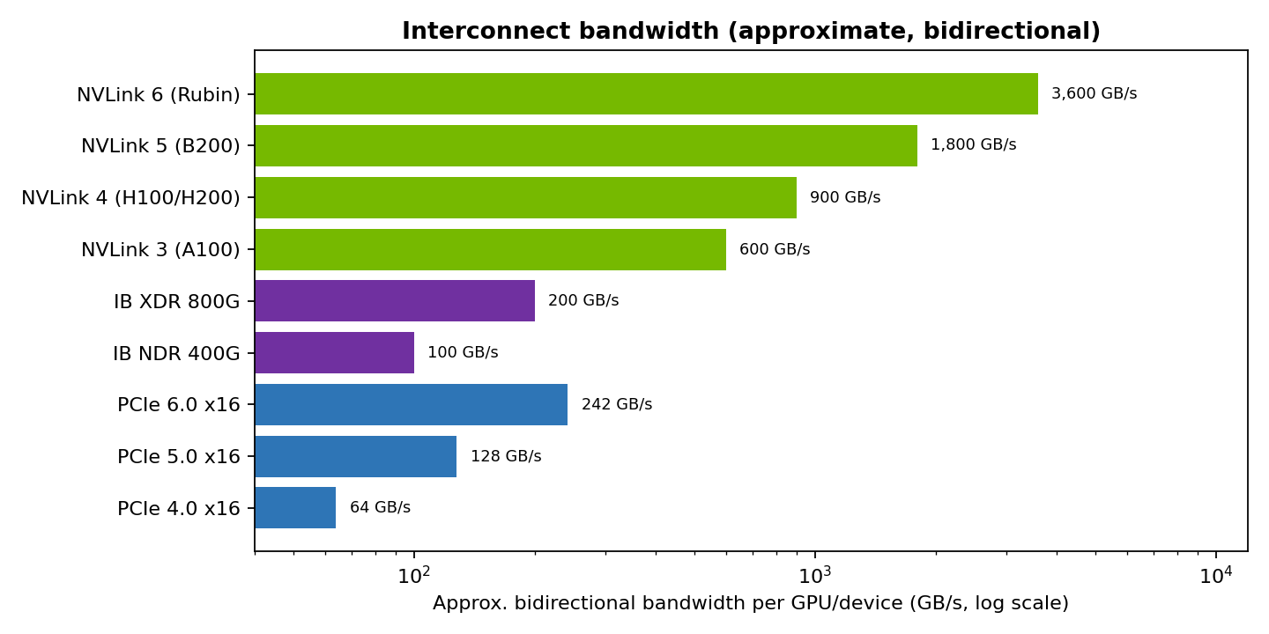
Figure 6.3 - Approximate bidirectional bandwidth of common interconnects (log scale).
Chart created for this guide from PCI-SIG, NVIDIA and InfiniBand Trade Association figures

Pros and cons
Pros | Cons
+ Order-of-magnitude more bandwidth than PCIe | - NVIDIA-only
+ Enables efficient tensor and expert parallelism | - Limited reach: one board, or one rack with NVLink Switch trays
+ NVSwitch gives uniform all-to-all topology | - Adds cost and power
+ Low latency, no network stack | - Cannot connect two ordinary servers

7. How a GPU Cluster Is Built
In simple words: A cluster is built like a city: GPUs live in servers, servers stand in racks, racks form pods. Inside a server GPUs use NVLink; between servers they use a very fast network.

7.1 Hierarchy: GPU -> node -> rack -> pod
- GPU: one accelerator with its own VRAM.
- Node (server): usually 8 GPUs on an HGX board plus 2 CPUs, system RAM, NVMe, and 8-10 network cards.
- Rack: a few nodes (power-limited; often 2-4 HGX nodes in an air-cooled rack) or one NVL72 system.
- Scalable Unit / Pod: a fixed block of racks with its own leaf switches, repeated to grow the cluster (e.g. NVIDIA's DGX SuperPOD reference architecture).

7.2 Scale-up vs scale-out
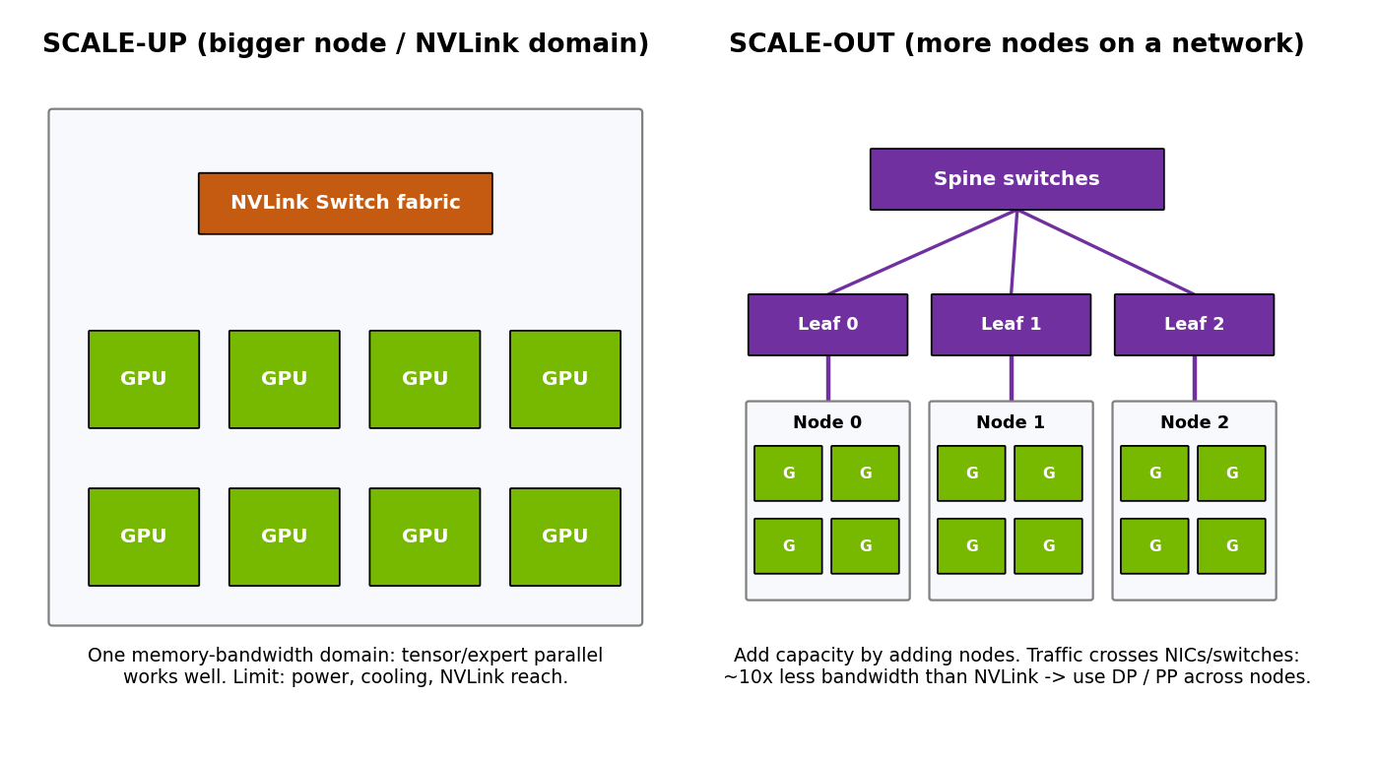
Figure 7.1 - Scale-up grows a single NVLink domain; scale-out adds nodes on a network fabric.
Diagram created for this guide from NVIDIA published specifications
 | Scale-up | Scale-out
How | Bigger node or bigger NVLink domain (8 -> 72 GPUs) | More nodes connected by InfiniBand/Ethernet
Bandwidth | 0.9-3.6 TB/s per GPU | 50-200 GB/s per NIC (400-1600 Gb/s)
Best parallelism | Tensor parallel, expert parallel | Data parallel, pipeline parallel, FSDP
Limits | Power density, cooling, NVLink reach, cost per box | Network cost, congestion, tail latency, failure rate
Pros | Simple programming model; low latency | Near-linear capacity growth; failure isolation
Cons | Big blast radius; expensive per unit | Communication overhead; needs tuning

7.3 The four networks of a GPU cluster
Network | Purpose | Typical technology
Compute (back-end / east-west) | GPU-to-GPU across nodes (NCCL all-reduce, KV transfer) | InfiniBand NDR/XDR or RoCEv2 at 400-800 Gb/s, one NIC per GPU
Storage | Datasets, checkpoints, model weights | 200-400 GbE or InfiniBand; parallel file systems (Lustre, WEKA, VAST)
Front-end (north-south) | User requests, APIs, internet | 25-100 GbE, often via BlueField DPUs
Management / OOB | BMC, IPMI/Redfish, provisioning | 1 GbE

7.4 InfiniBand vs RoCE Ethernet
 | InfiniBand | RoCEv2 Ethernet (e.g. Spectrum-X)
Congestion control | Built-in credit-based, lossless by design | Needs PFC/ECN tuning or vendor adaptive routing
Performance | Best-in-class latency, SHARP in-network reduction | Close to InfiniBand when well tuned
Operations | Separate skill set, subnet manager (UFM) | Familiar to network teams, standard tooling
Vendor lock-in | Essentially NVIDIA | Multi-vendor (NVIDIA, Broadcom, Arista, Cisco)
Cost | Higher | Usually lower

7.5 Rack-scale NVLink: GB200 NVL72
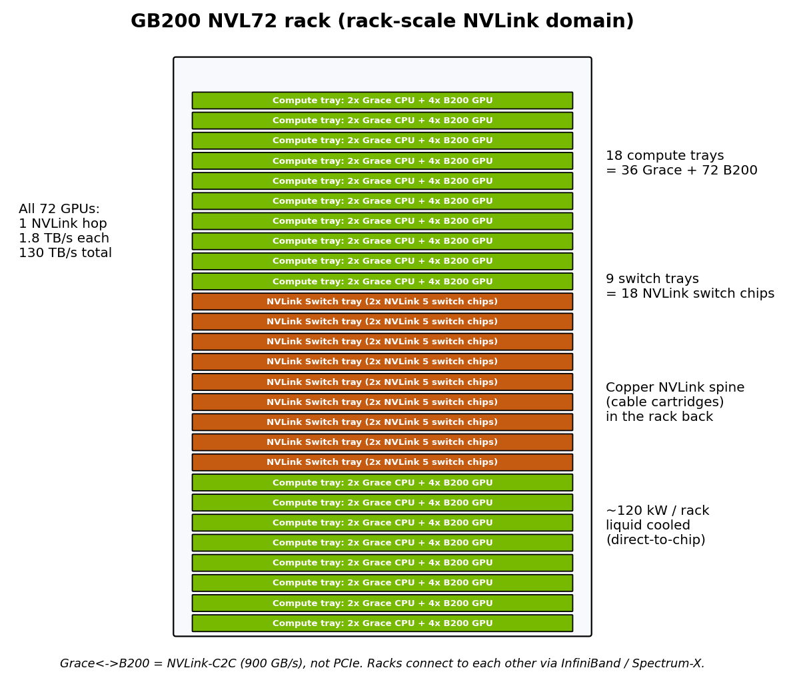
Figure 7.2 - GB200 NVL72: 18 compute trays and 9 NVLink Switch trays form one 72-GPU NVLink domain.
Diagram created for this guide from NVIDIA published specifications
NVL72 blurs the scale-up/scale-out line: tensor or expert parallelism can now span 72 GPUs instead of 8. This matters most for mixture-of-experts models such as DeepSeek-V3, where expert parallelism across many GPUs frees memory for KV cache.
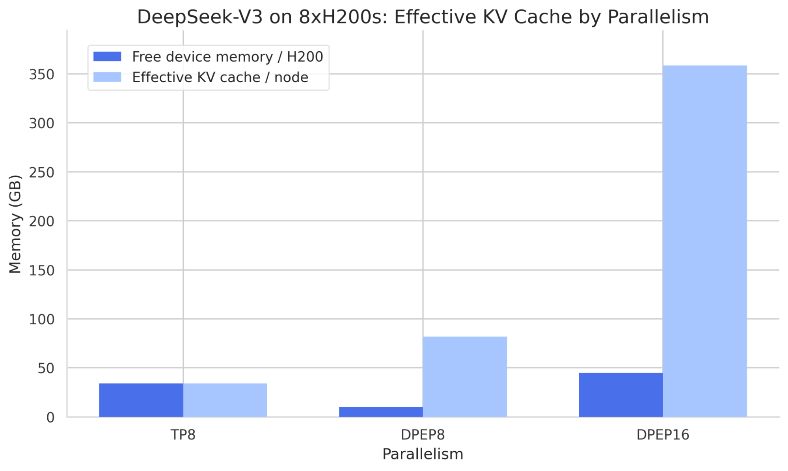
Figure 7.3 - DeepSeek-V3 on 8xH200: data + expert parallelism frees far more memory for KV cache than tensor parallelism.
Source: vLLM Blog, large-scale serving post (Dec 2025), vLLM Blog (github.com/vllm-project/vllm-project.github.io)

8. Connecting Two Nodes: Step by Step
In simple words: To join two servers, give every GPU its own network card, plug them into switches, check the link is really fast, and only then split the model so the chattiest work stays inside each server.
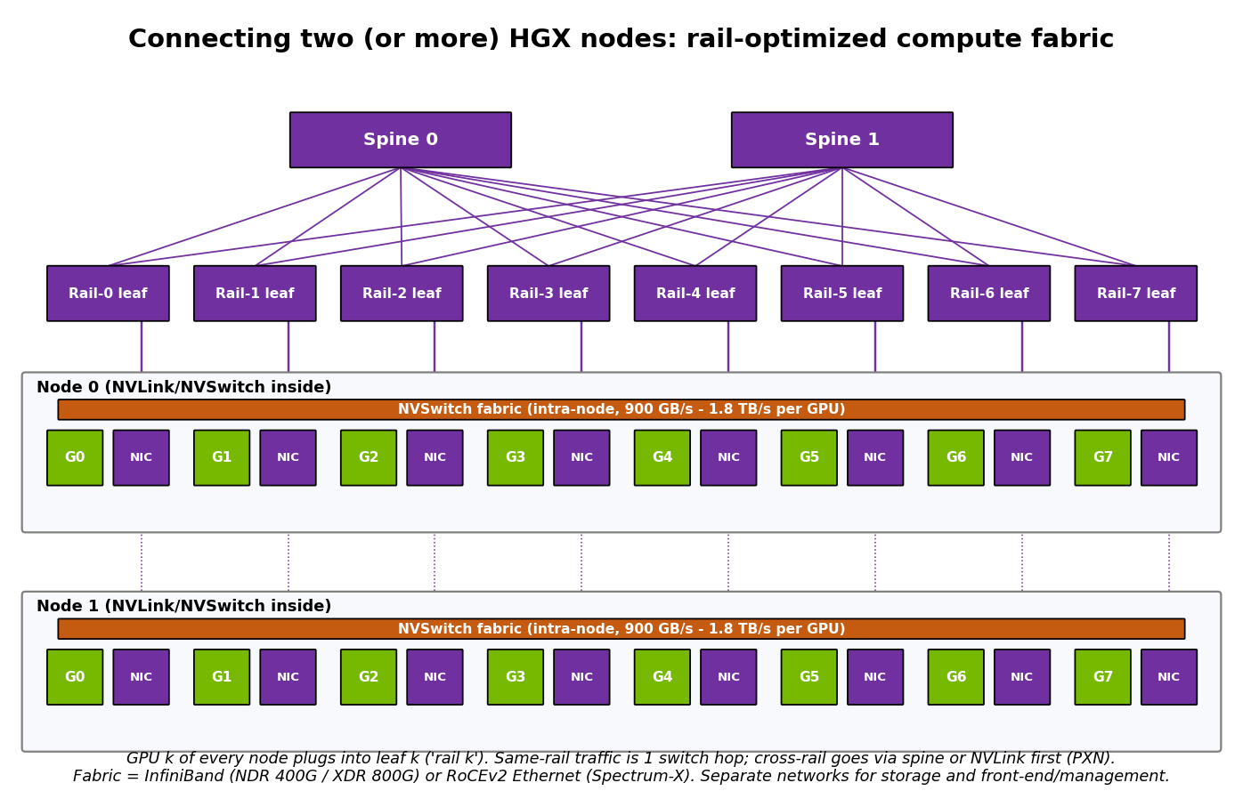
Figure 8.1 - Rail-optimized fabric: GPU k on every node connects to leaf switch k.
Diagram created for this guide from NVIDIA published specifications

8.1 Hardware
- One 400G/800G NIC per GPU (ConnectX-7/8 or equivalent), each sharing a PCIe switch with its GPU.
- Leaf switches arranged in rails: all GPU-0 NICs to leaf 0, all GPU-1 NICs to leaf 1, and so on; spine switches above the leaves. For exactly two nodes a single switch (or even direct cables for a lab) works.
- Separate storage and management networks so checkpoint traffic never competes with NCCL.
- Matching GPU model, driver, CUDA, NCCL and firmware versions on both nodes.

8.2 Software stack
- NVIDIA driver + CUDA, NVIDIA networking drivers (DOCA-OFED / MLNX_OFED), and the nvidia-peermem kernel module for GPUDirect RDMA.
- NCCL (collectives), plus a launcher: torchrun, MPI, Slurm, or Ray for vLLM.
- For RoCE: lossless configuration (PFC + ECN) on switches and NICs, consistent MTU.

8.3 Validate before running real jobs
# 1. Topology inside each node
nvidia-smi topo -m

# 2. Raw RDMA bandwidth between nodes, GPU memory to GPU memory
ib_write_bw -d mlx5_0 --use_cuda=0 -a # on node0
ib_write_bw -d mlx5_0 --use_cuda=0 -a <node0-ip> # on node1

# 3. NCCL collective bandwidth across 16 GPUs (nccl-tests)
mpirun -np 16 -H node0:8,node1:8 \
-x NCCL_DEBUG=INFO -x NCCL_IB_HCA=mlx5 -x NCCL_SOCKET_IFNAME=eth0 \
./build/all_reduce_perf -b 8 -e 8G -f 2 -g 1
In the NCCL_DEBUG output, confirm the transport says NET/IB with GDRDMA. If it says NET/Socket, traffic is falling back to TCP and you will lose most of your bandwidth.

8.4 Run a model across two nodes with vLLM
# node0 (head)
ray start --head --port=6379
# node1 (worker)
ray start --address=<node0-ip>:6379

# node0: TP inside each node (NVLink), PP across nodes (network)
vllm serve meta-llama/Llama-3.1-405B-Instruct-FP8 \
--tensor-parallel-size 8 --pipeline-parallel-size 2 \
--distributed-executor-backend ray
Key point: Placement rule: keep tensor parallelism inside the NVLink domain and put pipeline/data parallelism across the network. TP=16 over two HGX nodes connected by 400G NICs is a classic mistake: every layer's all-reduce crosses a link ~10x slower than NVLink.

Pros and cons
Pros | Cons
+ Serve models too large for one node | - Network becomes a bottleneck if parallelism is mis-placed
+ Higher total throughput | - More failure points (NICs, cables, optics)
+ Failure of one replica does not take down others (with DP) | - Harder debugging (NCCL hangs, timeouts)

9. Power Consumption and Cooling
In simple words: AI servers use as much power as several houses and get very hot. The newest racks are so dense they must be cooled with liquid instead of fans.
System | Approx. max power | Cooling
1x L4 card | 72 W | Air
8x L40S server | ~4-5 kW | Air
DGX/HGX H100 or H200 (8 GPU) | ~10.2 kW | Air (liquid optional)
DGX/HGX B200 (8 GPU) | ~14.3 kW | Air or liquid
GB200 NVL72 rack | ~120-130 kW | Direct-to-chip liquid (mandatory)
Vera Rubin NVL72 rack | ~190 kW and up (reported) | Liquid

- Rack density: traditional air-cooled racks are designed for roughly 10-20 kW, so they fit one or two HGX nodes, not four.
- PUE (Power Usage Effectiveness) = total facility power / IT power. Air-cooled facilities typically run 1.4-1.6; liquid-cooled designs can approach 1.1-1.2.
- Hot climates reduce the headroom of air cooling and make chillers work harder; liquid cooling and warm-water loops are increasingly the default for new GPU halls in such regions.
- Power capping (nvidia-smi -pl <watts>) often trades a small throughput loss for a large power saving; measure tokens per watt, not just tokens per second.
- Plan for redundant (N+1 or 2N) power feeds; a GPU job that loses power loses everything since its last checkpoint.
Cooling method | Pros | Cons
Air | Cheap, familiar, no plumbing | Limited to ~20-40 kW/rack; noisy; fan power
Rear-door heat exchanger | Retrofits existing halls | Moderate density gain only
Direct-to-chip liquid | Handles 100 kW+ racks; better PUE | Plumbing, leak risk, CDUs, new skills
Immersion | Highest density, silent | Hardware compatibility, messy servicing

10. Quantization and Batching
In simple words: Quantization makes the model smaller by storing numbers with fewer bits. Batching serves many users in the same GPU step so none of the GPU sits idle.

10.1 Quantization
Quantization stores weights (and optionally activations and KV cache) in fewer bits. It shrinks memory, which is the main constraint in decode, and on supporting hardware also speeds up the math.
Format | Bits | What is quantized | Hardware sweet spot | Quality impact
FP32 | 32 | Nothing (baseline) | Training master weights | Reference
BF16 / FP16 | 16 | Weights + activations | All modern GPUs | Effectively lossless
FP8 (E4M3) | 8 | Weights + activations (+ KV) | Ada, Hopper, Blackwell | Usually near-lossless
INT8 (W8A8, SmoothQuant) | 8 | Weights + activations | Ampere and newer | Small
INT4 weight-only (AWQ, GPTQ) | 4 | Weights only | Any GPU, great for small cards | Small to moderate; check evals
NVFP4 / MXFP4 | 4 | Weights + activations with micro-scaling | Blackwell and newer | Small with good calibration
GGUF (Q4_K_M, etc.) | 2-8 | Weights | CPU / llama.cpp / edge | Varies

- Weight-only quantization helps memory-bound decode the most; compute still happens in 16-bit.
- Weight + activation quantization (FP8, INT8, FP4) also speeds up prefill because the matrix math runs in low precision.
- KV cache quantization (FP8 KV) roughly doubles how many tokens fit, at a small quality risk on long-context tasks.
- PTQ vs QAT: post-training quantization needs only a small calibration set; quantization-aware training recovers more accuracy but needs a training run.
- Tools: llm-compressor (vLLM), NVIDIA Model Optimizer (TensorRT-LLM), AutoAWQ, GPTQModel, bitsandbytes.

Pros and cons
Pros | Cons
+ 2-4x less memory, so bigger models on fewer GPUs | - Quality loss, often invisible until you run task-specific evals
+ Larger batches and more KV cache | - Kernel support varies by GPU and format
+ Faster decode; faster prefill with FP8/FP4 kernels | - Calibration data must match your domain
+ Lower cost per token | - Outlier-heavy models quantize poorly

10.2 Batching
Strategy | How it works | Weakness
No batching | One request at a time | GPU mostly idle during decode
Static batching | Wait for N requests, run them together until all finish | Short requests wait for the longest one
Dynamic batching | Batch whatever arrived within a time window | Still request-level; padding waste
Continuous (in-flight) batching | Scheduler adds/removes sequences every decode step | Needs paged KV cache and a smart scheduler
Chunked prefill | Long prompts split into chunks mixed with decode steps | Slightly higher TTFT for very long prompts

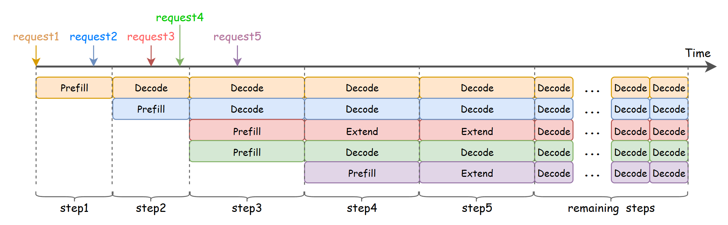
Figure 10.1 - Continuous batching: new requests join the running batch at the next step instead of waiting for others to finish.
Source: vLLM Blog, ROCm attention backend post (Feb 2026), vLLM Blog (github.com/vllm-project/vllm-project.github.io)
Key knobs in vLLM: --max-num-seqs (max concurrent sequences), --max-num-batched-tokens (token budget per step, which controls the prefill/decode mix), and --gpu-memory-utilization (share of VRAM for weights + KV cache).

Pros and cons
Pros | Cons
+ Throughput can rise by an order of magnitude | - Larger batches raise per-token latency (TPOT)
+ Near-full GPU utilization | - Long prefills can stall decodes without chunking
+ Lower cost per token | - Needs admission control to avoid KV cache exhaustion and preemption

11. Inference Engines: vLLM and TensorRT-LLM
In simple words: vLLM and TensorRT-LLM are the engines that actually run a model for many users at once, managing memory and scheduling far better than a simple script.

11.1 vLLM
vLLM is an open-source serving engine built around PagedAttention, which stores the KV cache in fixed-size blocks like virtual-memory pages. Sequences no longer need a contiguous memory region, so fragmentation disappears and blocks can be shared between requests.
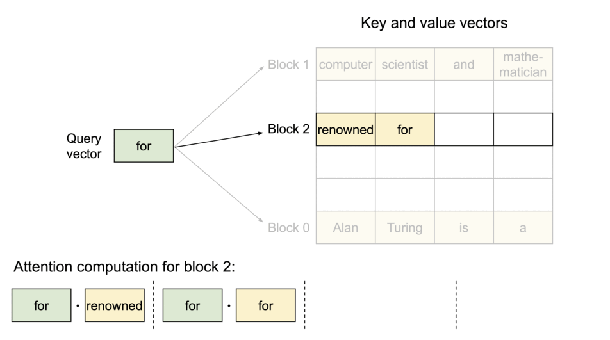
Figure 11.1 - PagedAttention: a sequence's KV cache lives in non-contiguous blocks mapped by a block table.
Source: vLLM Blog, "vLLM: Easy, Fast, and Cheap LLM Serving with PagedAttention" (2023), vLLM Blog (github.com/vllm-project/vllm-project.github.io)
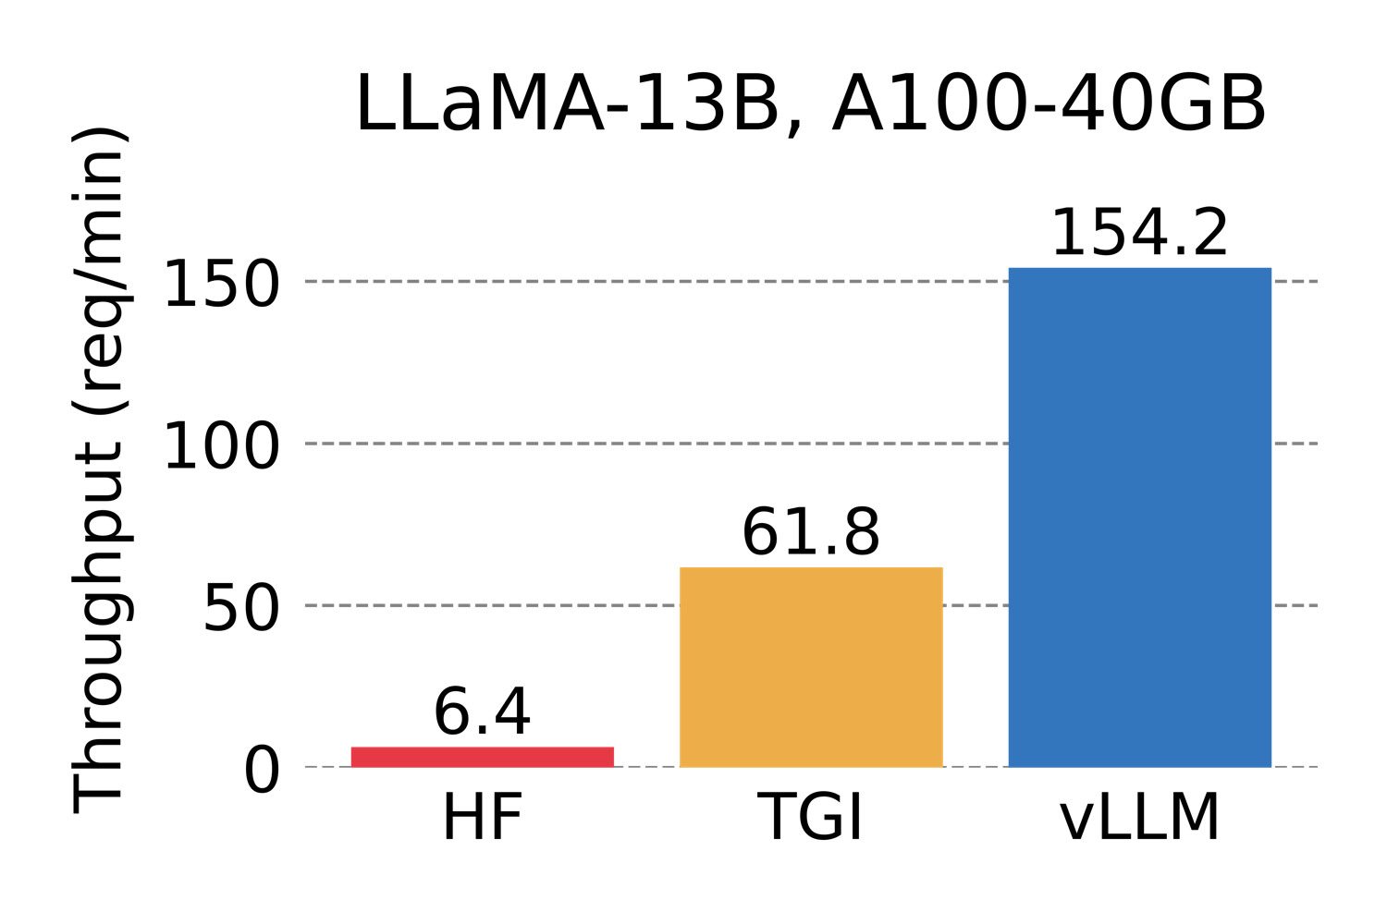
Figure 11.2 - Throughput from the original vLLM announcement (LLaMA-13B, A100-40GB) versus HF Transformers and TGI at the time. Numbers are historical; all engines have improved since.
Source: vLLM Blog (github.com/vllm-project/vllm-project.github.io)
Core features: continuous batching, chunked prefill, automatic prefix caching, tensor/pipeline/data/expert parallelism, FP8/INT4/FP4 quantization, speculative decoding, LoRA adapters, an OpenAI-compatible API, and Prometheus metrics. It runs on NVIDIA, AMD, Intel, Google TPU and other accelerators.
vllm serve Qwen/Qwen2.5-72B-Instruct \
--tensor-parallel-size 4 \
--max-model-len 32768 \
--gpu-memory-utilization 0.92 \
--kv-cache-dtype fp8 \
--enable-prefix-caching \
--max-num-seqs 256
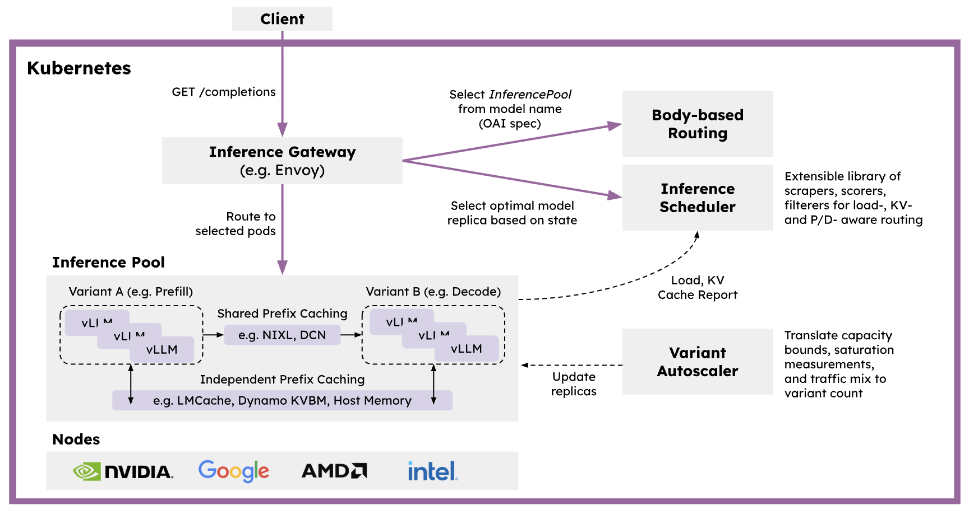
Figure 11.3 - llm-d: vLLM on Kubernetes with an inference gateway that routes by KV-cache and load awareness.
Source: vLLM Blog, large-scale serving post (Dec 2025), vLLM Blog (github.com/vllm-project/vllm-project.github.io)

11.2 TensorRT-LLM
TensorRT-LLM is NVIDIA's inference library. It applies kernel fusion, FP8/FP4 kernels, in-flight batching and paged KV cache, and has a PyTorch-based workflow in recent versions alongside its original compiled-engine flow. It is commonly served through Triton Inference Server or NVIDIA Dynamo, and packaged as NIM microservices.

11.3 Comparison
 | vLLM | TensorRT-LLM | SGLang
License | Apache 2.0 | Apache 2.0 | Apache 2.0
Hardware | Multi-vendor | NVIDIA only | Mostly NVIDIA/AMD
Time to first deploy | Minutes | Longer (tuning, sometimes engine builds) | Minutes
Peak NVIDIA performance | Very high | Often highest, especially on Blackwell FP4 | Very high; strong prefix caching
Model coverage | Broadest; new models land fast | Narrower, curated | Broad
Best for | Default choice, heterogeneous fleets | Squeezing max tokens/$ from NVIDIA | Agentic/structured workloads with heavy prefix reuse

Key point: Benchmark on your own traffic shape (prompt length, output length, concurrency). Vendor benchmarks are chosen to flatter the vendor, and rankings flip between workloads.

12. KV Caching and Speculative Decoding
In simple words: The KV cache is the model's notes about everything said so far; managing it well lets more users fit. Speculative decoding lets a small model guess ahead while the big model only checks the guesses.

12.1 KV cache
During attention, each token produces Key and Value vectors. Caching them means each decode step only computes the new token instead of re-processing the whole history. The price is memory that grows linearly with context length and batch size.
Technique | What it does | Trade-off
Paged KV cache | Fixed-size blocks, no fragmentation | Small indirection overhead
Prefix (radix) caching | Reuse KV blocks for identical prompt prefixes (system prompts, few-shot, chat history) | Only helps when prefixes repeat exactly
KV quantization (FP8) | Halves KV memory vs BF16 | Possible long-context quality loss
GQA / MQA / MLA | Fewer or compressed KV heads | Model architecture choice, not a runtime flag
KV offloading | Move cold blocks to CPU RAM / NVMe / remote store (e.g. LMCache) | Load latency; needs fast host links
Sliding window / eviction | Keep only recent or important tokens | Can lose information
Disaggregated prefill/decode | Prefill on one pool, ship KV to a decode pool | Needs fast KV transfer (RDMA/NIXL)

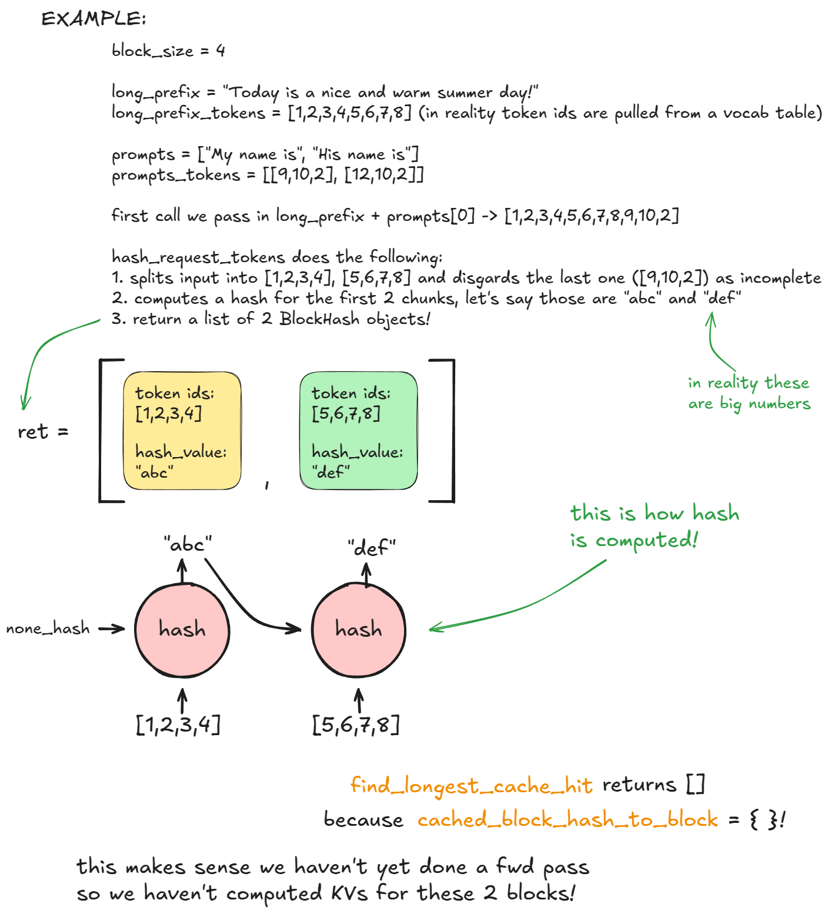
Figure 12.1 - Prefix caching: prompt tokens are hashed per block so identical prefixes map to already computed KV blocks.
Source: vLLM Blog, "Inside vLLM: Anatomy of a High-Throughput LLM Inference System" (A. Gordić), vLLM Blog (github.com/vllm-project/vllm-project.github.io)
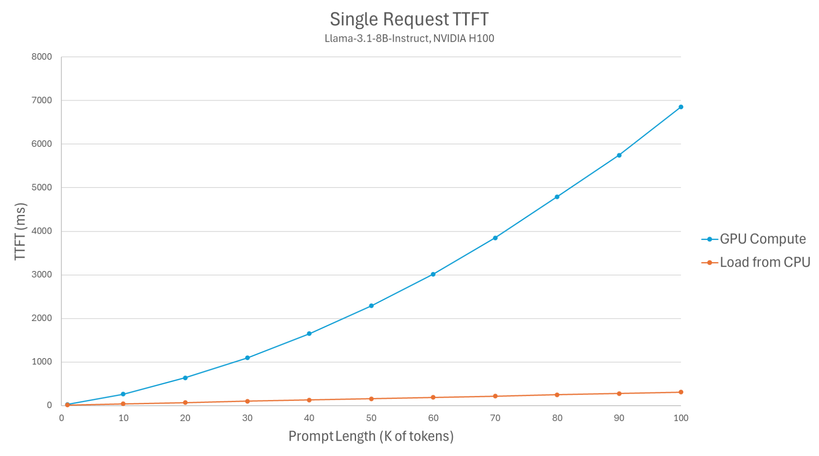
Figure 12.2 - Loading a cached prefix from CPU memory stays nearly flat as prompt length grows, while recomputing it on GPU grows steeply.
Source: vLLM Blog, KV offloading connector post (Jan 2026), vLLM Blog (github.com/vllm-project/vllm-project.github.io)
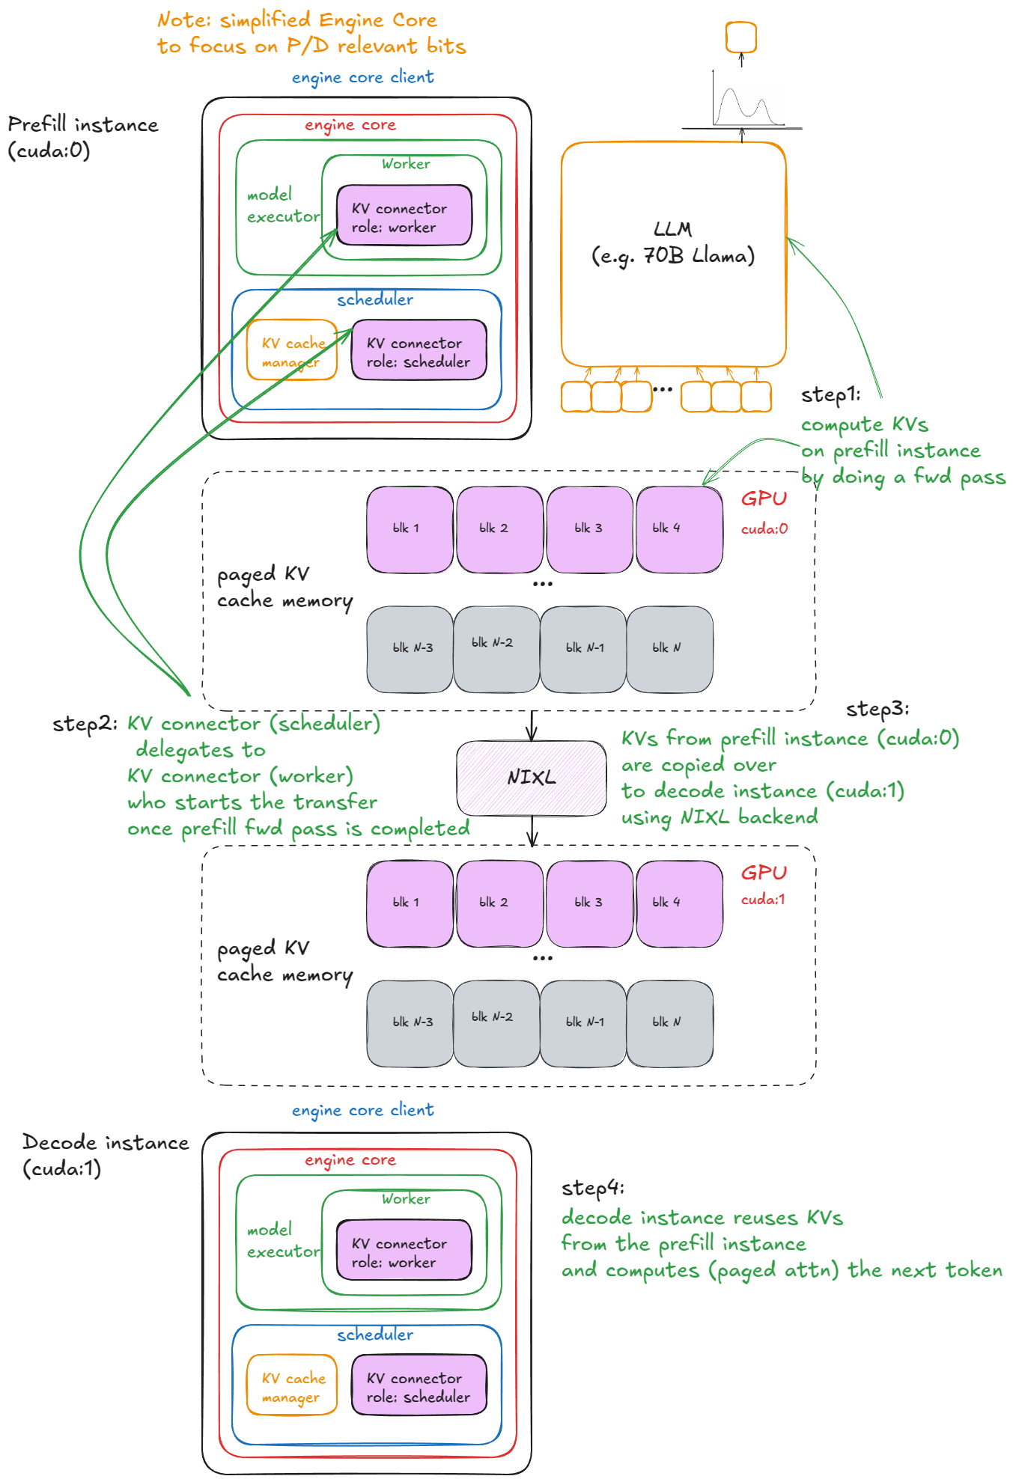
Figure 12.3 - Disaggregated prefill/decode: a prefill instance computes KV and a connector hands it to a decode instance.
Source: vLLM Blog, "Inside vLLM: Anatomy of a High-Throughput LLM Inference System" (A. Gordić), vLLM Blog (github.com/vllm-project/vllm-project.github.io)

12.2 Speculative decoding
A cheap draft proposes k tokens; the large target model verifies all k in one forward pass and accepts the longest correct prefix. With proper rejection sampling the output distribution is identical to the target model's, so it is lossless. Speed-up depends on the acceptance rate.
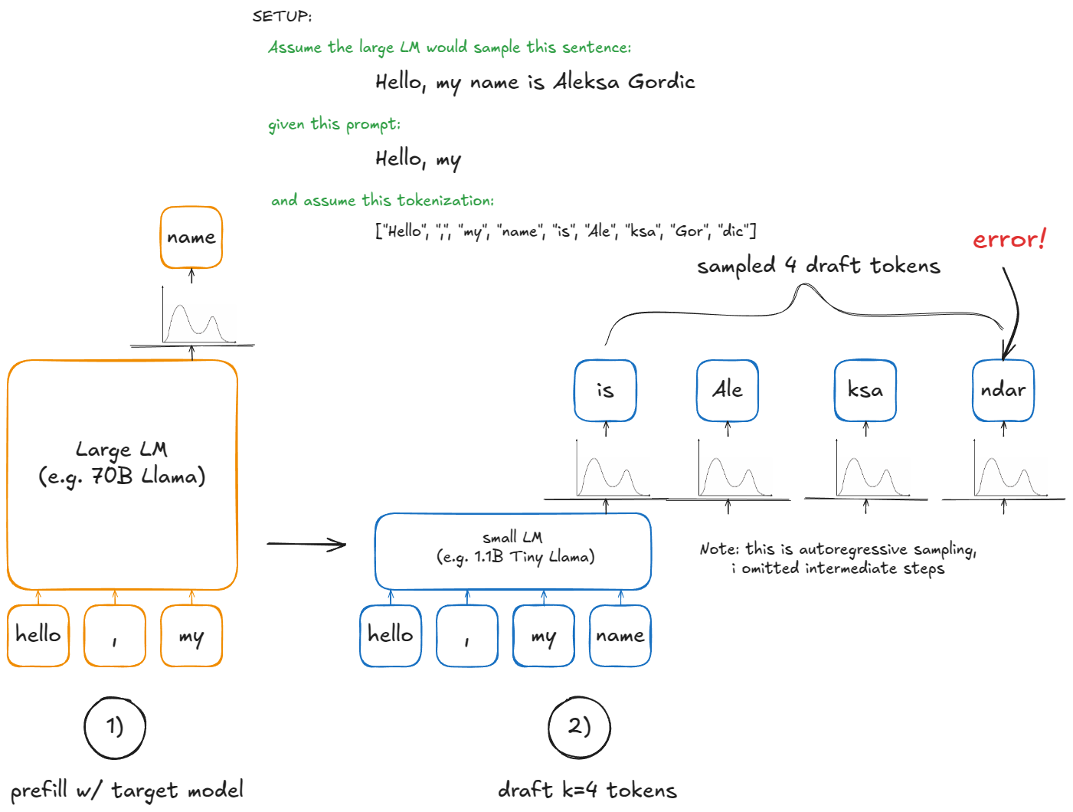
Figure 12.4 - Speculative decoding: a small draft model proposes tokens; the large model verifies them in parallel.
Source: vLLM Blog, "Inside vLLM: Anatomy of a High-Throughput LLM Inference System" (A. Gordić), vLLM Blog (github.com/vllm-project/vllm-project.github.io)
Variant | Draft source | Notes
Draft model | Small model of the same family | Needs same tokenizer; extra memory
N-gram / prompt lookup | Copies n-grams from the prompt | Free; great for RAG, code editing, summarization
Medusa | Extra decoding heads on the target | Needs fine-tuning
EAGLE / EAGLE-3 | Light head using target hidden states | High acceptance; widely supported
MTP (multi-token prediction) | Heads trained with the model (e.g. DeepSeek-V3) | Best acceptance when available

Pros and cons
Pros | Cons
+ 2-3x lower TPOT at low/medium batch sizes | - Gains shrink at high batch sizes when GPU compute is already saturated
+ Lossless output quality | - Extra memory and tuning (k, draft choice)
+ Works well for predictable text (code, extraction) | - Low acceptance rates can make it slower

13. Token Throughput and Latency Metrics
In simple words: Users feel two delays: how long until the first word appears (TTFT) and how fast the following words arrive (TPOT). Throughput is how many words the whole system produces per second.
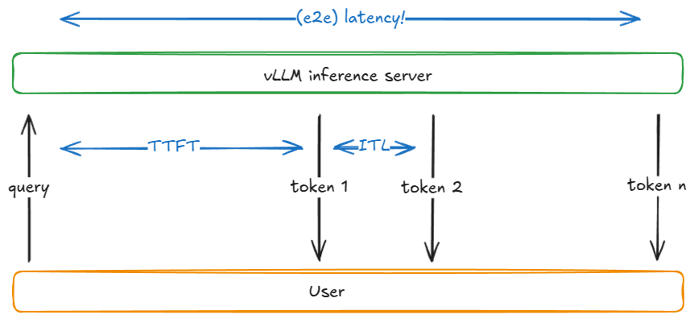
Figure 13.1 - Where TTFT, inter-token latency and end-to-end latency sit in a request's lifetime.
Source: vLLM Blog, "Inside vLLM: Anatomy of a High-Throughput LLM Inference System" (A. Gordić), vLLM Blog (github.com/vllm-project/vllm-project.github.io)
Metric | Definition | Driven by
TTFT (time to first token) | Request arrival -> first output token | Queue time + prefill compute; prompt length
TPOT (time per output token) | (E2E - TTFT) / (output tokens - 1) | Decode step time; batch size; memory bandwidth
ITL (inter-token latency) | Gap between consecutive tokens (distribution) | Same as TPOT; spikes from prefills and preemption
E2E latency | Arrival -> last token | TTFT + TPOT x output length
Throughput (tokens/s) | Output (or total) tokens per second across all users | Batch size, efficiency
Requests/s | Completed requests per second | Throughput / average output length
Goodput | Requests/s that meet all SLOs (e.g. TTFT < 500 ms and TPOT < 50 ms) | The metric that actually matters for capacity planning

Human reading speed is roughly 5-10 tokens per second, so TPOT below ~100 ms feels smooth for chat. Agents and batch jobs care about throughput and cost instead. Always report p50, p90 and p99, not averages.
vllm bench serve --model <model> \
--dataset-name random --random-input-len 2000 --random-output-len 300 \
--num-prompts 500 --request-rate 8
# sweep request-rate and plot throughput vs p99 TPOT to find the SLO knee
Goal | Levers
Lower TTFT | Prefix caching, chunked prefill, more prefill capacity or disaggregated prefill, shorter prompts, smarter routing
Lower TPOT | Smaller batches, speculative decoding, quantization, higher-bandwidth GPUs, tensor parallelism within NVLink
Higher throughput | Bigger batches, FP8/FP4, KV quantization, data parallelism, expert parallelism for MoE

14. Distributed Training: DDP, FSDP and DeepSpeed
In simple words: To train a model too big for one GPU, either copy it and split the data (DDP), or cut the model, its gradients and optimizer state into pieces spread across GPUs (FSDP, DeepSpeed ZeRO).
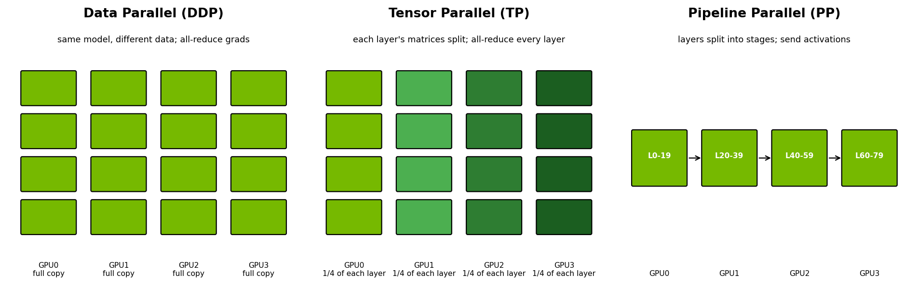
Figure 14.1 - Data, tensor and pipeline parallelism at a glance.
Diagram created for this guide

14.1 DDP (Distributed Data Parallel)
Every GPU holds a full copy of the model and optimizer, processes a different slice of the batch, and gradients are averaged with an all-reduce after the backward pass (bucketed and overlapped with computation).

Pros and cons
Pros | Cons
+ Simplest to use; near-linear scaling when the model fits | - Every GPU needs the full model + gradients + optimizer (~16 bytes/param)
+ Minimal code changes | - Useless once the model does not fit on one GPU

14.2 FSDP (Fully Sharded Data Parallel)
FSDP shards parameters, gradients and optimizer state across GPUs. Before each layer runs, it all-gathers that layer's parameters; after backward, it reduce-scatters gradients so each GPU keeps only its shard. FSDP2 in recent PyTorch uses per-parameter DTensor sharding.
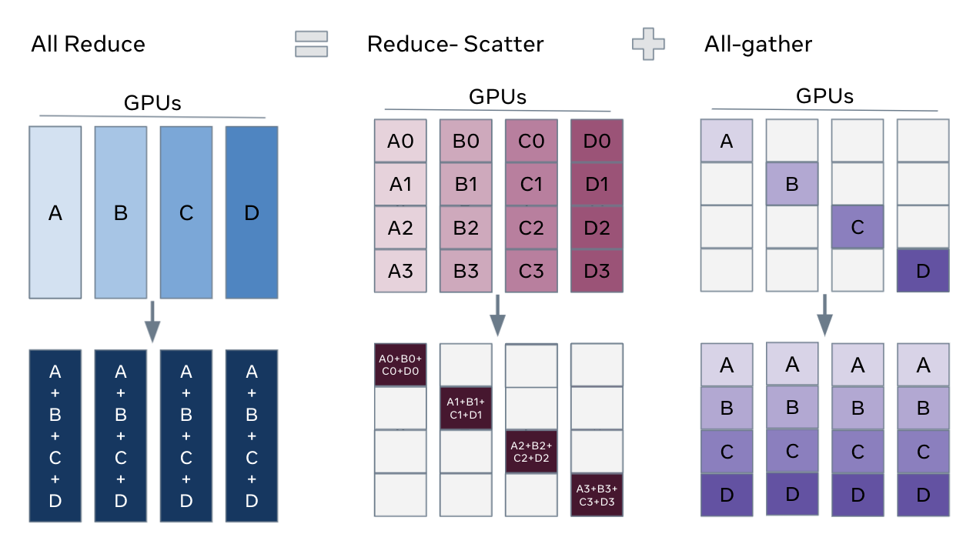
Figure 14.2 - All-reduce (DDP) vs reduce-scatter + all-gather (FSDP).
Source: PyTorch Tutorials, FSDP tutorial (github.com/pytorch/tutorials)
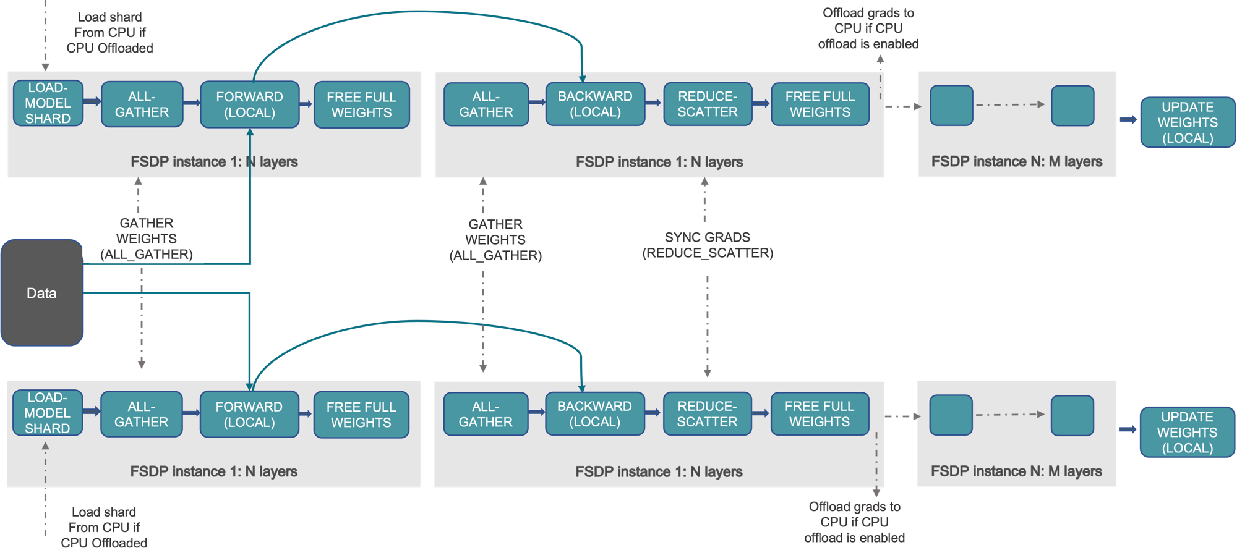
Figure 14.3 - FSDP workflow: shards are gathered for forward/backward, then gradients are reduce-scattered.
Source: PyTorch Tutorials, FSDP tutorial (github.com/pytorch/tutorials)

Pros and cons
Pros | Cons
+ Trains models far larger than one GPU | - Much more communication than DDP; needs fast interconnect
+ Native PyTorch, composes with TP and PP | - Tuning wrapping/prefetch policies matters
+ CPU offload option | - Debugging sharded state is harder

14.3 DeepSpeed ZeRO
Stage | Sharded across GPUs | Memory per GPU (approx., mixed-precision Adam) | Comm. cost
ZeRO-0 (= DDP) | Nothing | 16 x params | 1x
ZeRO-1 | Optimizer states | 4 + 12/N bytes per param | 1x
ZeRO-2 | + Gradients | 2 + 14/N bytes per param | 1x
ZeRO-3 (~ FSDP full shard) | + Parameters | 16/N bytes per param | ~1.5x
ZeRO-Offload / Infinity | Offload to CPU RAM / NVMe | Very small GPU footprint | Slow, PCIe-bound

Beyond ZeRO, DeepSpeed also provides pipeline parallelism, MoE training, and integrations with Megatron-style tensor parallelism. Hugging Face Accelerate can drive either FSDP or DeepSpeed from one config.

14.4 3D / 4D parallelism
Large runs combine TP inside a node (NVLink), PP across a few nodes, DP/FSDP across everything, plus context parallelism for very long sequences and expert parallelism for MoE. The design principle is the same as in inference: the most chatty parallelism goes on the fastest link.
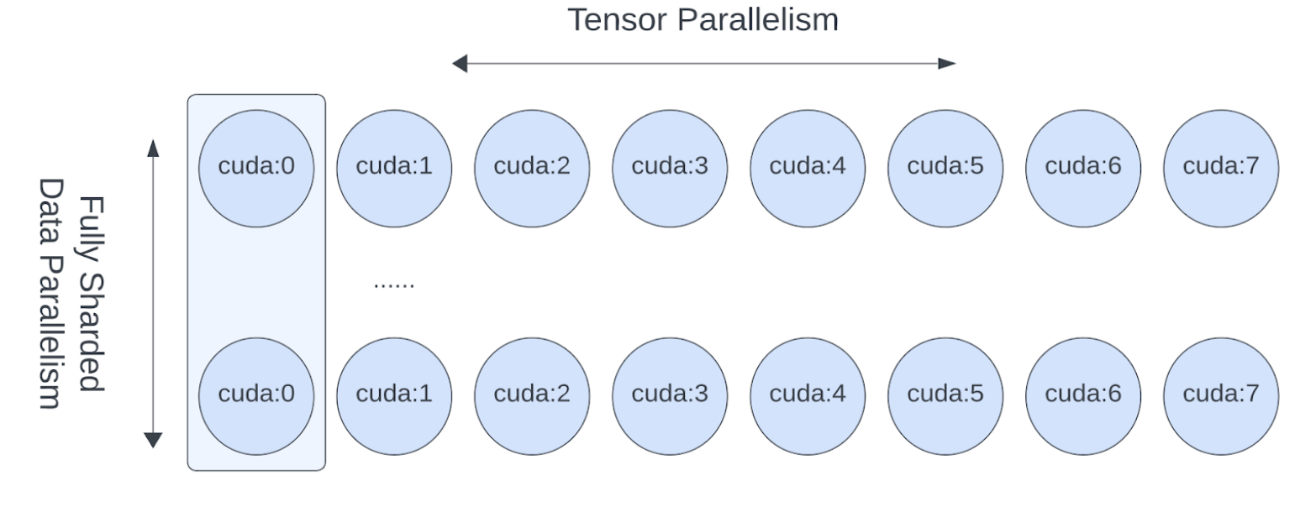
Figure 14.4 - Combining tensor parallelism inside hosts with FSDP across hosts.
Source: PyTorch Tutorials, FSDP + TP tutorial (github.com/pytorch/tutorials)

15. Model Serving, Autoscaling and GPU Scheduling
In simple words: Serving means keeping the model online for users; autoscaling adds or removes copies as traffic changes; scheduling decides which GPU runs what.

15.1 Serving stack
- Engine: vLLM, TensorRT-LLM, SGLang, TGI.
- Serving layer: Kubernetes + KServe, Ray Serve, NVIDIA Dynamo/Triton, or llm-d.
- Gateway/router: authentication, rate limits, model routing, KV-cache-aware and load-aware routing, fallbacks (e.g. LiteLLM, Envoy AI Gateway, Kubernetes Gateway API Inference Extension).
- Model storage: pre-staged weights on local NVMe or a fast shared file system to cut cold-start time.

15.2 Autoscaling
CPU utilization is the wrong signal for LLM servers. Scale on signals that track user pain.
Signal | Why it is useful | Caveat
Queue depth (requests waiting) | Direct measure of overload | Reacts only after users wait
KV cache utilization | Predicts preemption before it happens | Engine-specific metric
p90 TTFT / TPOT | Tied to SLOs | Noisy; smooth over a window
Tokens/s per replica vs benchmarked max | Good for capacity planning | Needs per-model benchmarks
GPU utilization (DCGM) | Easy to collect | Misleading: 100% util does not mean saturated throughput

- Cold starts for large models take minutes (image pull, weight load, CUDA graph capture). Keep a warm minimum, cache weights locally, and consider scale-to-zero only for rarely used models.
- Tools: KEDA or HPA with custom metrics, KServe autoscaler, Ray Serve autoscaling, llm-d variant autoscaler.

15.3 GPU scheduling and sharing
Mechanism | Isolation | Best for
Whole-GPU allocation (Kubernetes device plugin) | Full | Production LLM serving and training
MIG (Multi-Instance GPU) | Hardware-level memory and compute isolation, up to 7 slices | Small models, notebooks, multi-tenant inference
MPS (Multi-Process Service) | Shared context, limited fault isolation | Many small inference processes
Time-slicing | None (memory shared) | Dev/test only
Gang scheduling (Kueue, Volcano, Slurm) | Job-level | Multi-GPU training: all-or-nothing placement
Topology-aware scheduling | - | Keep TP groups on the same NVLink domain, DP groups on the same rail

The NVIDIA GPU Operator installs drivers, the device plugin, DCGM exporter and MIG manager on Kubernetes nodes. Slurm remains the default for large training clusters because of its gang scheduling and fair-share queues.

Pros and cons
Pros | Cons
+ Kubernetes: standard tooling, autoscaling, multi-tenant | - Kubernetes GPU scheduling needs add-ons for gang/topology awareness
+ Slurm: simple, excellent for big batch training | - Slurm is weak for long-running services
+ MIG: high density for small models | - MIG slices cannot use NVLink between them

16. Embeddings, Vector Databases, Retrieval, Reranking and RAG
In simple words: RAG lets a model answer from your own documents: turn text into vectors, find the most relevant pieces, rank them, and hand them to the model with the question.

16.1 Pipeline
INGEST: documents -> parse (PDF/OCR/tables) -> chunk -> embed -> index (vector + keyword)
QUERY: question -> (rewrite) -> embed -> hybrid search top-50 -> rerank -> top-5
-> build prompt (with citations) -> LLM -> answer -> log + evaluate

16.2 Components
Component | Options | Optimization notes
Chunking | Fixed-size with overlap, recursive, semantic, layout-aware | Chunk to meaning, keep headings/metadata; 300-800 tokens is a common start
Embedding model | BGE-M3, E5, GTE, Qwen3-Embedding, Nomic, commercial APIs | Match language (Arabic/English); benchmark on your data, not only MTEB
Embedding serving | Text Embeddings Inference, vLLM, Infinity | Batch aggressively; small GPUs (L4) are enough
Vector index | HNSW (fast, memory-heavy), IVF-PQ (compressed), DiskANN | Tune ef/nprobe for recall vs latency
Vector DB | pgvector, Qdrant, Milvus, Weaviate, OpenSearch, Elasticsearch | Prefer what your team can operate; pgvector is enough for millions of vectors
Hybrid search | BM25 + dense, fused with Reciprocal Rank Fusion | Critical for part numbers, codes and acronyms
Reranker | Cross-encoders (bge-reranker, Cohere Rerank), LLM rerankers | Big precision gain; rerank only the top 20-100
Evaluation | Ragas, TruLens, custom golden sets | Measure retrieval recall@k separately from answer quality

Pros and cons
Pros | Cons
+ Answers grounded in private, current data without retraining | - Retrieval failures are silent: the LLM answers confidently from wrong chunks
+ Citations improve trust and auditability | - Parsing tables/scans is often the hardest part
+ Cheaper than fine-tuning for knowledge | - Long retrieved contexts raise TTFT and cost
 | - Access control must be enforced at retrieval time

17. Prompt Caching and Cost Optimization
In simple words: Most AI cost is GPU time. Reusing work already done (caching), using smaller models when possible, and keeping GPUs busy cut the bill the most.

17.1 Prompt caching
- Self-hosted: automatic prefix caching (vLLM/SGLang) reuses KV blocks for repeated prefixes; KV offloading extends the cache to CPU/NVMe.
- API providers: cached input tokens are billed at a steep discount and skip most prefill latency. Check current provider pricing, as rates and cache lifetimes change.
- Design for cache hits: put static content (system prompt, tool definitions, documents) first and variable content (user question) last. Any change early in the prompt invalidates everything after it.
- Route for cache hits: send requests with the same prefix to the same replica (prefix-aware routing).
- Semantic caching (return a stored answer for a similar question) is a different technique: cheaper but risks wrong answers; use with strict similarity thresholds.
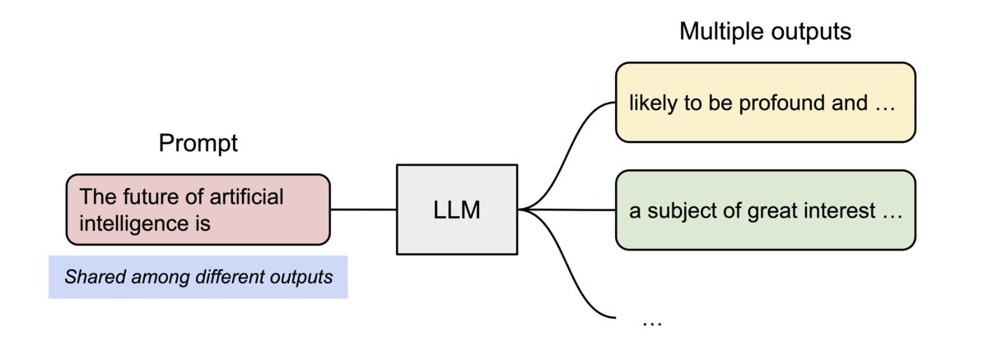
Figure 17.1 - Shared prompt KV blocks reused across multiple outputs, the same principle behind prefix caching.
Source: vLLM Blog, PagedAttention post (2023), vLLM Blog (github.com/vllm-project/vllm-project.github.io)

17.2 Cost model
cost per 1M output tokens = (GPU hourly cost x number of GPUs) / (tokens per second x 3600) x 1,000,000

Example: 8 GPUs x $3/hour = $24/hour; sustained 6,000 output tok/s at your SLO
-> 21.6M tokens/hour -> ~$1.11 per 1M output tokens (at 100% utilization)
At 40% average utilization the effective cost is ~2.5x higher.

17.3 Cost levers (roughly in order of impact)
- Right-size the model: route easy requests to a small model, hard ones to a large model.
- Raise utilization: consolidate traffic, batch offline jobs at night, autoscale down.
- Quantize (FP8/FP4, KV FP8) to fit more users per GPU.
- Maximize prefix-cache hits and trim prompts (RAG top-k, compressed history).
- Cap output length and use structured outputs to avoid rambling.
- Use speculative decoding for latency-sensitive traffic instead of over-provisioning.
- Pick hardware by tokens per dollar on your workload, not list performance.

18. Monitoring, Tracing and LLM Observability
In simple words: Observability means you can see, at any moment, whether the system is fast, correct, healthy and within budget, and trace any bad answer back to its cause.

18.1 Infrastructure metrics (DCGM exporter -> Prometheus -> Grafana)
Metric | What it tells you
DCGM_FI_DEV_GPU_UTIL | Whether a kernel was running (coarse; not true saturation)
DCGM_FI_PROF_SM_ACTIVE / GR_ENGINE_ACTIVE | Finer-grained compute activity
DCGM_FI_DEV_FB_USED | VRAM in use (vLLM pre-allocates, so expect ~90%)
DCGM_FI_DEV_POWER_USAGE, DCGM_FI_DEV_GPU_TEMP | Power and thermal headroom; throttling risk
DCGM_FI_DEV_XID_ERRORS | Driver-reported GPU faults (e.g. Xid 79 = GPU fell off the bus)
ECC / row-remapping counters | Failing memory; drain the node before it corrupts a job
NVLink and NIC error / throughput counters | Degraded links that silently slow collectives

18.2 Serving metrics (vLLM /metrics)
vLLM exposes Prometheus metrics such as running and waiting request counts, KV cache usage, TTFT and inter-token latency histograms, end-to-end latency, prompt/generation token counters and prefix-cache hit rates. Exact metric names change between versions, so check the /metrics output of your deployed version.

18.3 Tracing and LLM observability
- Distributed tracing with OpenTelemetry: gateway -> retriever -> reranker -> LLM -> tools, with the OpenTelemetry GenAI semantic conventions for model, token counts and latency.
- LLM observability platforms (Langfuse, Arize Phoenix, LangSmith, Helicone) store prompts, completions, costs and user feedback per trace.
- Quality monitoring: offline golden-set evals before deploys; online sampling with LLM-as-judge; track hallucination, refusal and groundedness rates.
- Security signals: prompt-injection attempts, PII in outputs, jailbreak patterns.
- Privacy: prompts often contain sensitive data; redact before logging and set retention limits.
Alert | Suggested trigger
SLO breach | p90 TTFT or TPOT above target for 5 minutes
Saturation | Waiting requests > 0 for sustained periods, or KV usage > 95%
Preemptions | Any sustained preemption rate
Hardware | Any new Xid, ECC uncorrectable error, NVLink down, GPU temp near limit
Cost | Tokens/day or $/day above forecast
Quality | Eval score or thumbs-down rate drops after a deploy

19. Optimization Playbook
In simple words: A repeatable order of work: set goals, measure the workload, choose the model and hardware, tune, benchmark, deploy, watch, and repeat.
- Define SLOs first: p90 TTFT, p90 TPOT, and a cost ceiling per 1M tokens.
- Profile the workload: input/output length distribution, concurrency, prefix reuse.
- Pick the model and precision: smallest model that passes evals; FP8 by default on modern GPUs.
- Size memory: weights + KV cache for target concurrency x context + overhead.
- Pick parallelism: TP within NVLink; DP for throughput; PP/EP across nodes only when needed.
- Tune the engine: max-num-seqs, max-num-batched-tokens, prefix caching, KV dtype, speculative decoding.
- Benchmark: sweep request rate; find the goodput knee; repeat after every change.
- Deploy with routing and autoscaling on queue/KV/latency signals.
- Observe: DCGM + engine metrics + traces + evals; alert on SLOs and hardware faults.
- Iterate on cost: utilization, caching, model routing, hardware choice.

20. Interview Questions and Answers
Answers are written to be spoken in about one minute. Interviewers usually follow up with "why?" or "what would you measure?", so know the reasoning, not just the conclusion.

20.1 GPU fundamentals and vocabulary
Q1. What is the difference between TF32, FP16 and BF16?
A: TF32 keeps FP32 storage but runs supported matmuls with FP32's exponent and a 10-bit mantissa, so it speeds up compute without saving memory. FP16 and BF16 both store 16 bits: FP16 has a 5-bit exponent (small range, needs loss scaling in training), BF16 has an 8-bit exponent (FP32's range, more stable). BF16 is the default for LLM training on Ampere and newer.
Q2. Why can nvidia-smi show 100% GPU utilization while the GPU is underused?
A: GPU-Util is the share of time at least one kernel was running, not the share of compute capacity used. Tiny batches or a slow CPU feeding many small kernels can show 100%. Use DCGM SM-active or engine-active metrics, MFU for training, or tokens/s against a benchmarked maximum for serving.
Q3. What is MFU and what does a low value tell you?
A: Model FLOPs Utilization is achieved FLOPS divided by the hardware's theoretical peak. Well-tuned large training runs often reach roughly 35-50%. A low MFU means time is lost to memory movement, communication, data loading or CPU overhead, so adding GPUs will not fix it.
Q4. Eight GPUs finish a job in 29 s that takes 100 s on one GPU. How do you describe that?
A: Speed-up is 100/29 = 3.45x and scaling efficiency is 100/(8 x 29) = 43%. More than half the added GPU time is lost to communication, synchronisation and waiting. I would profile NCCL time, check the interconnect with nccl-tests, and revisit the parallelism layout before adding GPUs.
Q5. How does ring all-reduce work and why is it popular?
A: It runs a reduce-scatter and then an all-gather around a logical ring. Each GPU sends about 2(N-1)/N times the data size, so bandwidth cost per GPU stays nearly constant as N grows, which makes it bandwidth-optimal. Its weakness is latency growing with ring length, which tree algorithms and in-network reduction (SHARP) address.
Q6. Why does quantization speed up decode even when compute stays in 16-bit?
A: Decode is memory-bandwidth-bound: each token requires reading all weights from HBM. Weight-only INT4 cuts the bytes read per token by about 4x versus BF16, so more tokens per second fit through the same memory bandwidth, even though the matmuls themselves run in 16-bit after dequantization.

20.2 Hardware and interconnects
Q7. Why is LLM decode memory-bound while prefill is compute-bound?
A: Prefill processes all prompt tokens in one large parallel matrix operation, so the GPU's compute is the limit. Decode generates one token per sequence per step: the math per step is small, but all weights and the KV cache must be read from memory every step, so memory bandwidth limits speed. That is why batching (sharing one weight read across many sequences) and higher-bandwidth memory (H200 vs H100) help decode so much.
Q8. How much memory does a 70B model need to serve?
A: Weights: ~140 GB in BF16, ~70 GB in FP8, ~35-40 GB in INT4. Add KV cache: for Llama-3-70B it is about 0.33 MB per token in BF16, so 8 users at 32k tokens need ~84 GB more. Add a few GB of runtime overhead. In practice: 2x H100 in FP8 for moderate concurrency, 4x H100 or 2x H200 for comfortable headroom.
Q9. What is the difference between PCIe, NVLink and NVSwitch?
A: PCIe is the general-purpose bus connecting CPUs to GPUs, NICs and storage (~64 GB/s each way on Gen5 x16). NVLink is a dedicated GPU-to-GPU link with far higher bandwidth (900 GB/s per GPU on H100, 1.8 TB/s on B200). NVSwitch is a switch chip that connects all GPUs' NVLinks so every pair talks at full speed in one hop.
Q10. What does 'SYS' mean in nvidia-smi topo -m and why do you care?
A: The two devices communicate across the CPU-to-CPU link between NUMA nodes, the slowest intra-node path. If a GPU and its NIC show SYS, GPUDirect RDMA performance suffers; if two GPUs in a TP group show SYS with no NVLink, tensor parallelism will be slow.
Q11. What is GPUDirect RDMA?
A: It lets a network card read and write GPU memory directly, skipping CPU memory copies. It requires nvidia-peermem (or dma-buf), compatible NICs, and ideally the GPU and NIC under the same PCIe switch. Without it, inter-node collectives bounce through host memory and lose bandwidth and latency.
Q12. Scale-up vs scale-out: when do you choose each?
A: Scale up (bigger NVLink domain) when communication is heavy and latency-sensitive: tensor or expert parallelism for huge models. Scale out (more nodes) when work is independent or communication is lighter: data-parallel replicas for serving, FSDP/DP training, pipeline stages. Most real systems do both: scale up to the NVLink domain, scale out beyond it.
Q13. What is a rail-optimized network?
A: Each node's GPU k connects through its own NIC to leaf switch k. Collectives in NCCL mostly communicate between same-index GPUs, so most traffic stays within one leaf (one hop), reducing congestion and cost compared with sending everything through spines.
Q14. InfiniBand or RoCE?
A: InfiniBand is lossless by design, has mature congestion control and in-network reduction (SHARP), and is the lowest-risk choice for large training. RoCEv2 Ethernet is cheaper, multi-vendor and familiar to network teams, and approaches InfiniBand performance when PFC/ECN and adaptive routing are tuned correctly. For small inference clusters, well-configured RoCE is usually sufficient.
Q15. What changes when you move from HGX H100 to GB200 NVL72?
A: The NVLink domain grows from 8 to 72 GPUs, the CPU-GPU link becomes NVLink-C2C instead of PCIe, power jumps to ~120 kW per rack, and liquid cooling becomes mandatory. Software can use tensor/expert parallelism across 72 GPUs, which especially benefits large MoE models.

20.3 Inference optimization
Q16. Explain PagedAttention.
A: The KV cache is split into fixed-size blocks allocated on demand and tracked by a per-sequence block table, like OS virtual memory. This removes fragmentation from reserving max-length contiguous buffers, raises usable batch size, and enables sharing blocks across sequences (prefix caching, parallel sampling) via reference counts and copy-on-write.
Q17. What is continuous batching and why is it better than static batching?
A: The scheduler decides the batch every decode step: finished sequences leave, new ones join immediately. Static batching waits for the longest sequence in the batch, leaving GPU slots idle. Continuous batching gives much higher throughput and lower average latency.
Q18. What is chunked prefill?
A: Long prompts are split into chunks processed alongside ongoing decode steps within a per-step token budget. It prevents one long prompt from freezing every other user's token stream, smoothing inter-token latency at a small TTFT cost for very long prompts.
Q19. How does speculative decoding stay lossless?
A: The target model verifies the draft tokens in one forward pass and accepts or rejects each using a rejection-sampling rule that guarantees the final token distribution equals the target model's. The draft affects speed only, never output quality.
Q20. When does speculative decoding not help?
A: At high batch sizes, when the GPU is already compute-saturated, verification of extra tokens costs real compute. It also hurts when acceptance rates are low (creative, high-temperature text, mismatched drafts).
Q21. Your TTFT is high but TPOT is fine. What do you check?
A: Queue time (are requests waiting? scale out or add admission control), prompt length (trim RAG context), prefix-cache hit rate (reorder prompts, prefix-aware routing), chunked prefill budget, and whether prefill should be disaggregated to its own pool.
Q22. Your TPOT degrades as load rises. Why and what do you do?
A: Larger batches mean more work per decode step, and prefills interleave with decodes. Options: cap max-num-seqs to your SLO knee, add replicas, quantize to free memory bandwidth, use speculative decoding, move to higher-bandwidth GPUs, or separate prefill from decode.
Q23. What is goodput and why is it better than throughput?
A: Goodput counts only the requests that meet every latency SLO. Throughput can rise while users suffer; goodput captures the capacity you can actually sell.
Q24. How do you choose between FP8, INT8 and INT4?
A: FP8 on Ada/Hopper/Blackwell is the default: near-lossless and faster. INT4 weight-only (AWQ/GPTQ) when memory is the constraint or GPUs lack FP8. NVFP4 on Blackwell for maximum throughput after validating quality. Always decide with task-specific evals, not perplexity alone.
Q25. What is disaggregated prefill/decode?
A: Running prefill and decode on separate GPU pools and transferring the KV cache between them over a fast link. Each pool is tuned and scaled independently, removing interference between the phases. It adds KV transfer latency and complexity, so it pays off mainly at larger scale or strict SLOs.
Q26. How do GQA and MLA reduce KV cache?
A: Grouped-query attention shares each KV head across several query heads (e.g. 8 KV heads for 64 query heads, an 8x reduction). Multi-head latent attention (DeepSeek) compresses keys and values into a small latent vector, shrinking the cache further.

20.4 Training and distributed systems
Q27. Why does full fine-tuning of a 7B model need far more than 14 GB?
A: Mixed-precision Adam needs roughly 16 bytes per parameter (BF16 weights and gradients, plus FP32 master weights and two Adam moments), so about 112 GB before activations. Solutions: FSDP/ZeRO-3 sharding, CPU offload, activation checkpointing, or parameter-efficient methods like LoRA/QLoRA.
Q28. DDP vs FSDP vs ZeRO?
A: DDP replicates everything and all-reduces gradients. ZeRO-1/2/3 progressively shard optimizer states, gradients and parameters. FSDP is PyTorch's native equivalent of ZeRO-3 (with other sharding strategies available). Use DDP when the model fits, FSDP/ZeRO-3 when it does not.
Q29. What collectives does FSDP use?
A: All-gather to materialize a unit's full parameters before forward and backward, and reduce-scatter to average gradients and leave each rank with only its shard. DDP uses all-reduce, which is equivalent to reduce-scatter followed by all-gather.
Q30. Why keep tensor parallelism inside a node?
A: TP performs collectives inside every layer, in both forward and backward. That volume needs NVLink-class bandwidth; across a 400G network it would dominate step time.
Q31. A multi-node job hangs at startup. How do you debug it?
A: Set NCCL_DEBUG=INFO, confirm every rank reaches rendezvous (MASTER_ADDR/port, firewall), check NCCL_SOCKET_IFNAME points to a routable interface, verify IB devices with ibstat, run nccl-tests between the nodes, and check for version mismatches in driver, CUDA or NCCL.
Q32. How do you handle GPU failures in long training runs?
A: Frequent asynchronous checkpoints to fast storage, automatic job restart with node health checks (DCGM diagnostics, Xid monitoring), hot-spare nodes, and elastic training where supported. Measure goodput of the cluster (time spent training vs recovering).

20.5 Serving, RAG, cost and operations
Q33. How would you autoscale an LLM service?
A: Scale on queue depth, KV-cache utilization, and p90 latency rather than CPU or GPU utilization. Keep warm minimum replicas because cold starts take minutes, cache weights on local NVMe, and use prefix- and load-aware routing so new replicas actually receive traffic.
Q34. When would you use MIG?
A: When several small workloads (embeddings, small models, notebooks) need isolated, guaranteed slices of one large GPU. Not for large LLMs that need a full GPU or NVLink across GPUs.
Q35. Design a RAG system for 10 million enterprise documents.
A: Layout-aware parsing and chunking with metadata; batched embedding on small GPUs; hybrid search (BM25 + vector with HNSW or IVF-PQ) with permission filters; cross-encoder reranking of top 50; LLM generation with citations; caching for static prompt parts; offline evals of recall@k and answer faithfulness; tracing of every step; incremental re-indexing when documents change.
Q36. Why add a reranker if the vector search already returns relevant results?
A: Bi-encoder embeddings compress a whole chunk into one vector, which loses detail. A cross-encoder reads query and chunk together and scores relevance much more precisely. Reranking the top 20-100 is cheap and usually gives a large precision gain, allowing fewer, better chunks in the prompt.
Q37. How do you estimate cost per million tokens for self-hosting?
A: Hourly cost of the GPUs (including power, cooling and depreciation) divided by tokens generated per hour at your latency SLO, times one million, then adjusted for average utilization. Low utilization is usually the biggest hidden cost.
Q38. How do you maximize prompt cache hits?
A: Keep static content (system prompt, tools, reference documents) at the start and identical byte-for-byte, put variable content at the end, avoid timestamps or IDs in the prefix, and route requests with the same prefix to the same replica.
Q39. Why is GPU utilization a misleading metric?
A: It reports the fraction of time any kernel was running, not how much of the GPU's capacity was used. A GPU can show 100% while running tiny batches. Use tokens/s against a benchmarked maximum, DCGM profiling metrics, and KV usage instead.
Q40. What do you monitor in production LLM serving?
A: Latency percentiles (TTFT, TPOT, E2E), throughput, queue depth, KV usage and preemptions, error rates, token and cost counters, GPU health (Xid, ECC, temperature, power, NVLink), and quality signals (evals, user feedback, hallucination and safety flags), all tied together by request traces.

21. References and Image Credits
Third-party images, including the Section 3 illustrations from the JAM with AI newsletter, are reproduced from the open-source repositories listed below with credit in each caption; the vLLM blog and PyTorch tutorials repositories are published under open-source licenses (check each repository's license before redistributing this document externally). Hardware topology diagrams and charts marked "created for this guide" were drawn from vendor specifications because vendor image sites were not reachable from the build environment. Verify specifications for new hardware against current datasheets.
- Shirin Khosravi Jam & Shantanu Ladhwe, "All GPU related concepts simply explained", JAM with AI newsletter, 17 Sep 2026 - source of the concept illustrations in Section 3 (reproduced for personal study; do not redistribute without the authors' permission)
- vLLM documentation - docs.vllm.ai
- vLLM Blog - blog.vllm.ai (source repository: github.com/vllm-project/vllm-project.github.io); posts: PagedAttention (2023), Inside vLLM: Anatomy of a High-Throughput LLM Inference System, Large-scale serving (Dec 2025), KV offloading connector (Jan 2026), ROCm attention backend (Feb 2026)
- PyTorch tutorials: Getting Started with FSDP; Large Scale Transformer Training with Tensor Parallel - pytorch.org/tutorials (source: github.com/pytorch/tutorials)
- Kwon et al., Efficient Memory Management for Large Language Model Serving with PagedAttention (SOSP 2023)
- Rajbhandari et al., ZeRO: Memory Optimizations Toward Training Trillion Parameter Models (SC 2020)
- Leviathan et al., Fast Inference from Transformers via Speculative Decoding (ICML 2023)
- NVIDIA HGX, DGX, GB200 NVL72 and NVLink product pages and datasheets - nvidia.com
- NVIDIA Technical Blog, Inside the NVIDIA Vera Rubin Platform (Jan 2026) - developer.nvidia.com
- NVIDIA TensorRT-LLM documentation - nvidia.github.io/TensorRT-LLM
- NVIDIA DCGM and GPU Operator documentation - docs.nvidia.com/datacenter
- DeepSpeed documentation - deepspeed.ai
- PCI-SIG specifications overview - pcisig.com

